|  |  |  |  |  |
| --- | --- | --- | --- | --- |
| AMARIA YOUNG | | | | |
|  | | | | |
| 912-650-3734 |  | Amariay2187@gmail.com |  | Savannah, GA |
|  | | | | |

**Objective**

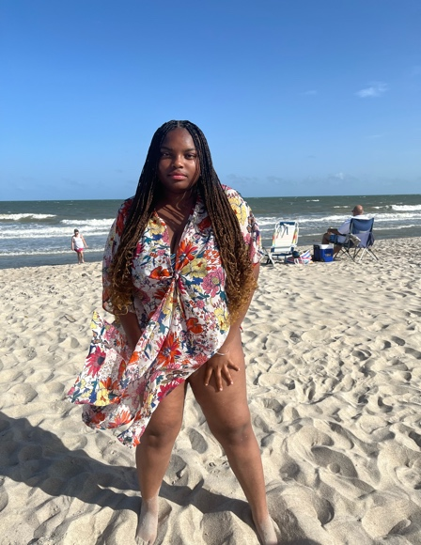To gain experience and build professional credits as an actor and screenwriter, utilizing my passion, versatility, and emotional depth across film and television projects.

Height: 5’5

Weight: 200

Hair: Brown / Honey Blonde

Eyes: Brown

**Experience**

**Legacy** – Independent / Unreleased Project

Role: Legend (Supporting)

Genre: Sci-Fi / Action / Drama

– Portrayed a powerful daughter in a dystopian world fighting to reunite with her her truth.

– Developed emotional scenes centered on betrayal, survival, and maternal strength.

**Legacy’s Legend** – Self-Directed Scene Study

Role: Legend (Supporting)

Genre: Sci-Fi / Family Conflict

– Played a genetically-engineered daughter confronting her origins and powers.

– Performed scenes of grief, anger, and awakening identity.

**Haunted** – Independent / Unreleased Pilot

Role: Sajani (Supporting cast)

Genre: Psychological Horror / Drama

* Played a teen unraveling the mystery behind a family that is being killed over and over every year.
* Focused on intense emotional acting, vulnerability, and slow-burn tension.

**Education**

Savannah Chatham eLearning Academy

High School Diploma – May 2025 – Graduating HONORS

**Awards & Acknowledgements**

– Accepted into SCAD (Savannah College of Art & Design) for Dramatic Writing

–Hand picked to be in an AP Writing class & College Level Dramatic Writing

– Developing 10+ original screenplays across film and TV genres

– Known for emotionally rich character work and high-concept storytelling

* + Building Amaria Studios production company for Black-led stories and original content.
  + Founder of Amaria Studios: A production company in progress, aimed at developing, producing, and starring in original, Black-led television and film content
  + Noted by peers and mentors for emotional depth, originality, and powerhouse ambition in both writing and performing.

**Additional Skills**

– Screenwriting

– Monologue Development

– Voiceover Potential

– Scene Connecting

– Improvisation

– Emotional Range (Tears, Rage, Calm, Joy)

**Representation**

Currently Seeking Agent and Manager for Acting and Writing