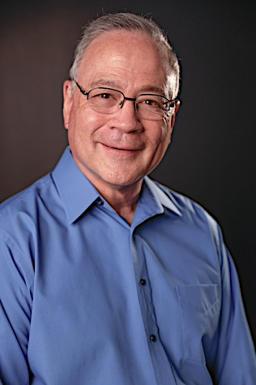

Mike Kozlowski
1037 Hastings Drive, Birmingham, AL 35242
334-806-6637
kozlohouse@gmail.com

What performing arts experience do I have? Below is a comprehensive list of my on-stage/on-screen acting credits:
Theatre Productions | Character
Confederate Letters (Southern Broadway Dinner Theatre) | Jackson Chandler
The Depot (Southern Broadway Dinner Theatre) | John Pittman
Mystery at Moss Street Mansion (Southern Broadway Dinner Theatre) | Chen Woo
Soda Shop Hop (Southern Broadway Dinner Theatre) | Joe Michell
Juror Number 7 (Southern Broadway Dinner Theatre) | Judge Roy Brantley
Hawkins Pass 2: Bunkhouse Blues (Southern Broadway Dinner Theatre) | Jude Thomas, Preacher
Hawkins Pass (Southern Broadway Dinner Theatre) | Jude Thomas, Preacher
Merchants of London (Southern Broadway Dinner Theatre) | Silas Hatcher
Song of My Heart (Southern Broadway Dinner Theatre) | Jack Culpepper
Granny and the French Maid (Southern Broadway Dinner Theatre) | Chen Woo
Oliver! (Southeast Alabama Community Theatre) | Mr. Bumble
South Pacific (Enterprise State Community College) | Henry
A Tribute To Soldiers (A WW2 Monologue) | Soldier
The Leper (A Monologue) | The Leper

On-Screen Credits | Character
Worth Fighting For (currently on Amazon Prime) | Pastor Solomon
Devoted (to be released Fall 2025) | Firefighter
“Alabama Click It or Ticket” 2024 Campaign (on YouTube) | Grumpy Old Man
Writing Christmas Cool (Kenosis Productions) | Walk-out husband

Other projects: I am a professional voiceover talent, having narrated 8 titles on Amazon’s Audible. Additionally, I have narrated a variety of other VO projects, including e-learning, corporate branding, and commercials. I’m currently voicing the Bible (New Living Translation)

