**KAI BROWN**

Model | Actor | Voiceover Talent

━━━━━━━━━━━━━━━━━━━━━━━━━━━━━━━━━━━━━━━━━━━━━

Email: BrownMonique1995@outlook.com | Phone: (347) 646-0020 | Location: New York, NY  
Portfolio: kaibrown.modelingfolio.com

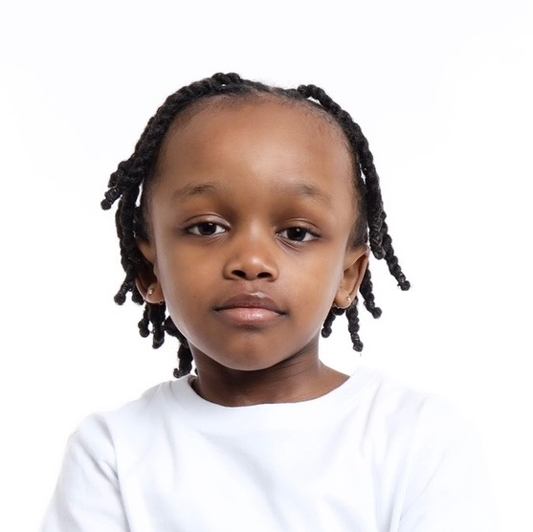

Age: 8 | Height: 3'6" | Weight: 42 lbs | Hair: Black/Brown | Eyes: Brown

## PROFILE

A lively, focused, and charismatic young talent, Kai Brown stands out with his dynamic energy and passion for the performing arts. With professional training and natural star power, he brings a joyful, cooperative spirit to every role—on camera, in photos, or through voice.

## EXPERIENCE

• “Is This Thing On” – Background Actor (Student Film)  
 Grant Wilfley Casting, Inc. | 2025 | New York, NY  
  
• “I Don’t Care, Tomorrow Will Be Better” – Featured Student  
 Director: Tony Peer | Artist: Devon Reed | 2025  
  
• “The Card” – Role: Aden (Student Film)  
 New York Film Academy | Director: Nehal Yaadav | 2025  
  
• Child Photo Series – Model  
 Photographer: Chase Middleton | Queens, NY | 2025

## TRAINING

Barbizon School of Modeling & Acting, NYC (Sep 2024 – Mar 2025)  
- Commercial Acting  
- Monologues, Improv, & Audition Techniques  
- Script Analysis & On-Camera Modeling  
- Vocal Training & Voice Projection  
- Dance Movement, Runway Practice  
- Performance Preparation

## SKILLS & INTERESTS

• Vlogging & On-Camera Personality  
• Reading & Storytelling  
• Loves Animals  
• Running & Jump Rope  
• Chess & Strategy  
• Team Player, Curious Mind, Quick Learner