Angela Everett, PhD

# angelaarchaeo@gmail.com

254-217-5656

Represented By:

Entourage Model & Talent (TX) (210) 733-

5007

Angela Everett has been on stage since she was 5 years old. What started out as one beauty pageant sparked many years of modeling and acting. She played a supporting role in the film Sense of Urgency, and has decades of theatrical acting experience. Some of her favorite roles include Emily Webb in Our Town, Marme in Little Women and Mrs.

Van Daan in The Diary of Anne Frank.

Angela is currently employed by Waco Civic Theatre as one of their theatrical directors. Recently she has been featured in a Love to Hear Again Audiology commercial, a Republic Services commercial, and modeled as a physician for a Baylor Scott & White Hospital print ad. Angela also has her PhD in Archaeology & Biblical History, and has extensive experience digging in the dirt!

Credits Include:

Film: Sense of Urgency/ Agent Conway/ Asst. Director

Television Commercial: Love To Hear Again Audiology/ Grandma

Television Commercial: Republic Services/ University Administrator

Television Commercial: American Nurses Association/ Parent

Television Commercial: Casey’s/Hand Model

Television: Lioness Season 2/ Background

Television: 1923 Season 2/ Background

Television: Flip n Move/ Home Buyer

Television: Heavenly High/ Ms. Mills

Print Ad & Social: UT Turn To Campaign/Mom

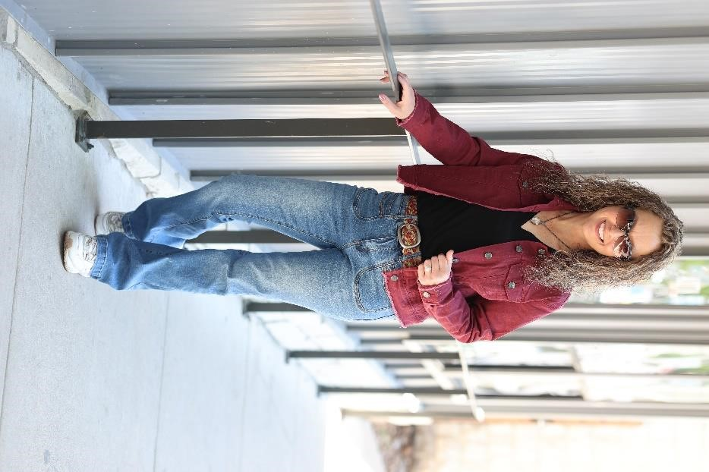Print Ad: Baylor Scott & White Hospital/ Physician

Theatre: The Diary of Anne Frank/ Mrs. Van Daan/ Director

Theatre: Little Women/ Marme/ Director

Theatre: Our Town/ Emily Webb

Theatre: The Wizard of Oz/ Lion

Theatre: Charlotte's Webb/ Mrs. Arable

Theatre: A Voice from the Titanic Dorothy/ Director

Theatre: And Miss Reardon Drinks a Little/ Anna

Theatre: California Suite/ Hannah Warren

Theatre: Cinderella Step-Mother

Theatre: Sarah Plain & Tall/ Meg Wheaton/Director

Theatre: The King & I/ Daughter of the King

Theatre: The Wizard of Oz Munchkin

Theatre: Anne of Green Gables/ Director

Special Skills

Archaeologist, PhD, Public Speaker, Aerobics, Bowling, Canoeing, Cycling - Mountain Biking, Equestrian - General, Fishing, Ice Skating, Jet Skier, Jump Rope, Kayaker, Ping Pong, Rock Climber, Roller Skating, Running - General, Running - Sprint, Snorkeling, Softball, Swimming - ability - general, Trampoline, Volleyball, Weight Lifting, Yoga, Host, Modeling, Vocal Range: Alto, Vocal Range: Soprano, Voiceover, American - Southern Accent, American

Physical Attributes:

Height: 5 ft. 4 in.

Weight: 131 lbs.

Hair: Brown/Gray/Long/Curly

Eyes: Brown