Angel Arrington
Contact details  Email  worksbyangelangel@gmail.com  Website  https://www.instagram.com/true_angel_yours/  Phone  901 831 9380  Education  BS In Kinesiology, Chemistry, & French  Austin Peay State University  Modeling & Runway Coached  Premier Models & ANTM Laura James | Bio  Eye Color: Brown  Height: 5’8”  Hair Color: Brown  Weight: 145 lbs |  | 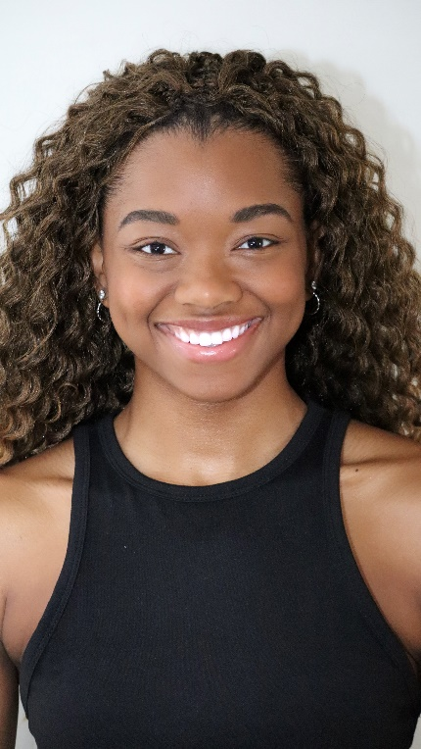
Film & Television Credits
NBC's Young Rock Season 3, Hoop Street Film, Multiple Major Recording Artist MVs, Tyler Perry Studios Film |  | Recurring BG |  | NBC Studios, and More
Red Panda Project |  | Actress/Performer |  | Roman Kolesnikov/Tik Tok AD
Special Skills
Fluent in French and English |  | Conversational and literate in Spanish |  | Singing (alto and soprano) full range
Athletic and Sports Background |  | Soccer, Biking, Running, Swimming, Pickleball, Tennis, Roller Skating, Cheer, Volleyball, Track & Field (shotput, high jump, sprints), NASM CPT, |  | Dancing: Contemporary, Hip-Hop, Cheer-Dance
Modeling |  | Runway, Commercial, Editorial, High-Fashion, Sports & Fitness Campaigns, |  | Featured Runway Model in Memphis Fashion Week 2023, NYFW 2024, LAFW 2024, Featured in Local Memphis Marketing and Fashion Magazines
Accents: French, Spanish, British, Valley, Australian, Northern England, South London

