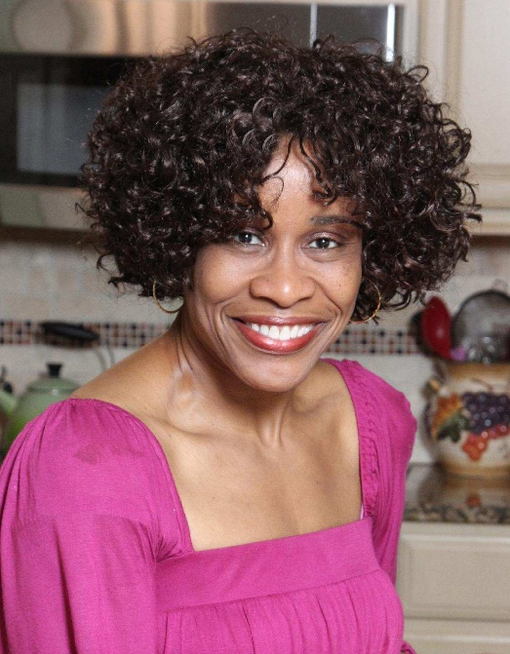
Pearl C. Peebles
Non-Union
Height 5’ 3” Hair: Black Eyes: Brown
Email: Peebles18@outlook.com
Instagram Link: www.instagram.com/theuncensoredhmecook/
Website: www.theuncensoredhomecook.com

TELEVISION

The Hampton Road Show Guest Star NBC (Local Affiliate)
(The Uncensored
Home Cook”)
The Price Is Right Contestant Winner CBS

MEDIA

The Uncensored Home Cook Cooking Content YouTube

THEATRE

Amateur Night Vocalist Winner Apollo Theatre
“The Wonder Hat” Theatrical Play “Margo” The Maid Theatre Festival

TRAINING

Talent Coaching Sessions Cameron McNamara Acting Coach
“Harriet” Motion Picture Extra Role Focus Feature LLC
Southern Women’s Show Guest Star The Uncensored Home Cook
Drama/Thespian Studies 1983-1985 Brunswick Senior High

WORKSHOPS

How to Book Commercials Laura Crawford Formation Talent Agency
Building Career for Serious Actors Anthony Reimer Neighborhood Playhouse NYC
Understanding the Music Industry Blaze Johnson, Producer Blaze Johnson Music
Improv Comedy Class Cipha Sounds, Comedian NICE CROWD
Sketch Comedy Workshop Isaiah Headen, Director NICE CROWD

