Christen Powell 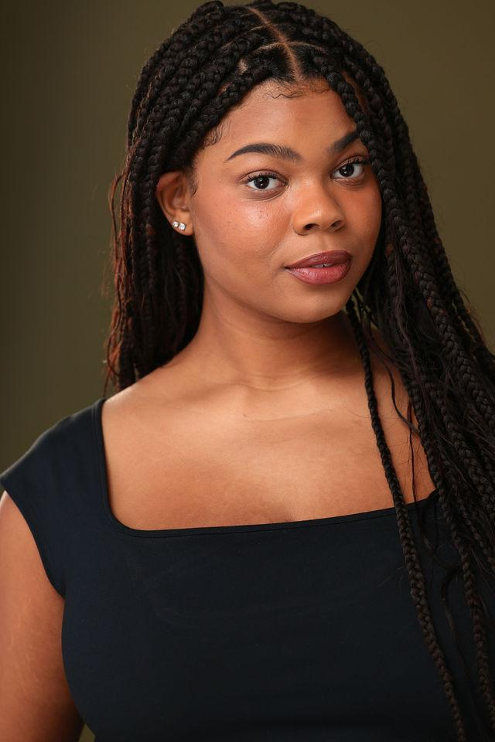

Contact:

[christendpowell@gmail.com](mailto:christendpowell@gmail.com)

Appearance:

African American | Eye Color: Brown | Hair Color: Black | Height: 5’10 | Age: 21

**Stage/Film**

**Production: Role: Director:**

Murder on The Orient Express Mary Debenham Daniel Ellis - UGA Theatre

Reflection Ivy Lauren Kring

PB&J Maya Noor Shaikhnag

Tenants Grace Amanda Whylie

Hayavadana Kali UGA Theatre

Classics Undone Publisher Sanghoon Lee

Heathers Heather Chandler Sam Marx x Next Act

Chessboxer Lauren London Albin Pepe

Brighter Than The Sun King/Ensemble UGA - Grant Production

A Night of Blood Delores Short Student film

Soda Hannah Short Student film

Legally Blonde Margot UGA Next Act x BTE

The Addams Family Alice Beineke Valdosta High School

Little Shop of Horrors Audrey 2 Valdosta High School

**Recitals/Concerts/Cabarets**

Summer Camp Cabaret - Livin’ it Up on Top (Persephone)

Whose Story Cabaret - duet (Feed Me - Little Shop of Horrors) trio (Who I’d Be - Shrek: The Musical)

New Millennium Cabaret - solo (Bust the Windows) quartet (Put Your Records On) quartet (Strut)

Spring Recital - solo (Burn - Hamilton) trio (The I Love You Song - 25th Annual Putnam County Spelling Bee)

Broadway Backwards Cabaret - solo (I Who Have Nothing - Smokey Joe’s Cafe) duet (Dear Theodosia - Hamilton) solo (Bring Him Home Les Miserables) duet (Whole New World - Aladdin)

**Performance Training**

Acting on Camera (Di Quon Wilms, Athens, GA)

* Trained in Chubbuck Method and Warner Loughlin Technique

Voice Class for Non-major (Michael Hadary, Athens, GA)

Acting 1 (Ray Paolino, Athens, GA)

Introduction to Acting for Non-major (Lyndsey Hadary, Athens, GA)

Singing for Musical Theatre (Ricardo Ipina, Valdosta, GA)

Gospel/Worship Vocal Training (Gary Sharper, Valdosta, GA)

Vocal Training for Beginner (Debrah Brown, Valdosta, GA)

Ballet/Tap/Pointe Training (Dance Arts Inc. Valdosta, GA)

**Awards**

Nominated Best Actor - Atlanta Women’s Film Festival