**Charley Arksey**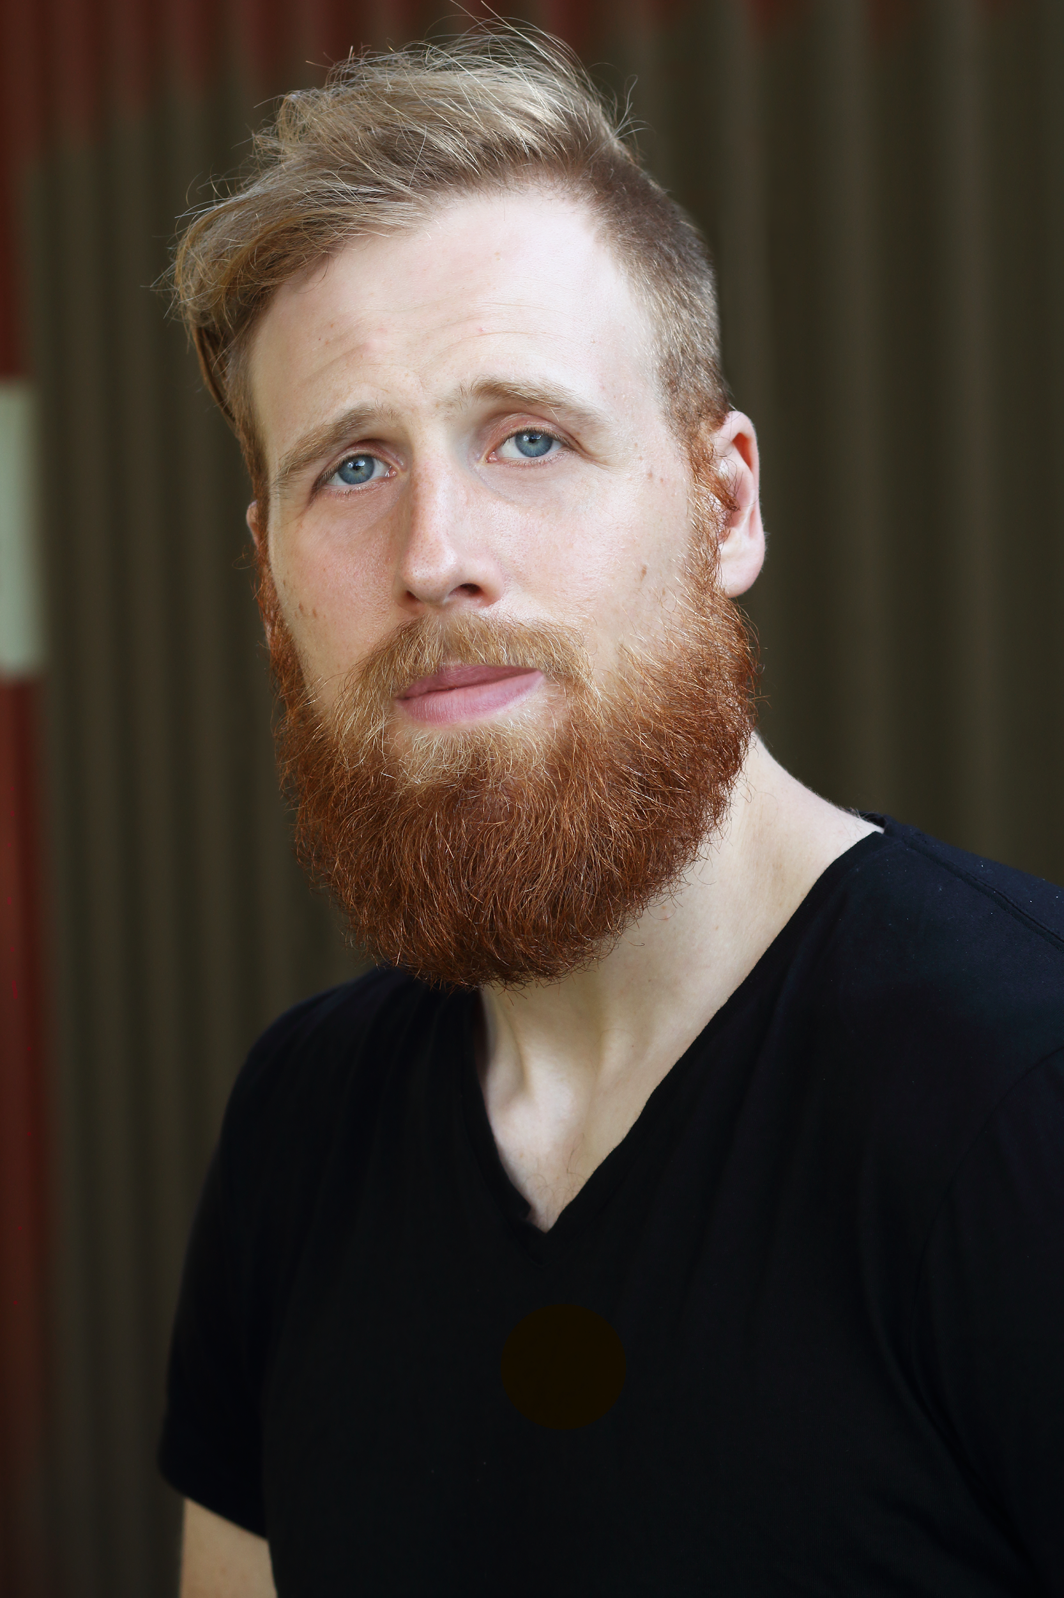

**938 N Hoyne Ave**

**Chicago, IL 60622**

**(402) 672-2904**

[**charley.arksey@gmail.com**](mailto:charley.arksey@gmail.com)

**www.charleyarksey.com**

**Personal Information**

Height 6'4''

Weight 230

Hair: Blond

Age: 32

Eyes: Blue

**Training:**

One Group Mind Training Program

Second City One Act Play Program Graduate

Second City Writing Program Graduate

Improv Conspiracy Improv Program Graduate

iO Chicago Improv Program Graduate

iO Chicago Musical Program Graduate

Annoyance Theatre Improv Program Graduate

Comedy Sportz Chicago Professional School

LinkedIn Learning: Marketing to Gen Z

LinkedIn Learning: Using Humor to Communicate and Persuade

LinkedIn Learning: Writing: The Craft of Story

**Projects/Work:**

[2hitmen Productions](https://2hitmen.com/) Co-Owner, Executive Producer, Writer

[Shook Ones](https://www.youtube.com/watch?v=WhFmOkr54OU&feature=youtu.be) Creator, Writer, Voice Actor

[Joe & Ark](https://drive.google.com/file/d/1GwkCh2b7M3MhJDRQhJWBRF2NDL-2dfAF/view?usp=sharing) Creator, Writer, Actor

[Word Brothel](https://wordbrothel.com/congress-passes-trickle-down-medicaid/) Staff Writer

Chronicling of the Chronic Creative Consultant

Mr. XEG Head Writer, Producer

Jack and Charley: Acid Trip Creater, Writer, Actor, Producer

Word Brothel: After Dark Creator, Writer, Actor, Producer

The Interns Head Writer, Producer

[Wingmen](https://www.youtube.com/watch?v=9974YkT1M-Y) Writer, Producer, Actor

HUSH Silent Improv Team Ensemble Member

McKay Arts Business Improv Team Lead, Ensemble Member

iO Theater: Monday Night Live Ensemble Member

**Skills:**

Leadership, creative collaboration, Zoom, webinar hosting, content creation and distribution, video production and editing, Adobe Premiere Elements, Adobe Photoshop, G Suite/Google Cloud, Todoist, Evernote, OneNote, Airtable, bachata dance, drums, Brazilian jiu jitsu

**Recommendations**

**Joe Janes (SNL’s Weekend Update, 365 Sketches)**

*“Charley is an exceptional human worth hiring. He generates material very quickly and of high quality. He also is great at listening to and incorporating feedback. Charley collaborates well often contributing ideas that can positively alter the direction of a project. I cannot recommend Charley enough.”*

**John Vorhaus (The Comic Toolbox, The Little Book of Sitcom)**

*“As the author of THE COMIC TOOLBOX: HOW TO BE FUNNY EVEN IF YOU'RE NOT, I know what's funny and what's not -- and Charley is capital-Fun funny. Also analytical, insightful, diligent and deeply in service to the work. Check him out. You must be 100 percent satisfied or your money cheerfully retained.”*

**Antoine Mckay (Empire, Review, Patriot)**

*“To whom it may concern: Charley Arksey is not only an incredible human being, he is an awesome talent. The work we’ve done, and I’ve seen him do, has been a highlight of the greatest experiences that I’ve had over the last 5 years. His hard work, passion and love for people is a blessing to any situation he is a part of. He is inspiring and kind. I’m honored to call him co-worker and friend.”*