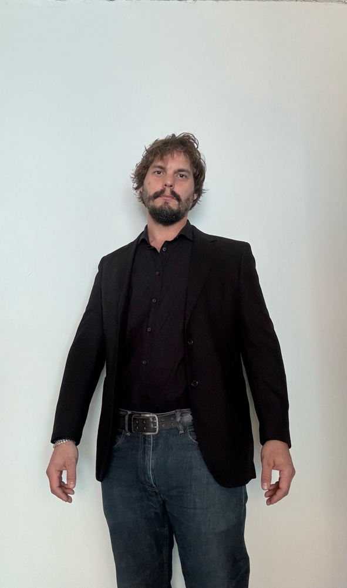

Acting resume Izzy Starke

|  |  |  |
| --- | --- | --- |
| **Film** | | |
| American Nightmare | By Damani Scott | Background - Boxing Coach |
| Agent Ling | By Alexander Bok | Featured Background - Agent |
| Pantomime | By Brian Follmer | Background - Karate Spectator |
| My Brothers Guardian | By Yonel Cohen | F. Background - Gangster/Clerk |
| Mark My Words  War Dawgz  Dope Unit | By ING Films  By Kevin Grevioux  By Lux Projects | Supporting - Gangster Bill  Background - Orochi Soldier  Background – Club Patron |
| **Streaming** **Series** | | |
| Post and Ghost TV - 51E6 | By Orphino Bros | Supporting - Silus the Shadow |
| Post and Ghost TV - S1E7 | By Orphino Bros | Supporting - Silus the Shadow |
| Revenge in Lace | By Purple Filter Production | Supporting - Tall Thug |
| Arranged Marriage With The Mafia Heir | By Awaken Species Production | F. Bkgrnd - Wedding Officiator |
| **Music** **Video** | | |
| Why Am I In California? | By Christian Taylor | Main Character - Sad Man |
| Airplane Mode | By Bones | Background - Passenger |
| High Voltage | By Shai Skyee | F. Background - Scientist |
| 88 times (P.I.A.N.O) | By Shauntey Walker | Background - Concert Crowd |
| **Game** **show** | | |
| The Contenders | By Hakeemshady Mohamed | Contestant - Boxing Coach |