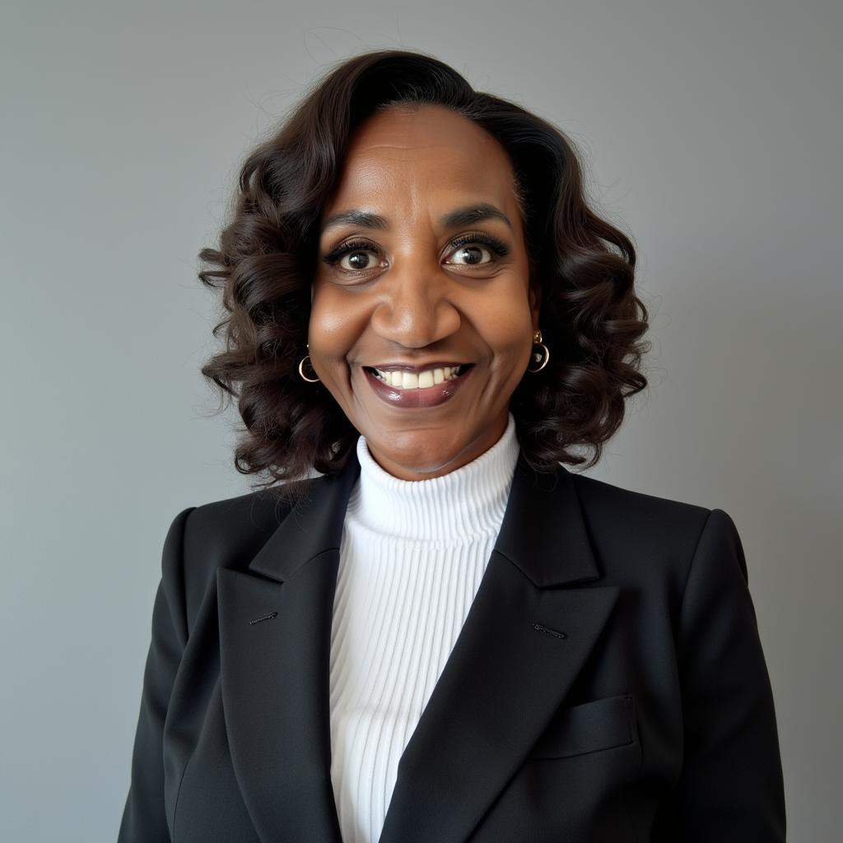
ACTOR RESUME
(770) 870-9392 Robbie Baker King rmbaker15@aol.com
___________________________________________________________________________________

FILM & TELEVISION
Title Role Production Co.
The Bobby Brown Story Funeral Goer BET Productions
Kevin Probably Saved the World Passenger on Plane ABC
Good Girls Mall Shopper NBC
The Watchmen Tulsa Riot victim HBO
Genius: MLK and Malcolm X Carnival Goer Disney+
The Big Door Prize Restaurant Patron AppleTV
The Last Days of Ptolemy Grey Neighborhood member AppleTV
HEELS, Season 1 & 2 Wrestling Fan in Attendance STARZ
Family Feud Audience member ABC
P-Valley Season 3 Casino Patron STARZ
P-Valley Season 3 Congregation Member STARZ
Single Drunk Female Diner Patron Hulu
Found Bus Station Patron NBC
Favorite Son Makeup Artist BET+
R&B Festival Attendee TPS
Can You Feel The Beat Mall shopper Lifetime
Genesis: Superman Refugees DC Comics
My Sister’s Secret Memorial Service Attendee Lifetime
The Resident Hospital Patient FOX
Cooking Up Christmas Featured Congregation Areu Studios
Monarch Grieving Fan at Estate Fox Ent.
I Love Boosters Beauty Salon Customer Neon

COMMERCIALS/VIDEOS:
Title Role Production Co.
Chime Financial Featured BG – Subway Brian Beegle
Clipse Worshippers Unknown
GloRilla/Lotto “Procedure”- Bank customer Unknown

- continued -
Acting Resume for ROBBIE BAKER KING
Page Two

TRAINING
Actors Momentum Bootcamp DaJuan Johnson Think Bigger Acting
Think Bigger Actors Summit DaJuan Johnson Think Bigger Courses
Improv I Workshop Kelley Cody-Grimm Acting Out Studios
Improv II Workshop Kelley Cody-Grimm Acting Out Studios
Slate Workshop Kelley Cody Grimm Acting Out Studios
Scene Study Workshop Lance Camarillo Acting Out Studios
Script Analysis Workshop Kelley Cody-Grimm Acting Out Studios
Headshot Workshop Luis Martinez Luis Martinez Photography
Talent Agent Workshop “Ask An Agent” Jason Lockhart Atlanta Models & Talent
Monologue Workshop Kelly Cody-Grimm Acting Out Studios
Rehearsal Workshop Lance Camarillo Acting Out Studios
Self Tape Audition Workshop Lance Camarillo Acting Out Studios
Casting Director Workshop Pat Skiles GS Casting

Biography:
- 15 years experience - BG/Extra. Worked on major productions on AppleTV, Starz, ABC, BET, HBO and NBC as well as local/regional productions.
- 24 seasons as Freelance Production Support for CBS Sports
- Graduate of Columbia School of Broadcasting
- Voice Over experience: inhouse corporate employee appreciation video

Personal:
- Height: 6’ 2” Weight: 175 lbs.
- Graduate: Valdosta State University, Valdosta GA
- Member: Alpha Kappa Alpha Sorority, Inc.

