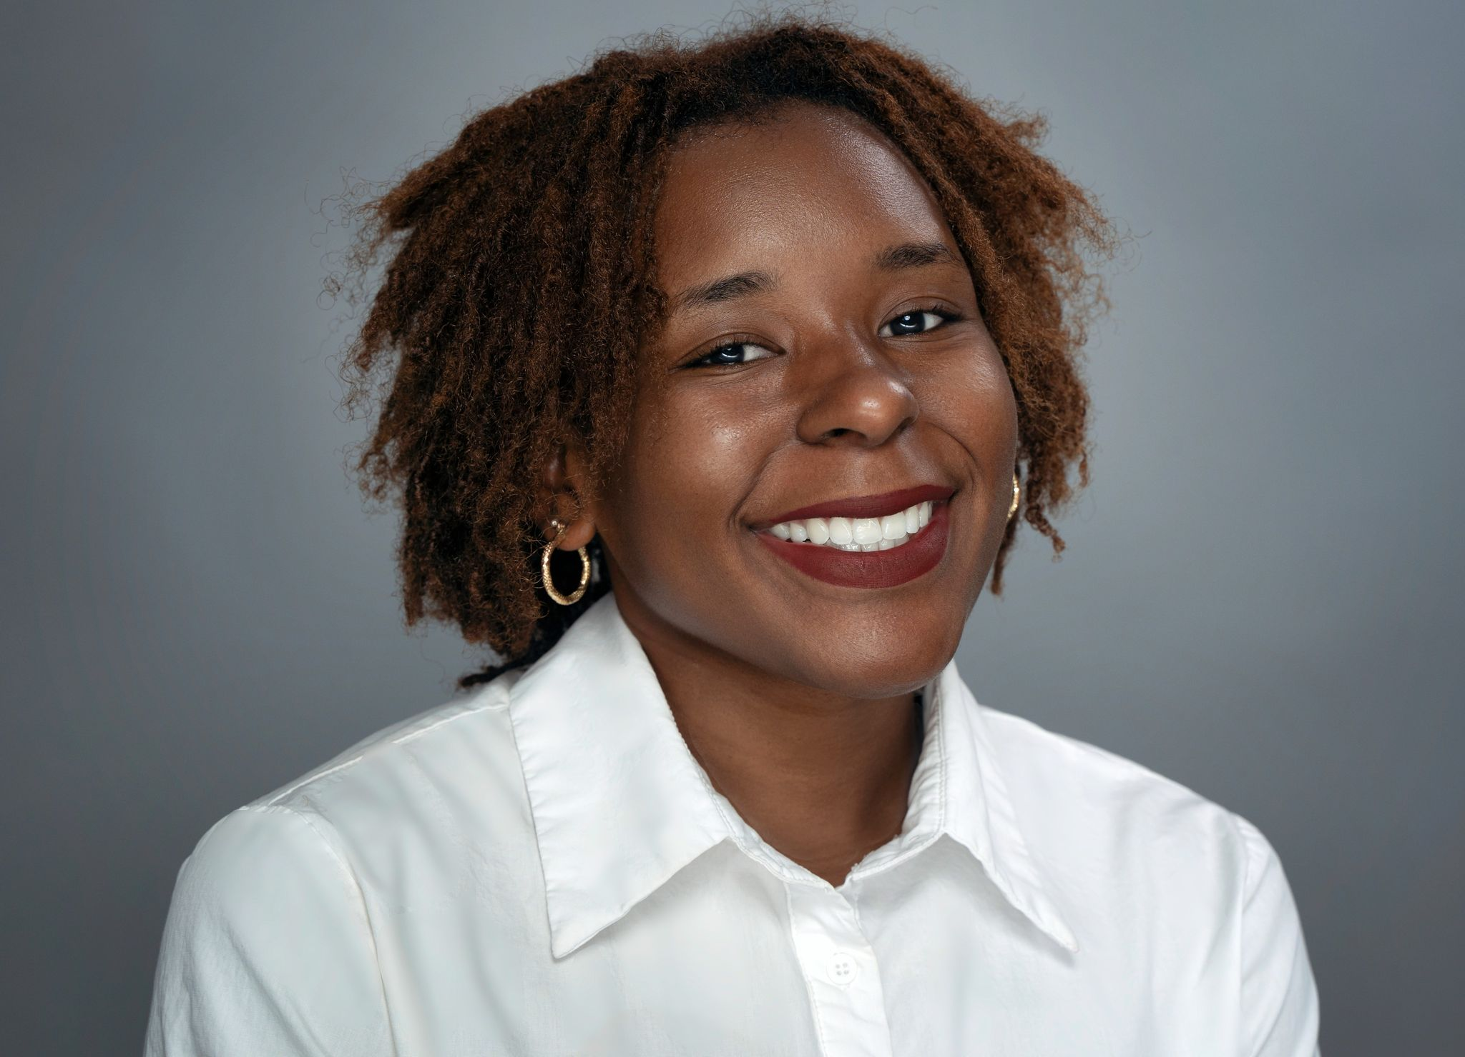 |  | Pamela Simon  Performer Resume
About Me  Bonjour!  I am from U.S, Florida currently located in Versailles, France  I has been a desire of mine to break into the Performance Industry since High School.  Please, do not hesitate to give me a call.  Contact  Address:  Dundee, FL 33838  Versailles, FR 78000  PHONE:  US: +1 (863) 419 6005  French: +33 07 72 44 59 30  WEBSITE:  www.linkedin.com/in/pamela-simon-308113190  Email:  pamelasimon108a@gmail.com  Hobbies  Theater Enthusiast  Muscle Conditioning and Building  Singing & Dancing |  | EDUCATION  Polk State University  2015-2021  Business Administration  International TEFL Academy  2019  English Second Language  WORK EXPERIENCE  High School Theatre Program  - Little Shop of Horrors – Dreamettes Girls  - All Shook Up – Mamma  - One Act Plays  Currently  - YouTube Series Channel – Obstacles  SKILLS  Languages: English (Native), Haitian Creole (Fluently), American Sign Language (Intermediately – Advance), French (Intermediately – Advance).  Gymnastics Skills  Compassionate, Flexible, Time Management, Computer Skills, Art Skills, Transferrable Skills, Problem – Solving, Adaptable, People – Oriented, Dependable.

