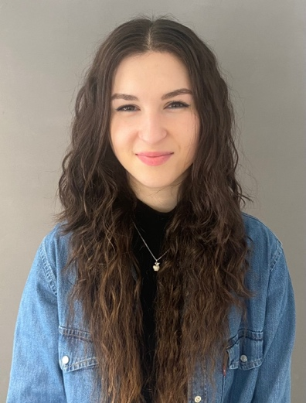
Resume

Last name, Name Jakupi, Ambera

Address Hirzenbachstrasse 76
8051 Zürich, Switzerland
+41 76 460 90 44

Birthdate 08.07.2002

Place of origin Adliswil, Switzerland

Parents Jakupi Ismail, CEO of Central Garage
Jakupi Shyrete, CEO of Geraj Boutique

Siblings Jakupi Eljesa, 1996, Retail Associate
Jakupi Temime, 1999, Pre-School Teacher
Jakupi Hasan, 2006, Apprentice Building Technician

Academic records 2019-2022 School of Pedagogic Winterthur, Zürich
2015-2018 Secondary School Stettbach, Zürich
2009-2015 Primary School Hirzenbach, Zürich

Languages Albanian Mother Tongue
German Mother Tongue
Turkish Fluent
English Fluent
Korean Basic Knowledge
French School Knowledge 4 years

Work experience

January 2025 Society Performers International (SPiN) Los Angeles
Since February 2024 Part-time English Group leader KiTa Wunderkind
Since January 2024 Marketing Assistant, Retail Associate YumiHana
August 2023 Pre-School Group Leader Globegarden
August 2019 Apprenticeship Pre-School Teacher Globegarden
August 2018 Internship Kindergarten Teacher

Hobbies Taekwondo, Reading, Singing, Novelist

References Marketing Manager K. Lee Trading Retail Manager
Thomas Kordik Lee Kyoung-Mi
+41 79 842 64 68 +41 76 370 58 80

