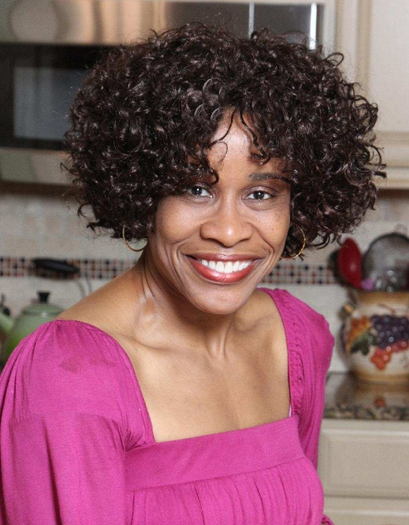

**Pearl C. Peebles**

Non-Union

Height 5’ 3” Hair: Black Eyes: Brown

Email: Peebles18@outlook.com

Instagram Link: [www.instagram.com/theuncensoredhmecook/](http://www.instagram.com/theuncensoredhmecook/)

Website: [www.theuncensoredhomecook.com](http://www.theuncensoredhomecook.com)

**TELEVISION**

The Hampton Road Show Guest Star Cook

The Price Is Right Contestant Winner

**THEATRE**

Amateur Night Vocalist Winner Apollo Theatre

“The Wonder Hat” Theatrical Play “Margo” The Maid Theatre Festival

**WORKSHOPS**

Building Career for Serious Actors Anthony Reimer, NBRHD

Playhouse NYC ARTS International

Improv Comedy Class Cipha Sounds, Comedian NICE CROWD

Sketch Comedy Workshop Isaiah Headen, Director/Editor NICE CROWD

**TRAINING**

ARTS International Showcase Vocalist/Monologue Performance ARTS International

Talent Coaching Sessions Cameron McNamara ARTS International

Southern Women’s Show Guest Star Cook The Uncensored

Home Cook

Drama/Thespian Studies 1983-1985 Brunswick Senior

High School

**SKILLS:**

Author, Comedy Writer, Home cook, Singer, Cosmetologist, Typist, Program Analyst (Investigative), Food Demonstrator, “Spades”/Blackjack Card Player, Southern Accent, and Advent Walker