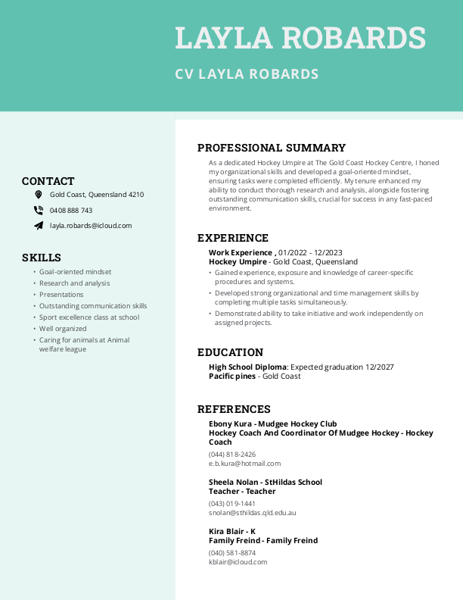

Address: 215 Riverstone Crossing

Date of birth: 01/10/2009