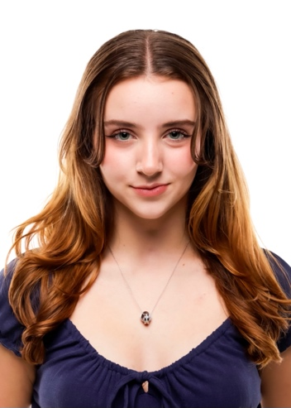**Kaelyn Flannery Bracco**

Kaelynbracco@gmail.com | (561)-569-1174 | www.linkedin.com/in/kaelynf

**Bio**: Height: 5’3” | Weight: 115lb | Hair: Brown | Eyes: Green

**EDUCATION & TRAINING**

**University of Georgia**, Grady College of Journalism and Mass Communication Athens, GA

*Bachelor of Arts, Entertainment and Media Studies* | Emphasis, Acting and Stage Combat May 2028

Minor, Film Studies | Certificate, Sports Media | GPA, 3.90

**Acting**, *ActTrue – Marc Durso* | Miami, Florida August 2017- August 2020

**Dance/Movement**, *Evolution X - Colleen and Gee Bethancourt, and others* | Parkland, Florida July 2015 - July 2024

**Stage Combat**, *University of Central Florida – David Reed* | Orlando, Florida March 2022 - March 2023

**ACTING EXPERIENCE**

**Poetic License** *Extra* Jewelbox Pictures– Maude Apatow

**Chad Powers** *Extra* Hulu – Tony Yacenda

**Carrie: The Musical** *Chris Hargensen (Supporting)* FL State Thespian Competition – Troupe 4879

**Legally Blonde: The Musical** *Pilar (Feature)* Next Stop Broadway – O’Brien

**The Wild Party** *Nadine (Feature)* Next Stop Broadway – O’Brien

**We Will Rock You** *John (Feature*) Marjory Stoneman Douglas Theater – Herzfeld

**The Adventures of Flat Stanley** *Choreographer (Leadership)* Marjory Stoneman Douglas Theater – Herzfeld

**Head Over Heels** *Featured Dancer* Marjory Stoneman Douglas Theater – Herzfeld

**The Importance of Being Ernest** *Sound Crew* Marjory Stoneman Douglas Tech Theater – Herzfeld

**Puffs** *Lighting Crew* Marjory Stoneman Douglas Tech Theater – Herzfeld

**Acting for the Camera** *Workshop* Florida State Thespian Convention

**ACHIEVEMENTS**

**All-Around FL State Champion**  *USA Gymnastics Xcel* USA Gymnastics

**3rd Place SE Region Floor Champion** *USA Gymnastics Xcel* USA Gymnastics

**All-Around FL State Champion** *Varsity Raiders* Junior Reserve Officers' Training Corps (JROTC)

**National Champion: Emotional Attentiveness** *Solo Dancer* Intrigue National Dance Competition

**Regional Champion: Emotional Execution** *Solo Dancer* Edge Talent Dance Competition

**1st Place Regional Champion: Senior Solo** *Solo Dancer* StarQuest, Shake the Group, & Hype Dance Competition

**Superior Rating: Large Group Musical** *Troupe 4879* Florida State Thespian Competition

**Excellent Rating: Costume Design** *Troup 4879* Florida State Thespian Competition

**MOVEMENT EXPERIENCE**

**Aerial & Unicycle Skills** Sanca School of Acrobatics

**Advanced Tumbling**  American Twisters Gymnastics

**Advanced Jazz, Lyrical, Contemporary, Hip-Hop** Evolution X Performing Arts

**Intermediate Ballet (Classical American)** Lorenzo Agramonte

**Intermediate Tap** Colleen Bethancourt

**SKILLS**

**Language**: American Sign Language (Proficient)

**Dialects & Dictions**: American Southern

**Movement**: Abilities Include: 550lbs Team Tire Flip (50 Meters), Assemble & Cross One-Rope Bridge, Comfortably Complete 5k Run Under Limited Time, Complete Advanced Stand Still and Series Tumbling, & Can Ride 5ft Unicycle

**Music**: Singing (Soprano, 8 Years)

