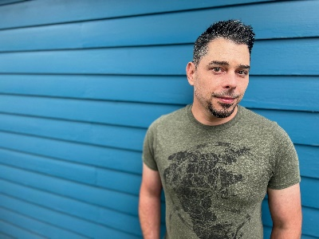**Gerald J. Kelel**

[jkelel75@outlook.com](mailto:jkelel75@outlook.com)

773.805.9725

height: **5’7”** weight: **150** eyes: **hazel** voice: **tenor**

**Bachelor of Arts in the Performing Arts (specialization Musical Theatre), Oakland University**

Theatre

*Jekyll/Hyde* JEKYLL & HYDE BrightSide Theatre

*Count Carl-Magnus* A LITTLE NIGHT MUSIC BrightSide Theatre

*Dennis Galahad* SPAMALOT North Riverside Players

*Harold Hill* THE MUSIC MAN North Riverside Players

*Beedle Bamford* SWEENEY TODD North Riverside Players

*Fredrick Frankenstein* YOUNG FRANKENSTEIN North Riverside Players

*Fred Graham* KISS ME, KATE North Riverside Players

*Don Lockwood* SINGIN’ IN THE RAIN North Riverside Players

*Garry Lejeune* NOISES OFF North Riverside Players

*Man1/Man2 – US* I LOVE YOU, YOU’RE PERFECT…Noble Fool Theatre

*Dick Dockstrap\**  PINAFORE! Bailiwick Repertory Theatre

*Featured Soloist* SWEENEY TODD Ravinia Festival

*Jinx/Sparky* FOREVER PLAID Royal George Cabaret

*Seth/Shem* CHILDREN OF EDEN Porchlight Theatre

*Ludovic/Augenti*  PASSION Porchlight Theatre

*Rusty Charlie* GUYS & DOLLS Stage Right Dinner Theatre

*Headwaiter* SHE LOVES ME Stage Right Dinner Theatre

*Company Member* NTYA SEASON Northbrook TYA

*Ché* EVITA Avon Players

*Dickon*  THE SECRET GARDEN Pontiac Theatre IV

*Brad/Narrator – Understudy* THE ROCKY HORROR SHOW Meadow Brook Theatre

Other Performing Experience

*Vocalist*  THE FOUR CNOTES Spirit Art LLC

*Vocalist* FILM TO FOOTLIGHTS Royal Caribbean Productions

*Vocalist*  RHYTHM NATION Royal Caribbean Productions

*Vocalist*  JUMP JIVIN’ SWING Royal Caribbean Productions

*Vocalist*  FIESTA CALIENTE Royal Caribbean Productions

*Vocalist*  IRVING BERLIN GALA CHF Kevin Stites

*Vocalist*  THE CAROLING PARTY Patti Lupo Productions

*Vocalist/Dancer*  THAT’S ENTERTAINMENT U.S.A. Cedar Point Live Entertainment

*Vocalist/Dancer*  ROCKIN’ COUNTRY U.S.A. Cedar Point Live Entertainment

*Vocalist/Dancer*  FREEZE FRAME FLASHBACK Cedar Point Live Entertainment

*Vocalist/Dancer*  MEADOW BROOK ESTATE Oakland University

Special Skills

Dance (Ballet, Jazz, Musical Theatre), Vocal Styles (Classical, Jazz, A Capella, Pop, Choral), Dialects (Standard British, Cockney), Juggling, Basketball, Whistling

*\*Nominated for a Joseph Jefferson Citation (Best Actor in a Lead – Musical)*