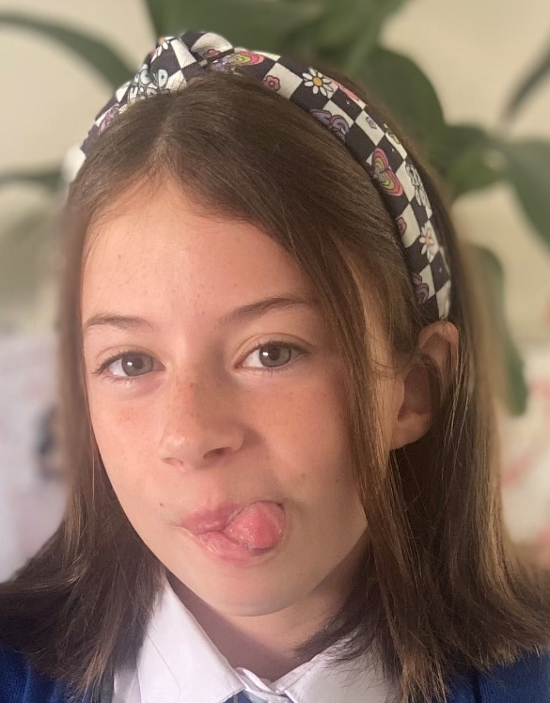
Personal Information

Honey Greenaway

Email: honeygreenaway@outlook.com

Mobile: 07792 037029

Location: Cardiff, Wales, UK

Age: 11 years old
DOB: 12th October 2013
Height: 4’11”
Eye Colour: Green
Hair Colour: Brown

THEATRE

Madagascar the Musical (Junior) Lead (Marty the Zebra) The Atrium, Cardiff
Frozen the Musical (Junior) Supporting (Sven) The Atrium, Cardiff
SpongeBob the Musical (Junior) Supporting (Sardine) The Atrium, Cardiff
Elf the Musical (Junior) Supporting (Elf No.3) The Atrium, Cardiff
Robin Hood & Babes in the Wood. Pantomime Main Cast RWCMD, Cardiff

FILM / TV

Bad Apples (2024) Extra (School Kid) Director: Jonatan Etzler

EDUCATION & TRAINING

Kinetic School of Performing Arts:
- Singing, Voice & Acting through song
- Dance, Choreography & Performance
- Drama, Physical Theatre & Acting styles

Kinetic Youth Academy:
- Theatrical Productions (Madagascar / SpongeBob / Elf)

SPECIAL SKILLS

Singing (Voice: Soprano)
Church Chorister (3 years experience / training)
Skilled Gymnast
Martial Arts: Taekwondo (Green belt)

