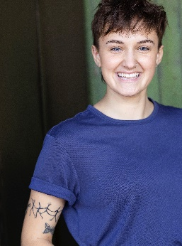**Emma Mansfield**

**They/Them - She/Her**

[Emfield15@gmail.com](mailto:Emfield15@gmail.com) Eyes: Blue

(906) 259-3511 Hair: Brown

Vocal Range: C5-E3 Height: 5’6”

**Theatre** * Staged Reading ^ Upcoming

|  |  |  |  |
| --- | --- | --- | --- |
| *Macbeth*  *Jepthah’s Daughter’s Name*  *Missoula Children’s Theatre*  *When She Went to Mantua*  *King Lear*  *Two Gentlemen of Verona*  *Terror in the Timbers*  *Arden of Faversham \** | Macbeth  Actor 1  Company Member  Ro  Ensemble/Goneril u/s  First Outlaw/Speed u/s  Scare Actor  Alice | Production Productions  Piller Productions  Missoula Children’s Theatre  Black Cat Theatre Company  Kingsmen Shakespeare Festival  Kingsmen Shakespeare Festival  Terror in the Timbers  Kingsmen Shakespeare Festival | Vi Burnette  Camryn Pillay  Amy Ellis  Jared Sheldon, Cee Scallen  Michael Ardnt  Brett Elliott, Caitlyn Arndt  Robb Combs  Jason D. Rennie, Seta Wainiqolo |

**Educational**

|  |  |  |  |
| --- | --- | --- | --- |
| *The Caucasian Chalk Circle*  *Life is A Dream*  *She Kills Monsters*  *The Language Archive*  *The Wolves* | Corporal/Grand Duke  Segismundo  Tilly  Mary  #13 | Northern Illinois University  Northern Illinois University  Northern Illinois University  Northern Illinois University  Lake Superior State University | Alex Gelman  Stanton Davis  Kendra Holton  Bethany Mangum-Oles, Emily Vitrano  Spencer Christianson |

**TV/Film** ^ Upcoming

|  |  |  |  |
| --- | --- | --- | --- |
| *My Apocalypse ^*  *Hook, Line, and Sinker*  *Let’s Finish Dinner*  *Discontinuity* | Scholar  Kit (Lead)  Cara (Lead)  Interviewee | Independent *(Documentary)*  Independent *(Web Series)*  Independent *(Short Film)*  815 Cinema *(Commercial)* | Steve Summers  Bailey Skarbalus, Natalie Krenik  Elora-Danan Bolthouse  Jim Barker |

**Education and Training**

**Northern Illinois University**

BFA in Acting

A four-year Meisner-based Professional Training Program that integrates heightened language, body/mind work, and period style

|  |  |
| --- | --- |
| Acting: The Meisner Technique  Voice/Speech: The Fitzmaurice Technique, Dialects, IPA, Rhetoric  Movement: The Williamson Technique, The Laban Efforts  Period Styles: Victorian, Elizabethan, Regency  Ballet, Modern Dance  Acting on Camera  Audition Preparation | Patricia Skarbinski, Bethany Mangum-Oles, Emily Vitrano  Stanton Davis, Bethany Mangum-Oles  Laura Sturm  James Hendley, Emily Vitrano  Rich Grund, Marc Macaranas  Alex Gelman  Kay Martinovich |

**Internships**

Kingsmen Shakespeare Festival Acting Apprenticeship

Arcola Theatre Participation Internship: Charlotte Croft

**Special Skills**

**Stage Combat** (Rapier and Dagger, Broadsword, Unarmed), **Facilitation/Teaching Experience**, **Beginner Vocal Training**,

**Visual Art** (Design, Painting, Drawing, Woodworking, Printmaking, Adobe), **Wiggle Ears, Competitive Swimming** (4 years),

**Ice Skating, Snowboarding, Waterskiing, Valid Boating License, Valid Driver’s License, Valid Passport.**

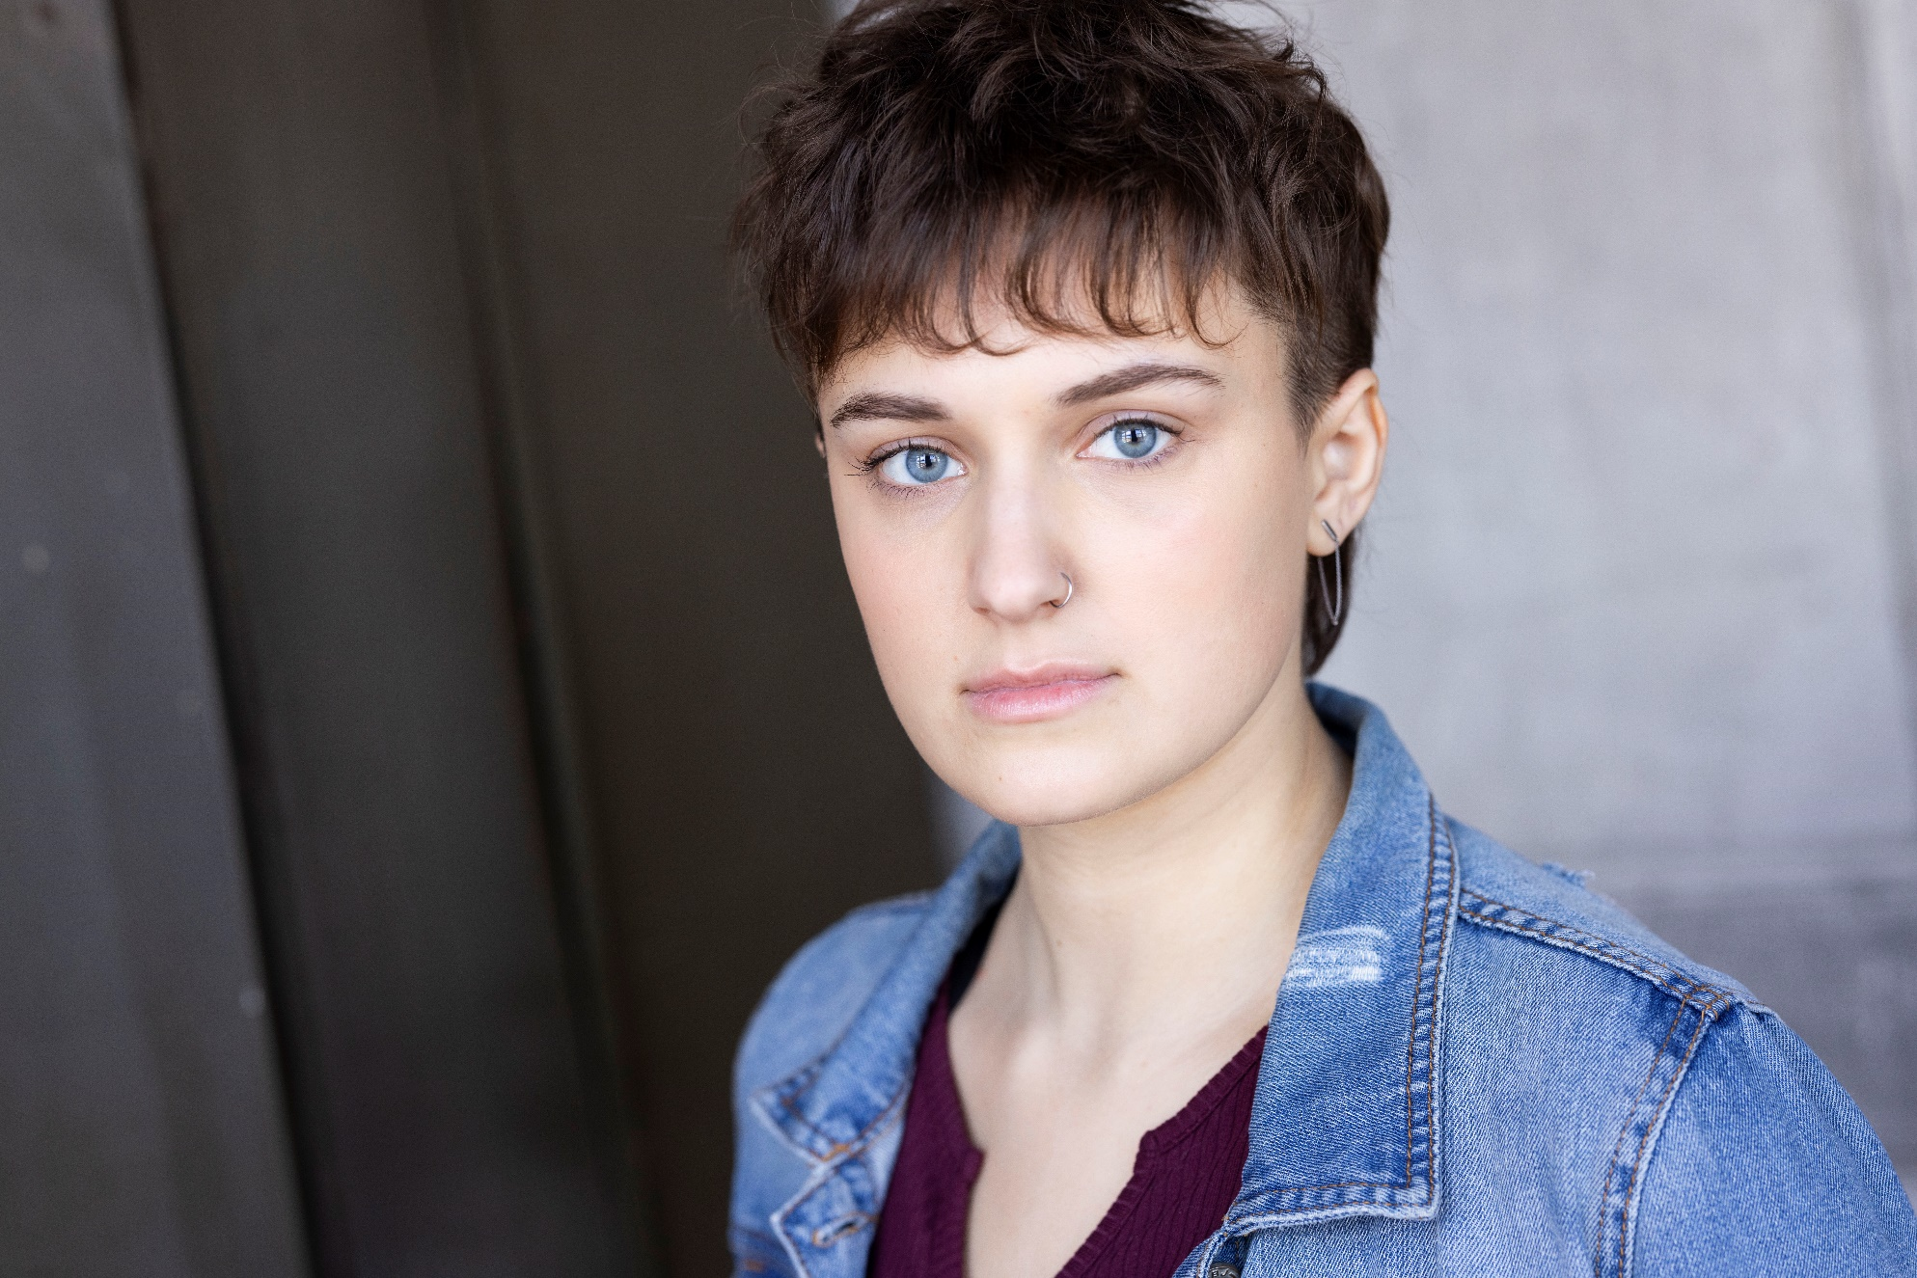

**Emma Mansfield**