T**ROYLI FAN SANTIAGO**

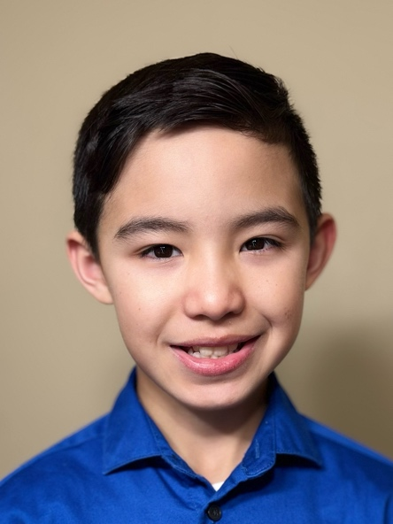

Union Status:

NON-UNION

|  |  |  |
| --- | --- | --- |
| **DZIADZIA** | Marco (Supporting) | Thomas Kuc |
| **The** **Beast** **in** **me** | Birthday party (BG/Silent line) | Antonio Campos |
| **Charter** **Homes** (**Commercial**) | Neighborhood Kid | Andrew Bilindabagabo |
| **Sweet** **Pala** | School kid (BG) | Tao Okamoto |
| **Higher** **Education** (TV/Film) | Jeremiah | Tessa Lee, Jenna Rossman |
| **BrickHollow** **Concert** | Just can't wait to be King (Lion Maine - BrickHollow  King) |  |
| **South** **Pacific** (R&H) | Jerome | Maine State Music Theatre |
| **South** **Pacific** (R&H) | Jerome | Fulton Theatre Opera House |
| **Anastasia** Youth Edition | Police man/ Usher / Ensemble Servant Stage |  |

Professional Biography: TROYLI FAN SANTIAGO is excited and thankful. His passion for entertainment began at age 5 and started writing scripts a few years later. He attended multiple Fulton Academy of Theatre classes and camps. His first stage debut was with Servant Stage for Anastasia the Musical (Policeman, Usher, Ensemble). He enjoys theater but also takes private coaching for TV/film. He wants to thank God, his family, his acting coach, friends, and teachers for their love and support! @TroyLi_Santiago

Special Skills

Beatboxing, Rapping, Stopmotion Film, Baseball, Martial Arts, Martial Arts - Mixed, Martial Arts - Taekwondo, Running - Sprint, Track & Field, Trampoline, Gamer (Console), Improvisation, Piano, Violin