**Inna Bondar**

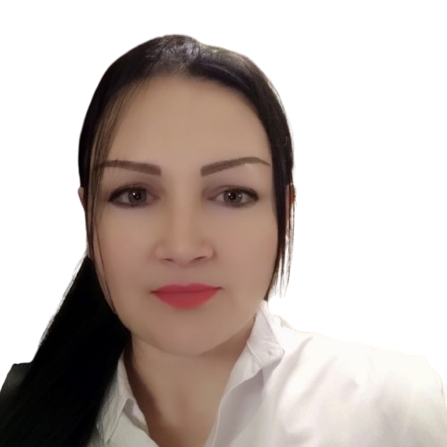

Lisbon, Portugal  
WhatsApp: +351 920 655 966 | Phone: +351 920 655 966 email: **innabondarmia@gmail.com**   
Telegram: [ib22mia](https://t.me/ib22mia) | linkedin <https://www.linkedin.com/in/inna-bondar-b05477234/>

**Professional Summary**

Seasoned media professional with extensive experience in television production, reality casting and reality project management.

Skills in leading a team, developing creative concepts and managing large-scale projects with tight deadlines and budgets.

Known for his strong interpersonal skills, attention to detail, content analytics and ability to achieve success in the reality genre.

**Work Experience**

**Executive TV Producer** *Dates: 2021- 2022* Ukrainian-Lithuanian Reality Project "Love Without Borders" (original project name “MEILĖ be SIENŲ”) Lithuanian television production JUST.TV

Skills:

* Oversaw the production of the TV show.
* Managed the budget and financial aspects of the production.
* Hired key personnel such as directors, camera operators, gaffers, technical staff.
* Approved project participants.
* Coordinated the work of the filming process.
* Made creative decisions and ensured the overall vision of the project was met.
* Handled legal and contractual issues related to production.
* Troubleshooting and troubleshooting issues that arise during production.

**Casting Director television reality projects** *Dates: 2015- 2021*

Ukrainian TV channels of top media holdings: 1+1 Media, StarLightMedia, Inter Media Group.

* **“Visit my home”**, culinary travel show;
* **“Lie detector”** - psychological show, similar to the American project "The Moment of Truth";
* **“Goddess of Shopping”**, fashion game show;
* **“Roman with Olga”**, talk show;
* **“From Tomboy to lady”**, transformational reality project;
* **“City ​​girl-village girl”**, constructed reality, the participants exchange living conditions for 3 days;
* **“Win ​​Win Show”** aspiring businessmen compete for the main prize from an investor;
* **“Country to taste”**, international culinary show;
* **“Candidate”**, newcomers to politics test their professional suitability;
* **“Wife swap”**, American format of the reality show of the same name;
* **“Blind wedding”**, Ukrainian original dating game shows, 3 seasons;
* **“Voice of the Country”**, a talent show;
* development of a pilot project about psychics.

Skills:

Talent Sourcing and Evaluation:

* Expertise in identifying and recruiting diverse talent for reality shows, scripted content, and specialized formats.
* Conducted live castings and video auditions, ensuring candidates meet project-specific requirements.

Interviewing and Character Analysis:

* Skilled in conducting in-depth interviews to evaluate personalities and predict behavior in high-pressure scenarios.
* Ability to assess chemistry between participants to create compelling dynamics for shows.

Script Development and Briefing:

* Collaborated with scriptwriters and producers to align casting decisions with project narratives.
* Prepared briefs and tracts for presenters, hosts, and experts, ensuring alignment with the project vision.

Relationship Management:

* Built and maintained strong relationships with presenters.
* Negotiated contracts and ensured participants understood project expectations and commitments.

Budget and Logistics Management:

* Managed casting budgets, including participant accommodations, travel, and location scouting.
* Coordinated documentation for contracts, legal requirements, and international relocations when needed.

On-Set Support and Coaching:

* Supported participants on set to maintain morale and ensure natural performances.
* Helped shape dramatic arcs and storylines through strategic interaction with cast members.

Crisis Management and Problem Solving:

* Effectively handled last-minute casting changes and resolved conflicts during production.
* Adapted quickly to changing production needs, ensuring smooth operations under tight deadlines.

Industry Knowledge and Networking:

* Deep understanding of reality television formats, audience preferences, and trending themes.
* Leveraged an extensive contact base to source high-quality participants and experts.

**Screenwriter and editor of the filming process of reality projects** *Dates: 2016- 2018*

* “Wife swap”, American format of the reality show of the same name
* “Blind wedding”, Ukrainian original dating game shows, 3 seasons
* “Visit my home”, culinary travel show.

Skills:

Pre-Filming Coordination: - Researched the background of the participants to predict behavior and improve storytelling potential. - Developed dynamic editorial plans and scripts that captured the essence of reality TV storytelling. - Developed storylines and dramatic arcs, compelling storylines based on the participants’ behavior that deliver dramatic and emotional impact. - The ability to construct a clean frame, the skill of correctly presenting those in the frame: clothing style, hairstyles, make-up, body language, speech, voice.

On-Set Supervision: - Managing and monitoring the filming process to ensure script goals are met. - Guiding participants during filming to ensure authentic reactions and exciting moments. - Communicating with the production team to manage timing, pacing, and dramatic flow during filming.

Crisis Management and Adaptability: - Adapt scripts and shooting plans in real time. - Manage on-set contingencies to ensure continuity of production without compromising creativity or production quality.

Team Collaboration: - Led the team on set using a collaborative and organized approach, ensuring that we functioned as a unit. I was responsible for the production process, managing both the creative and logistical aspects of the production. As the lead editor on set, I was the central point of coordination, and my team trusted my leadership to deliver high-quality results.

- I ensured that all elements of the production, from camera work to cast interactions, were cohesive, while maintaining a calm environment on set, given the nature of reality filming and the tight, multi-hour, non-stop shooting schedule and physical fatigue of the crew.

Documentation and Reporting: - Maintain detailed documentation including shot lists, script updates, and editorial notes. - Control that a filming permission agreement was signed with each person who appeared in the frame, other than the project participants.

**Information Producer** *Dates: 2017 – 2018*Ukrainian TV channel – NTN, program: "Life's Truth**"**

Skills:

* Researched newsworthy events and wrote detailed script plans.
* Organized filming logistics and coordinated film crews.
* Negotiated filming permissions with locations and interviewees.
* On-Set Supervision & Problem Solving: Managed on-set processes, adapting content as needed to address real-time changes and challenges.

**Guest Editor** *Dates: 2016 – 2017* Kyiv Live TV Channel – Morning Program: "The City is Waking Up"

Skills:

* Find compelling stories, heroes and experts to feature on our live morning show.
* Expertise in identifying and analyzing relevant news and trending topics.
* Collaborated with influencers and bloggers to increase audience engagement.
* Coordinated filming schedules and organized on-site logistics.
* Directed interviews, developed editorial scripts, and oversaw filming processes.
* Monitored behavior on set and worked with participants to improve storytelling.

**Education**

**Kharkiv State Academy of Culture***2002 – 2007, Master*Directing Mass Theatrical Performances

**Tulchin College of Culture***1998 – 2002, bachelor*Artistic Direction of the Choir

**Higher School 1+1 Media & Production***2015 – 2016, college*Television Production

**Key Skills**

* Project and budget management
* Crew formation
* Reality casting
* Script writing and creative development
* Crisis management and problem solving
* Time management and prioritization
* Strong communication skills and marketing acumen

**About Me**

Sociable, friendly, highly organized and attentive to details, I react quickly in a rapidly changing environment, I have artistic taste and a sense of humor. I am interested in marketing, swimming, traveling, meeting interesting people.