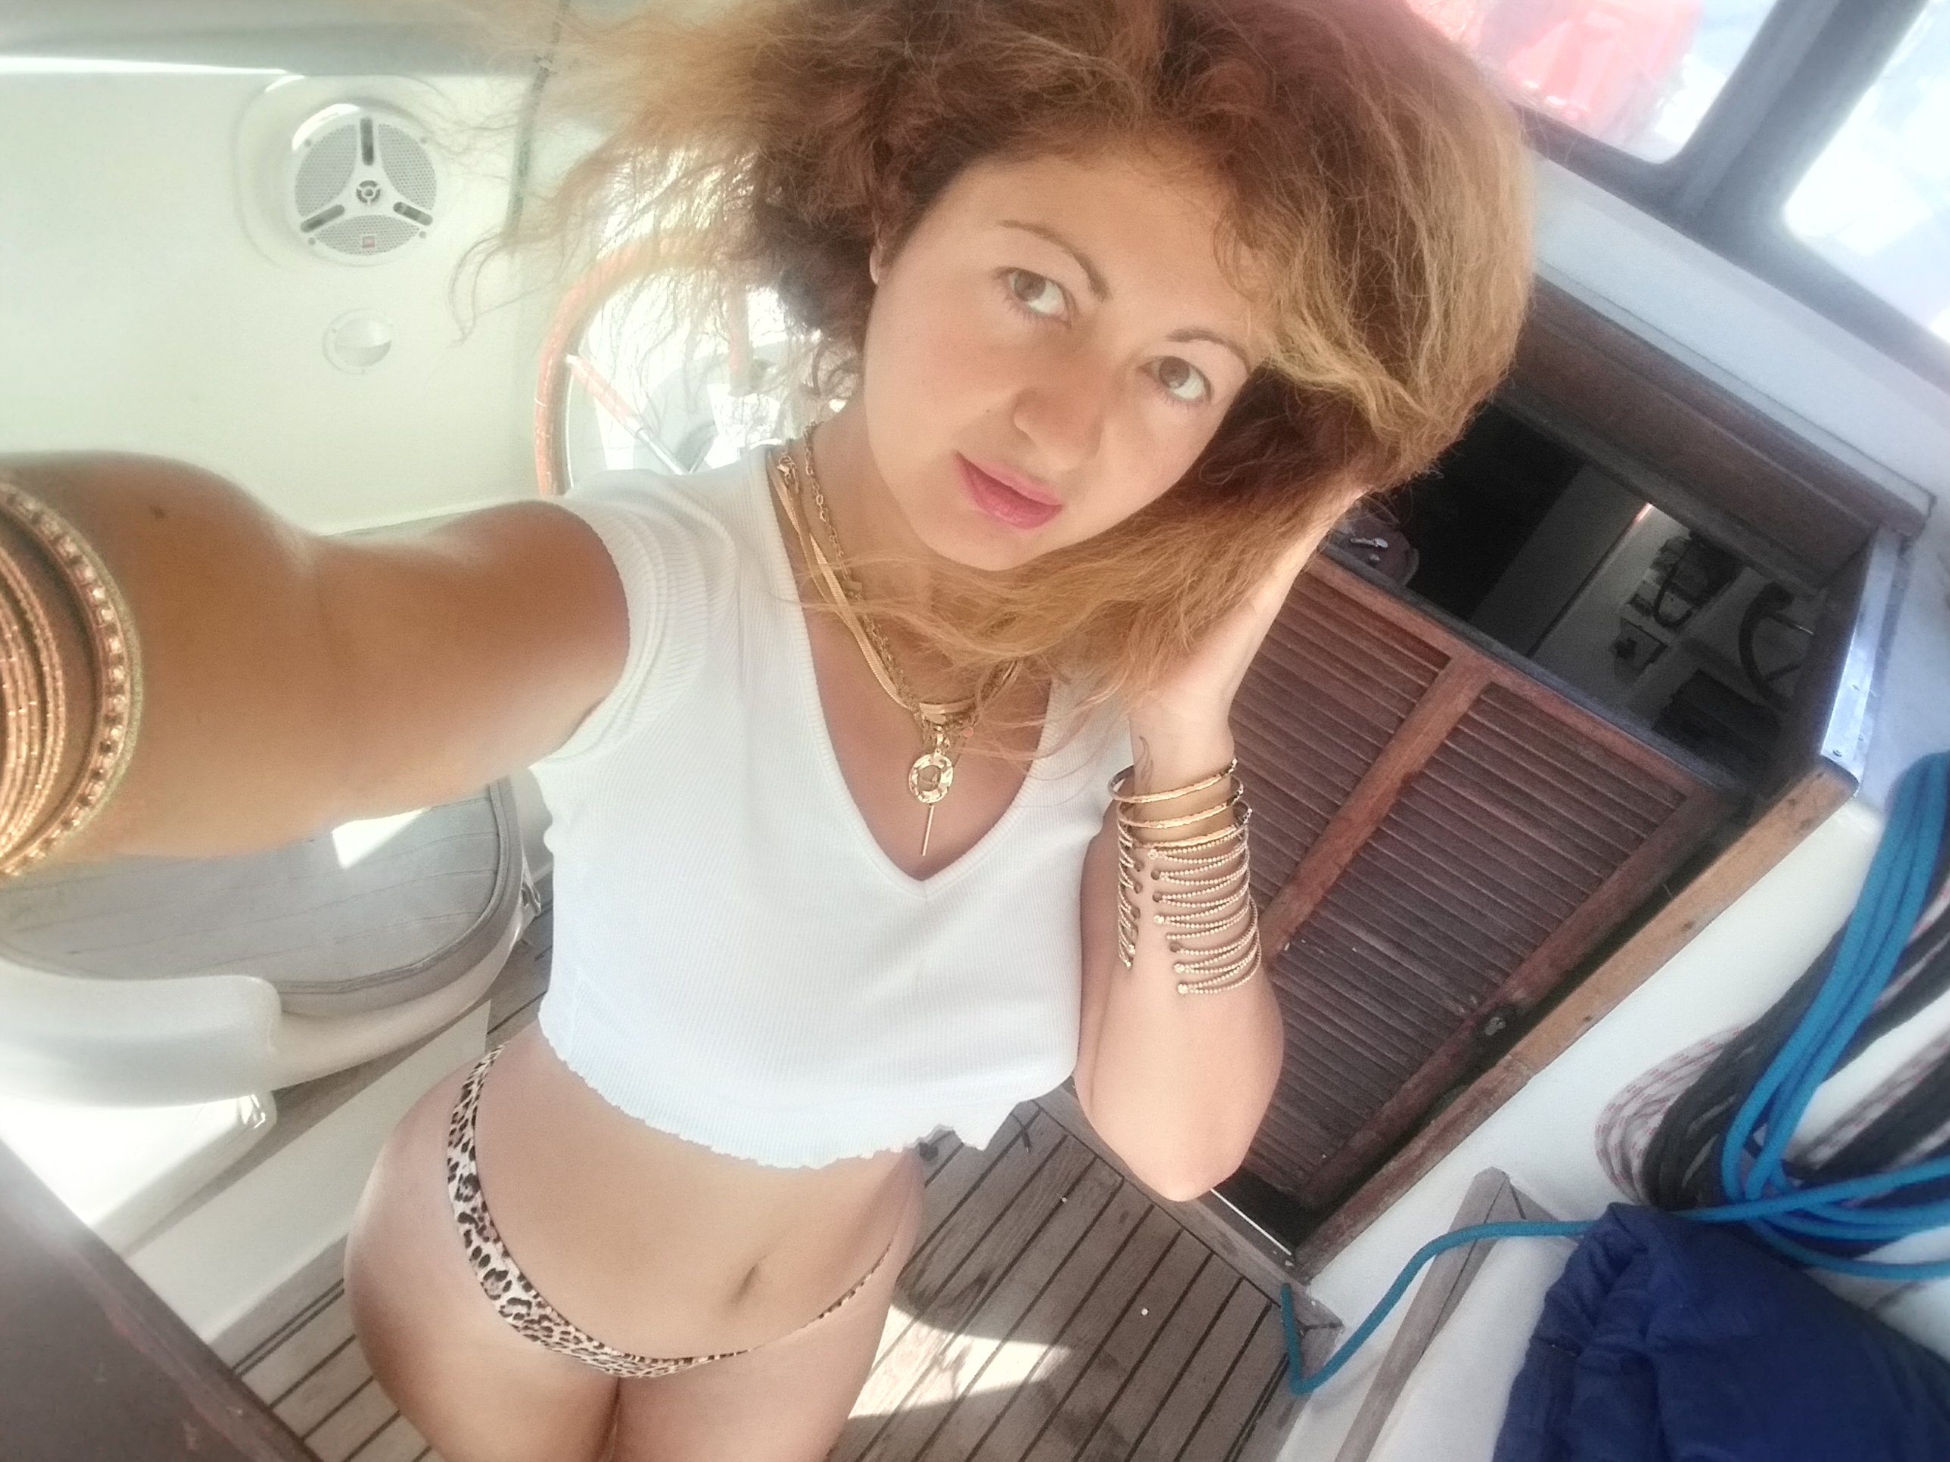 VENUS QUEEN 🔥🔥🔥👑

# ***MODEL***

**PERSONAL DATA**

+4915124166031(whatsApp)

+306947281579

[venusqueentopdancer@gmail.com](mailto:venusqueentopdancer@gmail.com)

instagram @thequ_een9539

fcbook Venus Queen

Tik tok Venus Queen

## **EDUCATION**

Bachelor degree in Social Studies and Communication

## **EXPERIENCE**

## Fitness Model-Affiliate for Vita Strong Italy(Global Nutrition supplements chain)

Official model-Jewelry and clothing luxury brands

**DALMORY , GLAMISH and LUX dresses**

Official ambassador for the luxury jewelry

Brand **Francyfloy**

Official model for the sportswear brands

**Gofit, Tutempire.active and Fitmodel.Ig**

Official influencer cooperation with the luxury fashion brand

**Apeiro💫**

Official influencer cooperation with

**DnG Influencers(Travel content creator, Instagram influencer)**

## **LANGUAGES**

German English Greek native level

**SKILLS**

Multilingual-Multicultural

Strong Team leader-Efficient Team worker

Communication skills

Happy Shiny high vibrant personality

Unique beauty-face-body-physical appearance-energy-vibe

Charisma of capturing any audience in seconds

Enthusiastic

Dedicated

Open to global work travels

Creative

Life curious

Hardworking

Funny and professional

Spectacular performance

Amazing vibe

Open to any new artistic challenge

MODEL-AMBASSADOR-AFFILIATE

DANCER(GO GO,BELLY,SALSA-SAMBA HOT🔥🔥🔥**DANCER)**

ACTRESS-COMMERCIALS

INFLUENCER-CONTENT CREATOR

TRAVELER

FASHIONWEEK

ARCHEOLOGY

LIFESTYLE

LUXURY-FITNESS

TRADING

***LIFE FIGHTER-WINNER MENTALITY***