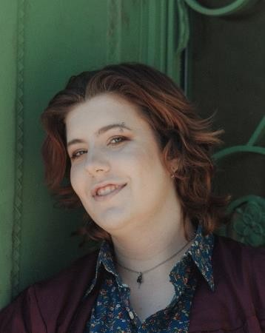 Avery Thompson (they/she/he)

HEIGHT: 5’10”

HAIR: Brown

EYES: Blue

VOICE: Tenor-Contralto (E3-C6)

averybombastic@gmail.com 608-520-8919

# PERFORMANCE

|  |  |  |  |
| --- | --- | --- | --- |
| Once |  | Andrej | Dir. Kelly Howe |
| Polaroid Stories |  | D | Dir. Lavina Jadhwani |
| The Boys and The Nuns |  | Christina | Dir. Sandra Delgado |
| Does It Feel Like Home |  | Performer/Writer | Dir. Millie Le |
| The Old Man and The Old Moon |  | Cookie/Ensemble | Dir. Emily Ritger |
| Somewhere |  | Corin | Dir. Denise Serna |
| The Hunchback of Notre Dame |  | Choir | Dir. Brain Cowing |
| Untitled Dream Girl |  | Shut-in Friend | Dir. Emily Ritger |

# TRAINING

Dance Ballet, Jazz, Musical Theatre, Show Choir

Acting Timothy Kane

Vocal Master Class Julian Decker

Dialect Training Carrie Hardin

Intimacy Coordination Workshop Maggie Bittinger

# EDUCATION AND ACCOLADES

Loyola University Chicago *Minor in Theatre*

Wisconsin State Honors Choir *Performer*

Wisconsin Solo and Ensemble  *Three Time* *State Qualified*

Wisconsin High School Forensic Association *Outstanding Performer in a Play*

# SPECIAL SKILLS

Ukulele, acoustic guitar, bass guitar, dialect training, in-depth character worker, proficient sight singing/ear training, stage combat experience

