**Acting CV**

**Name**: Edward Dawe-Halls

**Email**: [edwarddh1003@gmail.com](mailto:edwarddh1003@gmail.com)

**Social Media Accounts:** edward_behindthescenes

I am an amateur actor who studied performing arts at West Herts College for 2 years. I am willing to play and learn new skills and unique roles outside of comfort. I would like to expand my choices of roles and not afraid to try new things and to learn new skills to make my experiences more entertaining for me and others around me.

* **Height**: 6’3/190.5cm
* **Build**: Ectomorph
* **Hair** Colour: Brown
* **Eye**: Brown/Hazel/Green

| **Title of Show** | **Role** | **Director** | **Venue** | **Year** |
| --- | --- | --- | --- | --- |
| Fear and Misery | Lloyd Grayson/Sydney Snipes   * Farmer * Sister * Herald * Prosecutor * Jewish Wife Husband | Michael Neale | West Herts Campus | 2024 |
| Red Riding Hood | Handyman Husband | Michale Neale | West Herts Campus | 2023 |
| Macbeth | Macbeth | Donna Weightman | West Herts Campus | 2023 |
| The Play That Goes Wrong | Robert/Thomas Colleymore | Donna Weightman | West Herts Campus | 2023 |
| Yours Truly | Kyle | Savannah Keywood | Tring | 2024 |
| Epitaph | Ozzy | Sam Kennedy | Bushey/Watford |  |
| Modelling Show | Model | West Herts | West Herts Campus | 2024 |
| Got a lighter | Elliot | Alex Gehring | Cassiboury Park/Watford | 2024 |
| Modelling | Model | West Herts College | West Herts Campus Watford | 2024 |
| Real talk | Host | Jonathan Vianello | West Herts Campus Watford | 2023/24 |
| Levi’s Revamp Advert | Tyler | Olivia Russel | London Underground | 2023 |
| The Death Sentence | Bully | Billy Halls | Cassiboury Park | 2023 |
| The Lost Box | Zeus | Jess Sendall | Abbots Langley | 2023 |
| Snicker Revamp Advert | Businessman 2 | Nicole Du Casse | West Herts Campus | 2023 |
| Billy’s DJ thing | D.J | Billy Halls | House | 2023 |
| Bigfoot thing | Russel | Billy Halls | Cassiboury Park | 2023 |
| Edge of the Woods | David | Lillie Smith | Cassiboury Park/West Herts Campus | 2023 |
| Til death do us part | Eric | Leah Cruise | West Herts Campus | 2023 |
| Slip up | Carter | keelie | West Herts Campus | 2023 |
| Faded | Toby | Keelie | West Herts Campus | 2023 |
| Static | Matthew | Jake Church-Furness and Elliot Kerse | West Herts Campus | 2024 |
| The Dork Knights falls | Dick Grayson (Nightwing) | Lewis Frost  Dan Ilahi | Lewis’s house  Oxhey Park | 2024 |
| William Beveridge: The man with the plan | extra | Chritine Ezard | Sands Studio | 2024-2025 |

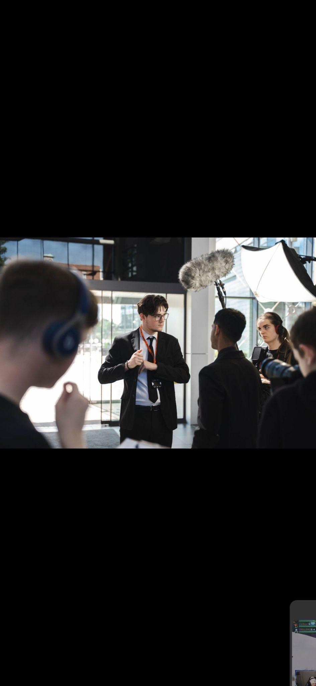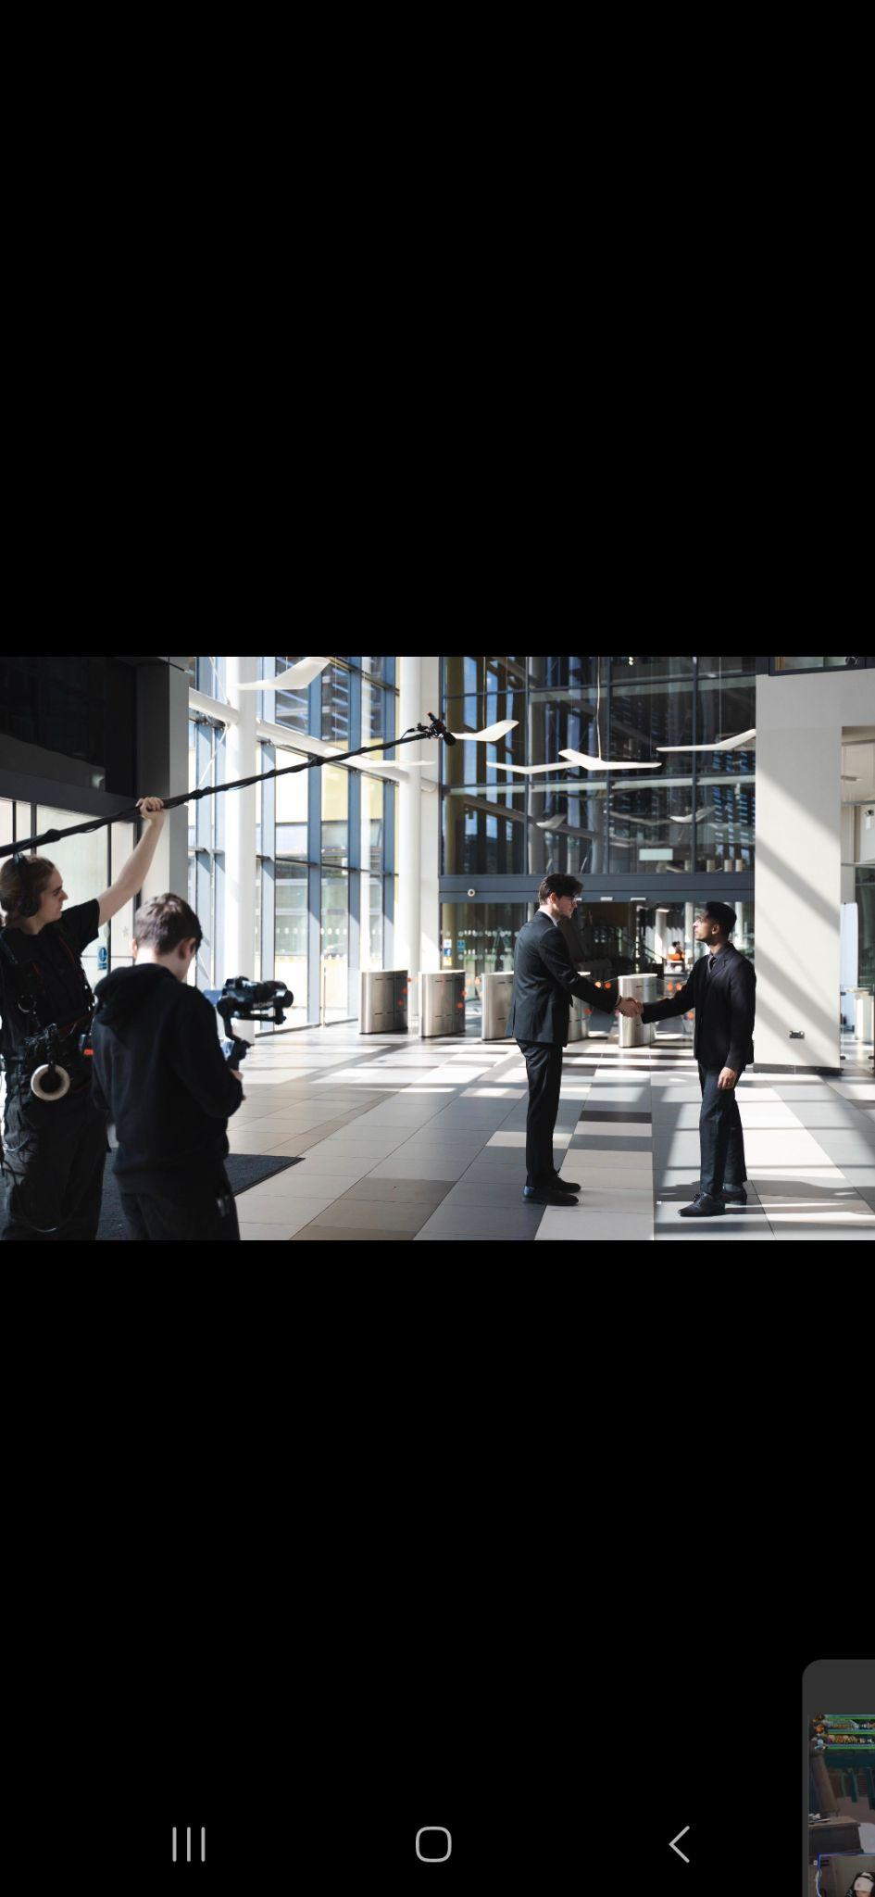

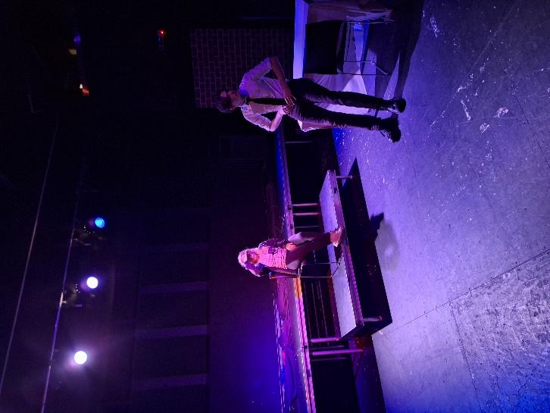

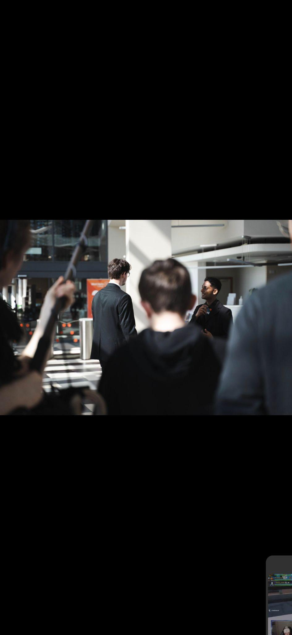

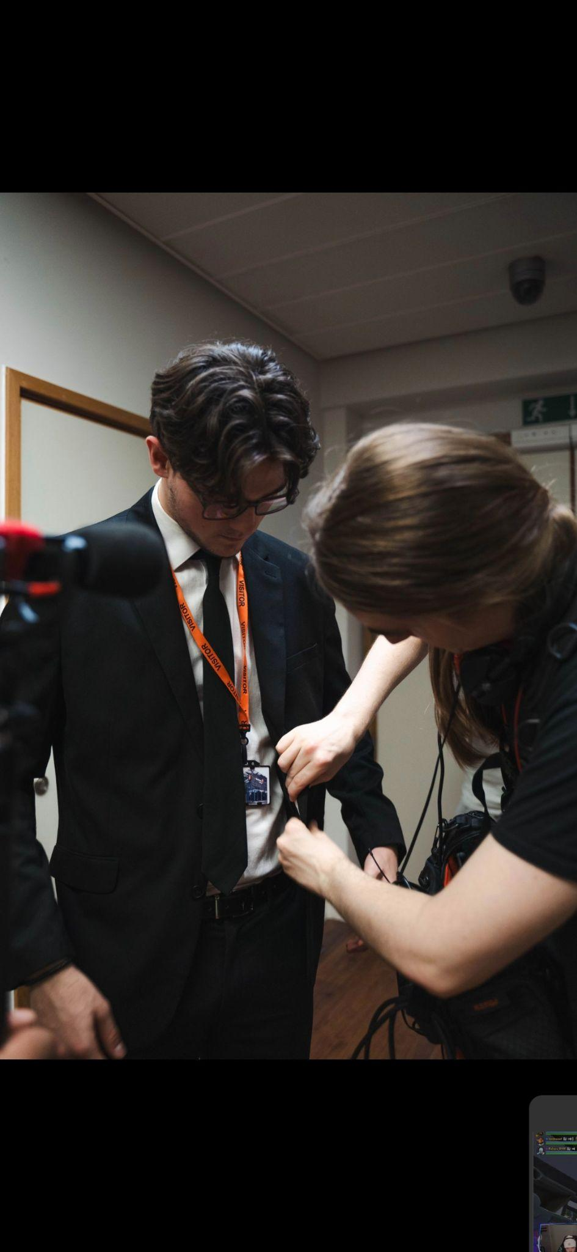

m