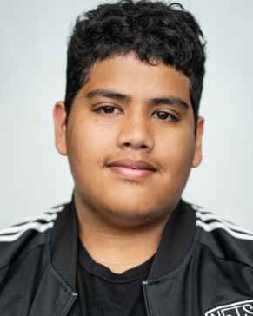
Mason Lokhandwala
c/o: masonmahalo@gmail.com
917.776.7728

Performance Credits
THEATER
-Into The Woods (2023) Big Bad Wolf Dir. Chip Lamb

FILM
-The Underdoggs (2023) Football Player Dir. Charles Stone III
-Your Monster Teen Dir. Caroline Lindy
-This Boy’s Vida Student Dir. Adrienne Acevedo Lovette
-Turbo Tax Spec. Teen Poker Player Dir. Amanda Lundquist
-The Bushwick Psycho Neighbor Boy Dir. Brian DiLorenzo

TV

-Diarra From Detroit: All In Student Season 1, Episode 4 (2024)
-Powerbook lll: Raising Kanan Extra Teen Mall Goer Season 3, Episode 9

MUSIC VIDEO
-“Young Dylan Tick Tock” Background Kid Dir. Rock Davis
-“Garden” Dancing Child Dir. Color Tongue

SOCIAL MEDIA
-Atlanta Meta/Instagram Photo / Video Shoot Prod. Chelsea Pictures

PHOTOGRAPHY
-Stock Photography for Gov’t Photo Shoot Prod. Maya Elby

OTHER
-Product Demo Video Prod. Bolex Studios

