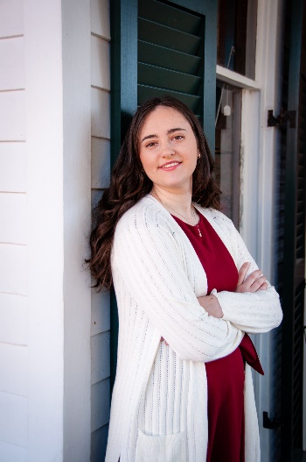

**Lauren Breedlove**

**Voice Actor**



**Role**

**Veronica**

**Sofia (Episode 2 onwards)**

**Reese Vanguard**

**Kushina Wayne**

**Siren**

**Mrs. Bellee**

**Lily**

**Sydney**

**James Karia**

**Ms. McKenna**

**Additional Voices**

**Client**

**Wønder_Alex**

**Wønder_Alex**

**Kaen**

**Kaen**

**Luna Moonstone**

**Nuggy**

**Nuggy**

**Kat**

**Sebastien Martinez**

**Sebastien Martinez**

**Sebastien Martinez**

I am a voice actor of almost 2 years of experience in voice acting who can bring a huge variety of characters to life using my voice. I am 21, and have loved acting for as long as I can remember. When I’m not voice acting, I’m spending time with my family, playing video games, watching anime, walking my dogs, or just writing my own music.

**Role**

**Recon/Shinichi Nagata**

**Robin (Female)**

**Grima (Female)**

**Emmeryn**

**Cherche**

**Cordelia**

**Aversa**

**ATTENTION!!**

**This voice actor does not consent to her voice being used for AI or any form of automation of any kind!**

**Production**

**Variants**

**Gamerz**

**Hajime Genesis (Canceled)**

**Hajime Genesis (Canceled)**

**The Night is Young (Canceled)**

**Step Forward**

**Step Forward**

**Chaos Clashdown (Likely canceled)**

**Friends Forever**

**Friends Forever**

**Friends Forever**

**ANIMATION**

**Production**

**Sword Art Online FANDUB**

**Fire Emblem: Awakening FANDUB**

**Fire Emblem: Awakening FANDUB**

**Fire Emblem: Awakening FANDUB**

**Fire Emblem: Awakening FANDUB**

**Fire Emblem: Awakening FANDUB**

**Fire Emblem: Awakening FANDUB**

**Client**

**Random Fandubs**

**KitKat**

**KitKat**

**KitKat**

**KitKat**

**KitKat**

**KitKat**

**FANDUBS**

* **English: FLUENT (Native language)**
* **Spanish: Took two years of Spanish classes in high school**
* **Japanese: Can read Hiragana and Katakana, as well as understand certain basic sentences**
* **Italian: Can piece some sentences together, however I only know a few words**

**LANGUAGES**

* Scarlett Studio Condenser Microphone
* Unknown brand boom microphone stand (possibly OnStage)
* SoundAssured Pop Filter
* Scarlett Focusrite 2i2 3rd Gen XLR Interface

**HOME STUDIO**

**Accents**

**General American, General British**

**Services**

**ADR/Dubbing, Animation, Narration, Video Games, Audiobooks**

**Vocal Range**

**Female Child, Female Teen, Female Young Adult, Female Adult, Female Senior, Male Child, Male Teen**

**SKILLS**

Deville, Louisiana

https://laurenbreedlove.wixsite.com/laurensofficial

**CONTACT**

laurenthehylian@outlook.com