**TARA ZAMANI**

**516-941-6652**

**Tarazamani92@gmail.com**

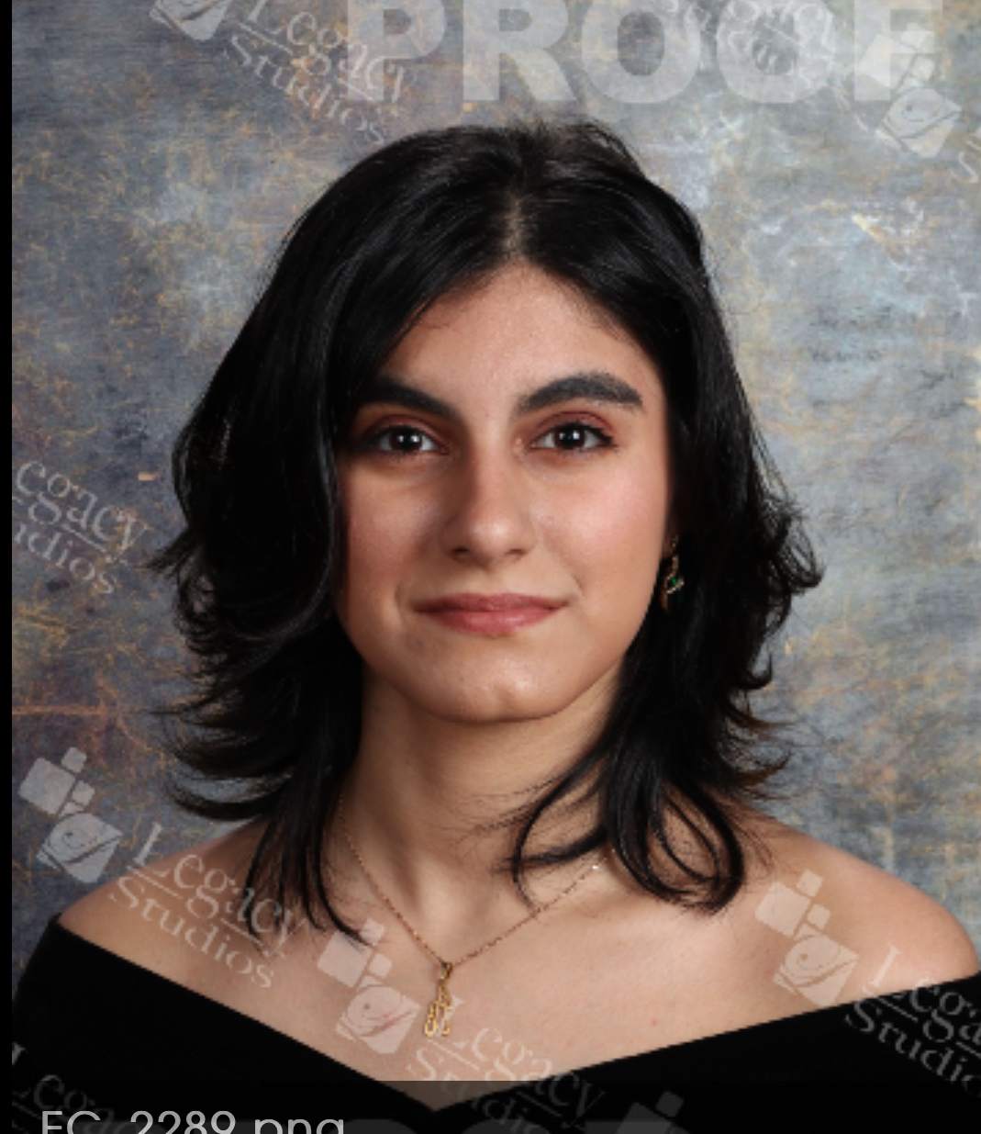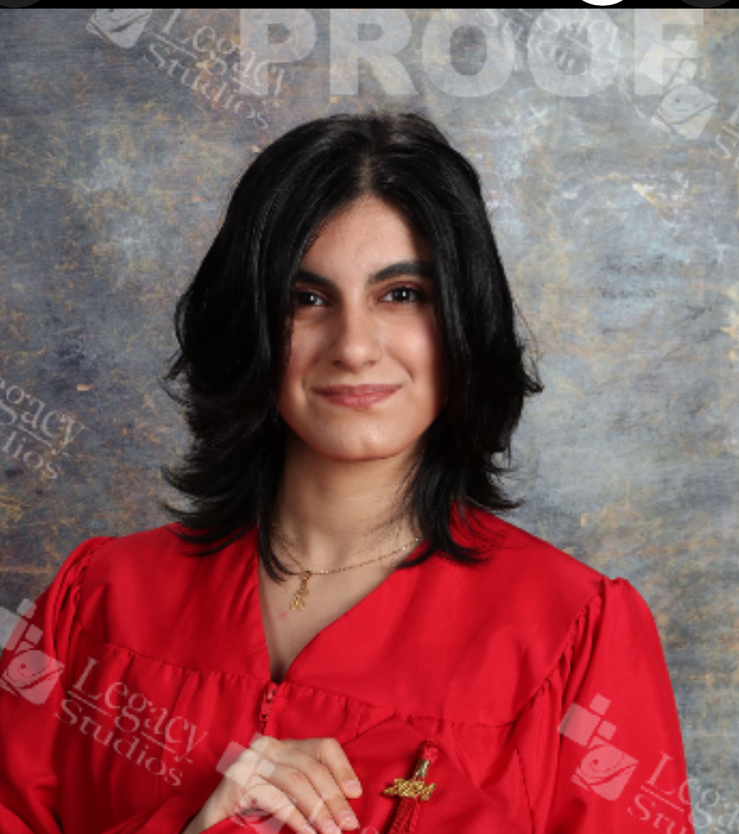

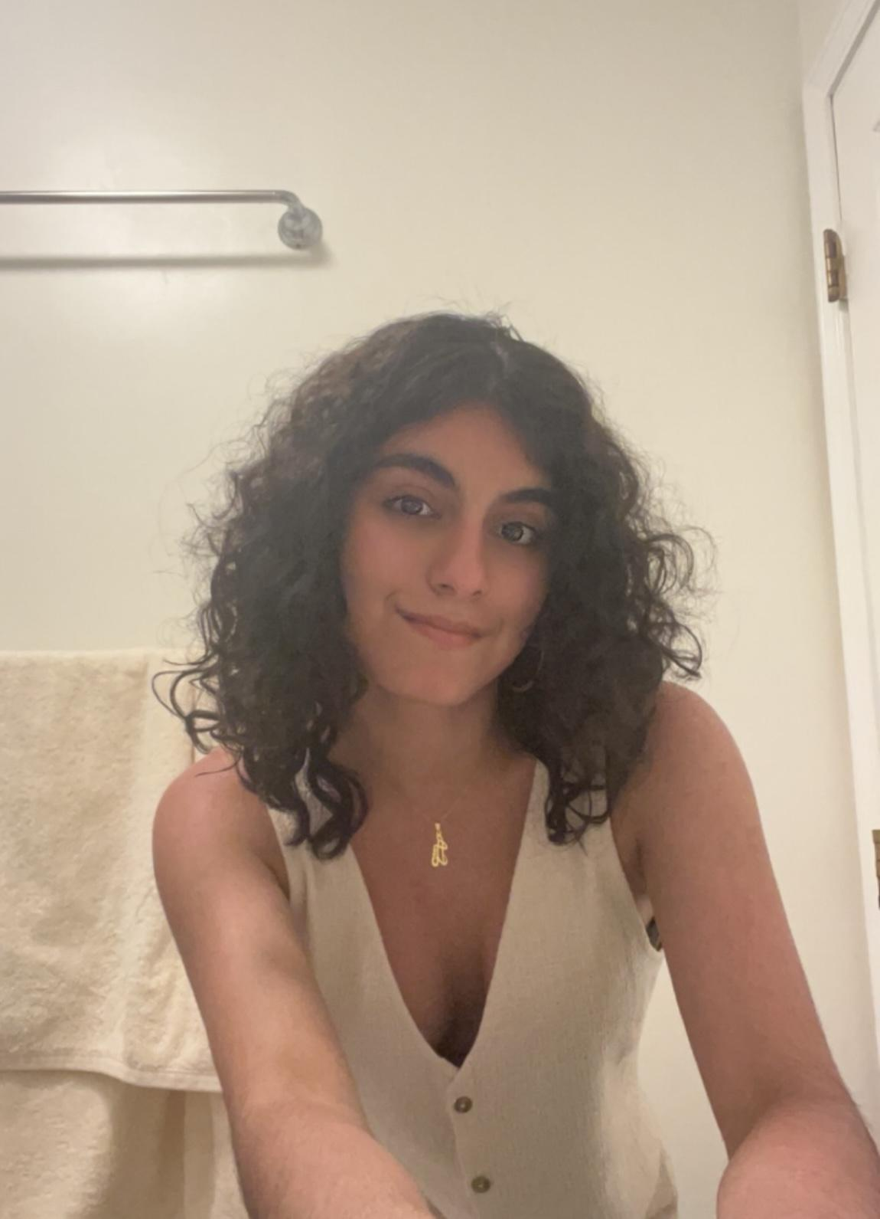

**Height: 5’3’ Hair: Dark Brown w highlights**

**Size: 33/38/28 Eye Color: Brown**

**Shoe:7 1/2 DOB: 12-14-2005**

**Acting Training:**

* **TV Acting- Television Acting Skills**
* **TV Acting- Audition Procedures**
* **TV Acting- Script Copy Techniques**
* **Advanced Acting- On Camera products**
* **Advanced Acting- Cold Read Techniques**
* **Business Casting- Improvisational Acting Groups**

**Monologue Casting- Commercials, Spokesperson, & Monologue Delivery**

**Modeling Training:**

* **Runway Techniques: Basic turns, Freestyles, and double ramp routines**
* **Photo Shoots**
* **Photo Posing**
* **makeup application**

**Special Skills:**

* **Works great with Animals**
* **Bilingual persian/English/dari/tajik**
* **Figure skater**
* **Follows directions well**
* **gymnast**
* **dancer**
* **different forms of martial arts**
* **plays piano**
* **competition swimmer**
* **work great with kids**
* **martial arts instructor**
* **Horseback riding**