Roger E. Palomino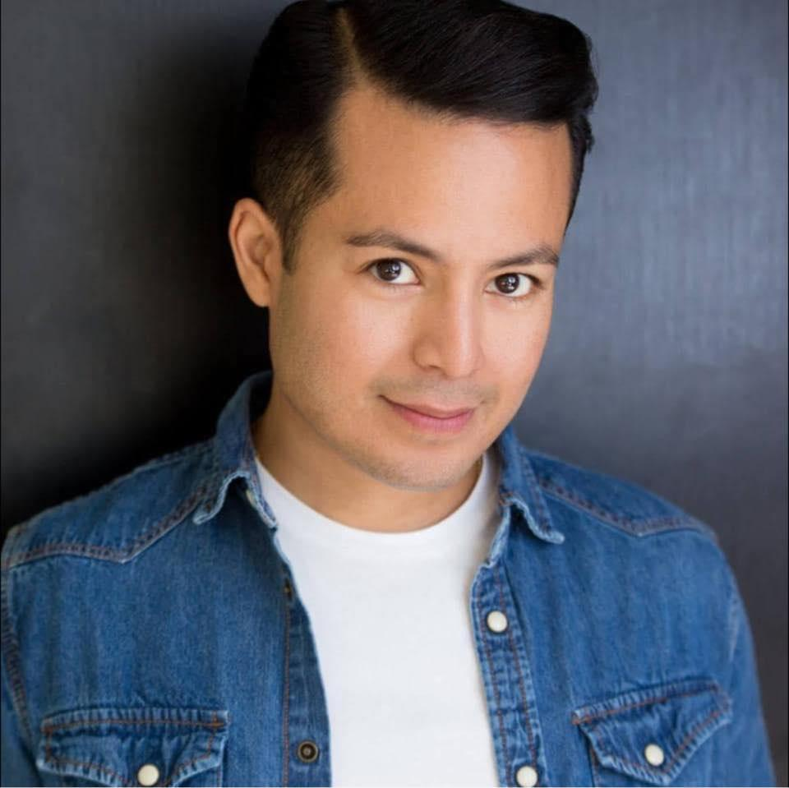

(Non-Union)

281-433-2661 Height: 5’ 4” (162 cm)

r_palomino@hotmail.com Weight: 130 lbs (58kg)

Eye Color: Brown

Hair Color: Black

____________________________________________________________________________________

**THEATER**

*The Moon Is Blue* Don Gresham/Lead Huntsville Community Theater

*Plaza Suite* Bellhop/Groom/Assist. Dir. Huntsville Community Theater

*Last Chance Inn Calamity Gulch* Happy Bender Huntsville Community Theater

*Barefoot In The Park* Old Man Huntsville Community Theater

*Bocon*  Miguel/Lead Talento Billingue De Houston

*Moon Over Buffalo* Paul Upstage Theater

*Wait Until Dark* Officer Upstage Theater

*Comedy Of Errors* Bromeo Conroe Shakespeare Festival

____________________________________________________________________________________

**FILM/TV**

*Metro* TV Commercial Spectator Texas Video & Post

*SiTV’s Fandemonium* TV On Air Talent/Contestant SiTV Cable Television

*Logros Television* TV Host HMSTV

*Living The Dream* TV Host HMSTV

*Houston Refocused* TV Host HMSTV

*The Life of David Gale*  Background ReporterUniversal Pictures  *Convergence* Eddie/Lead LG/Think Big Productions

*Woogie* Sunset Clubber U Never Die Entertainment

*The Green Lantern* Party Goer DC Entertainment/Warner Bros

*Bar Room Blitz Thug #3 Lucky Chucky Productions*

June Ralph Royster Lazy Gal Productions

El Secreto De Emiliana Padre Damian Lolita Bonita Films

Mariachi Monday Mariachi Miguel Inourcity Films/Full Bloom Films

No Place To Hide Ryan Breakshot Films

Never Die Twice Carlos/Jorge Films For Actors

Beer & Seed Jimmy “The Nail” Bill Cox Productions

The Extrovert Jose Phantos Film

Ausenia Angel All Inclusive Pictures

Sanitized Worker Amatol Productions

The Big Slip Detective Baker Breakfast Machine Media

____________________________________________________________________________________

**EDUCATION & TRAINING**

Sam Houston State University: Bachelor of Business Administration in International Business and Economics, Minor in Speech Communication

Connecticut School of Broadcasting , specialization in broadcasting and teleprompter.

Joanna Sanchez Actors Studio, Meisner Method.

The Working Actor, Auditioning with Derek Nixon and Andrew Aguilar.

Dance: Tap (3 Years) with Tap Happy Studio. Sara Draper.

____________________________________________________________________________________

**SPECIAL SKILLS**

Singing (Voice: Tenor), Dialect (Southern American), Languages: Fluent Spanish and English.

Performance Skills: Improv, Hosting, Voice Over.

Athletic Skills: Track & Field, Martial Arts, Roller Skating, Baseball, Swimming,

Dance: Modern, Salsa, Latin and Freestyle