William Laurence Durante Screenwriter + Journalist.
Creative Director at Far From Professional LLC.

About Me
Born and raised in New Orleans, LA. I attended Benjamin Franklin High School. I played soccer in college, wrote music and then cooked for many years before returning to the University of New Orleans for Film and Theatre. I have worked on many sets and have experience writing scripts, music and news stories.
I take influence from my city and my beautiful friends and family.
 | William Durante
 | - Film and television
 | CONTACT |  |  | PROFILE
 | 504-250-3717  WILLLDURANTE@GMAIL.COM  https://williamdurante.dorik.io |  |  | I WAS BORN AND RAISED IN NEW ORLEANS. I COOKED FOR FIVE YEARS BEFORE RETURNING AND GRADUATING CUM LAUDE FROM UNO FILM SCHOOL. I EXCEL AT EDITING, DIRECTING, WRITING AND WORKING WITH PEOPLE ON SET. I HAVE EXSTENSIVE EXPEIENCE WORKING AS AN EXTRA ON MANY HOLLYWOOD BLOCKBUSTERS SUCH AS JACK REACHER, THE DIRT AND CAUSEWAY. I AM HARDWORKING AND GREAT TO HAVE ON SET.
 | SKILLS |  |  | EXPERIENCE
 | WRITING  DIRECTING  EDITING  3D SOFTWARE  SOUND  GAFFER |  |  | EXTRA WORK-  JACK REACHER 2010  THE DIRT 2017  CAUSEWAY 2019  STUDENT FILMS-  THE VENERABLE BENEFACTOR  https://drive.google.com/file/d/1R5F1xsq7KJzHSXClSZPb2NmCLrM0byW4/view?usp=drive_link  SOUL NOLA-  https://www.youtube.com/watch?v=Dl_0-tfY5YA
 | EDUCATION
UNIVERSITY OF NEW ORLEANS
2020-2024
CUM LAUDE
BA IN FILM AND THEATRE

Skills & Tools

3D Software

Film Directing

Script + Music Writing

Projects

Feature Article
Covering the oak Street Po-Boy Fest 2023
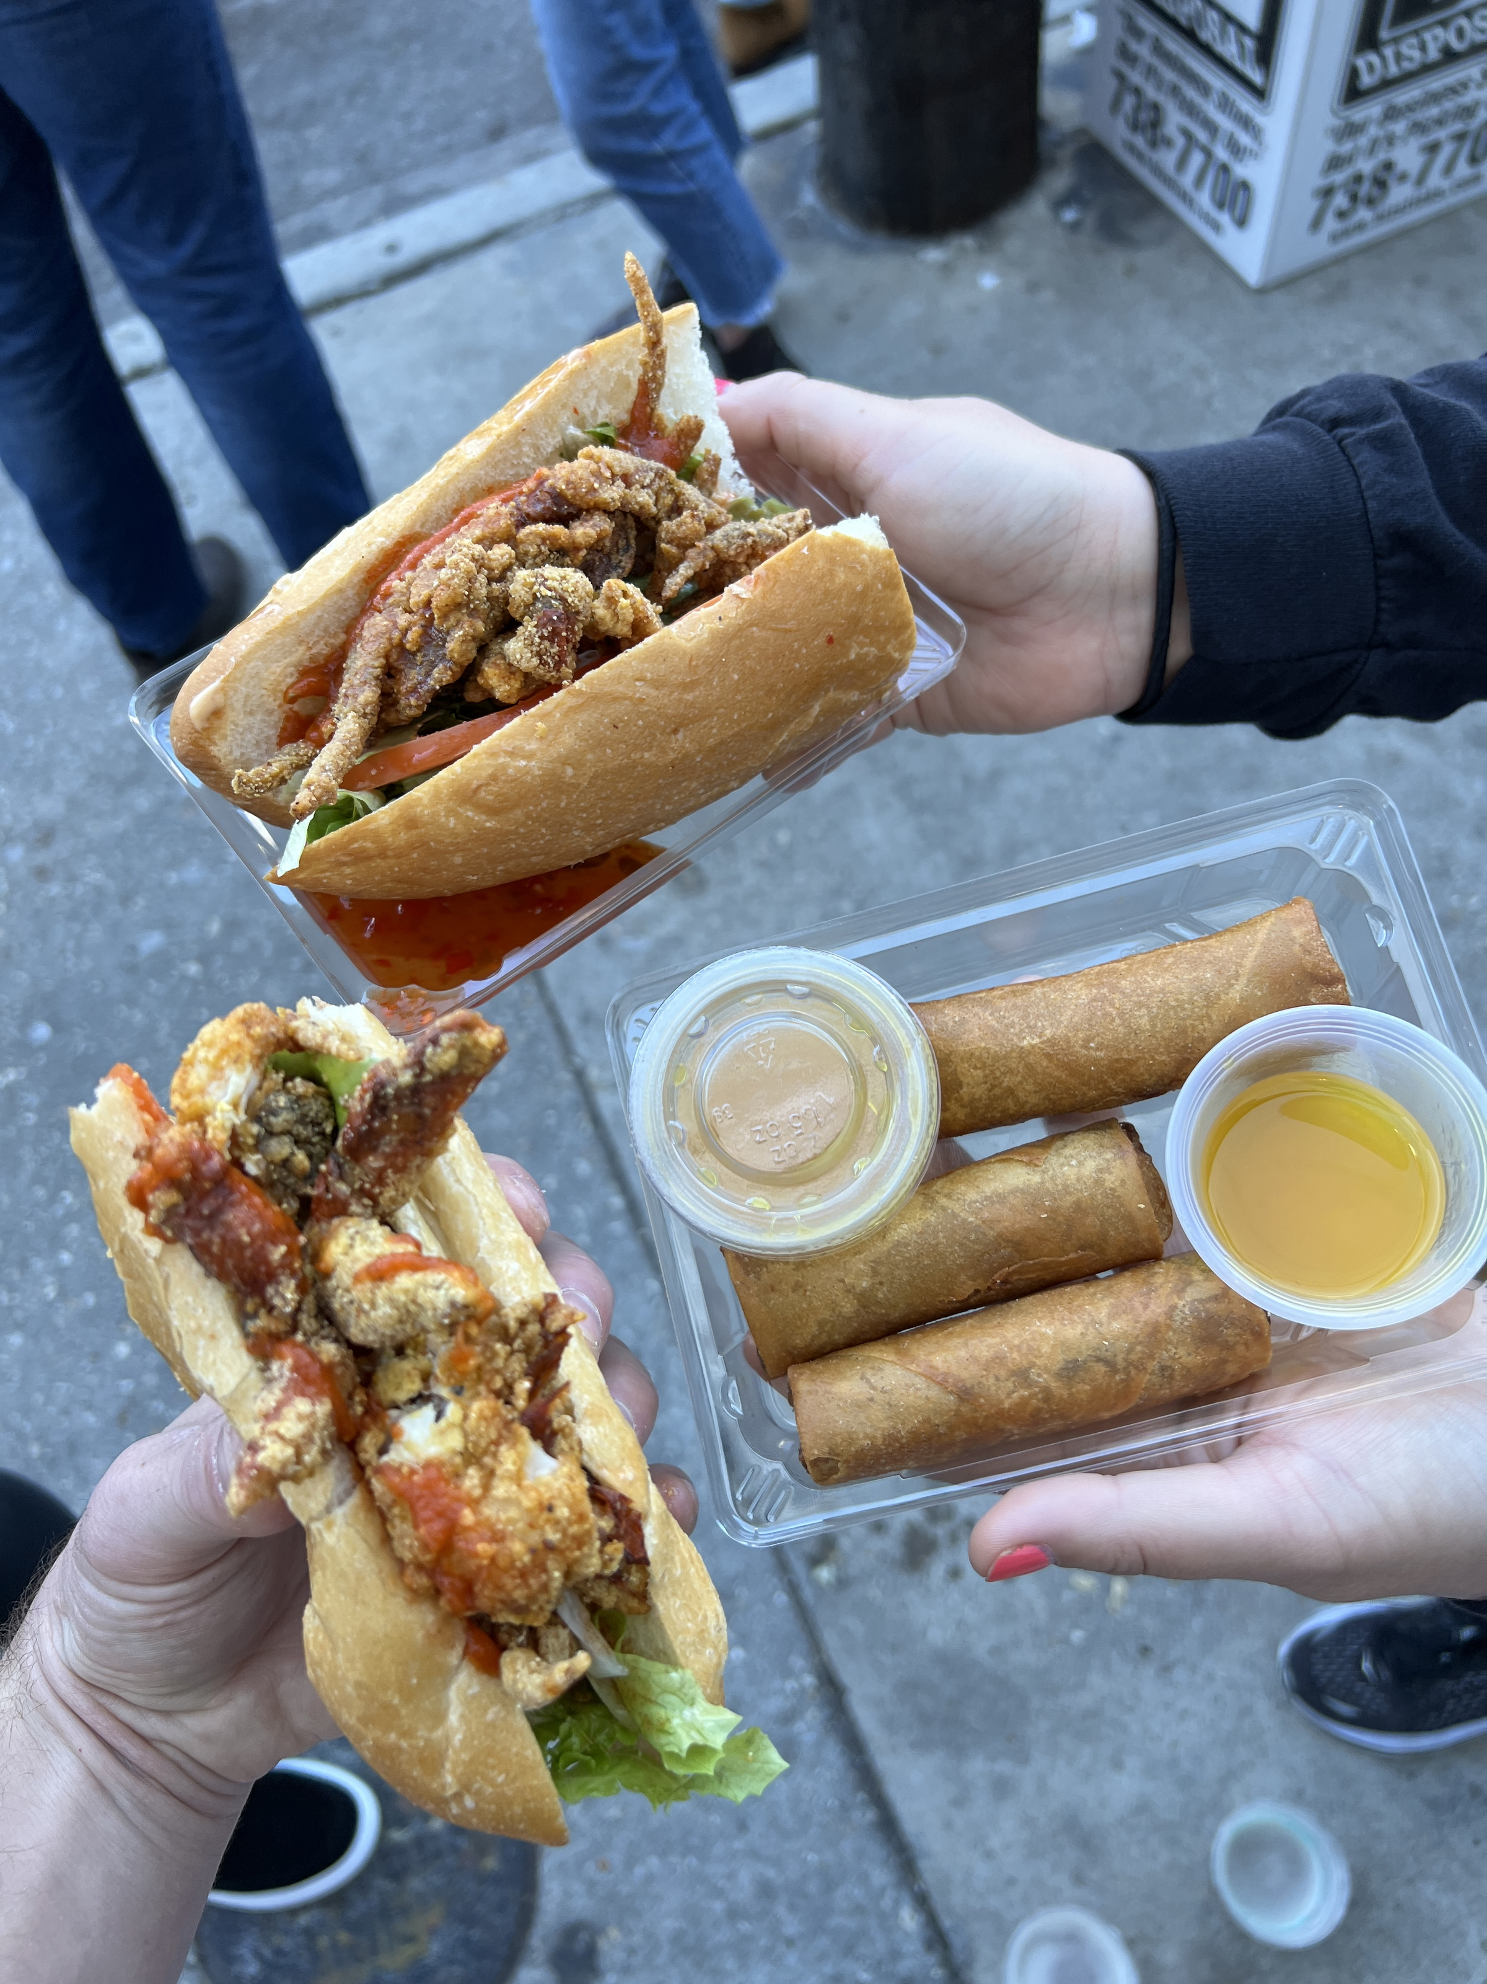
Oak Street Po-Boy fest 2023
Oak Street’s 15th annual Po-Boy Fest was held last Sunday November 19, and boy was it a special one. It is from 10 am to 6pm on the seven blocks from Carrollton to Eagle Street. Over 40 vendors had set up shop, ranging from Breads on Oak to Tony Chachere’s to Parkway Bakery and Tavern. They have all gathered here for a little friendly competition, to see who will be crowned best po-boy. Some vendors stick to their staples while others use the fest to try something fun and different. The fest is sponsored by Son of a Saint and has tents for Planned Parenthood and other non-profits from the city looking to make a difference. There are 40 food vendors, Arts Markets, Kids Zone, VIP Area, sponsored activities, beverage vendors and a Po-Boy competition with awards for best of the fest, best shrimp, best seafood, best pork, best beef and best specialty.
I walked down from my house with my mother and sister. The walk helped us work up an appetite. It was a gorgeous day and by the time we got there at 2pm it was not that crowded either. We bought one wristband pass which is needed to order any po-boy and started with a couple beers. It is structured very similarly to Jazz Fest in that there are different musical stages. Each stage corresponds to the side street it's on. There was the Maple Leaf Stage, Piano truck, front Porch Jams, Urban South on Dante, James Clesi’s Eagle Street Stage and the Leonidas Street Stage. We were just in time for Julian Primeaux’s band who was throwing it down on Dante.

They were very talented and incorporated many genres at once. He looked a lot like Jim Morrison but played an even better guitar. He would walk in the middle of the street and engage with the audience, a real character. I talked to the sound guy for the Dante stage named George. George was a young guy and carried around an iPad controlling the speakers from an app. We chatted for a bit, and he told me this was the second year the Oak Street Po-boy fest has been back since Covid. We talked a bit about the band's history and then it was time to eat.
The first vendor we went to was Magasin. They won best of the fest in 2022 and were selling soft shell po-boys which brought me back to Jazz Fest which is the first thing I got when I entered.

We got two soft shell crab po-boys and an order of egg rolls. They had hot pepper sauce and crystal that I added in heavy doses. It was the perfect way to start the fest. I talked with the owner Sara who informed me that they just opened a Magasin on Oak Street two years ago, which was at first their mukbang restaurant they decided to turn it into their sister restaurant. I was excited to hear that since “Pho Camly” closed a couple years ago, I haven't found a replacement for my neighborhood pho spot. This seems promising. I asked Sara how many soft shell crab po-boys she sold, and she told me she only ordered 300 and we got two of the last nine of the day. Sara said that the fest was much busier earlier in the day and that we missed the crowd. The egg rolls were hitting differently with that Urban South gold ale to wash it down. Glad we went there first before they 86ed them.

Our next stop was the Paino truck with Dom Pipkin who was playing his heart out. We stopped at Crabby jacks to bring home some souvenir cups for our cabinet at home. We ordered three Moscow Mules and sat down to listen to some piano. I remember when “Ninja Sushi” was there and now a place called Ajun Cajun stands, which I have never been to but have heard good things about. I have so many childhood memories of eating at Ninja with family and friends and it was such a relaxing place to get some sun and sip sip.
Inserting image...
My mother and sister then visited some shops looking at clothes and soaps while I went for the good stuff an Alligator sausage Pimento Cheese Po-Boy from Crabby Jack’s no less. I told myself on the walk to the fest that I would have to order the first Alligator sausage Po-Boy I saw, and I didn’t let myself down. Pimento is having a moment right now as it is being featured on Chic Fil A’s new sandwich, but no chain can come close to what happened that day in my mouth. We kept flowing down the street as one does and stopped for a bit outside the Front Porch Jams which was just that stage on someone's front porch. The artist was Randy MC. A young man with a great high-end voice, who covered a wide range of songs. He played “Landslide” by Fleetwood Mac, which is one of my mom's favorites, so we sang and danced and ordered some more liquids.

We then met some locals Alex and Marie who had brought their dog. We asked them what anyone at this fest wanted to know. What was your favorite po-boy? They told us to try Seither’s Seafood. I knew something was up with Seither’s because they had the longest line in the fest, so they were obviously doing something right. They told us that Breads on Oak was doing a vegan menu true to their restaurant's fashion and that they tried a Chargrilled Oyster Mushroom Po-Boy with smoked bacon, roasted inions, and house made blue cheese, buttermilk dressing, tomatoes and lettuce on sourdough bread, that they loved. Such a unique spinoff to use oyster mushrooms like that.
Ur next stop was the James Celsi’s Eagle Street Stage to see “Zoomst.” A bunch of young guys making electronic funk jam band music was a good way to wind down. We had one more stop at Cochon to try their Whole Hog Po-Boy: slow smoked whole hog the pig was roasted for over ten hours, cilantro-roasted jalapeno slaw and house made BBQ sauce was out of this world. It was so good I agreed to buy a smoker for Christmas for my mother. The way the pig fell apart was out of this world. While in line I met this man named Brandon from Australia who moved to New Orleans right before Covid. He was very gracious as all Aussies seem to be and we exchanged numbers. He told me he worked at Lilette. I told him I used to play soccer with the head chef, Mr. Harrison, and that they make great food. He told me to come eat there and he would “hook it up.” So, I can't wait to visit.
Inserting image...
Now mind you, all this can be done on a minimal budget. You only need one person to buy a ticket to enable you to purchase the right to buy po-boys. The average price of a po-boy was 12 dollars, but you can “byob” with no check points. So, get together three friends and all throw in 5 dollars for one ticket, split a twelve pack of your favorite beer from Conseco’s a block away from the entrance and all buy and share one po-boy puts you down for around 22 dollars. Really not too shabby. The music is free and unlike Jazz Fest you won't be overwhelmed by crowds and lines.
Now to announce the winners; winner of the “best shrimp po-boy" which I consider the staple was Southerns Food Truck with their Lt Dan with fried shrimp, garlic herb aioli and sweet heat sauce, a good name goes a long way. The “best seafood po-boy" was Seithers Seafood for their Voodoo fish and chips po-boy with blackened redfish, homemade slaw and Zapp’s Voodoo potato chips crushed on top! “Best pork po-boy" went to Southerns Food Truck with grits and grillade po-boy. The “best beef po-boy" went to Seither’s Seafood for their sirloin with gravy and potato sticks. The “best specialty po-boy" went to Southerns Food Truck for their surf and turf po-boy with braised pork belly, smoked beef rib and onion rings. A common theme is to keep some crunch. For the grand finale the “best of the fest” was won by none other than Southerns Food Truck for their grits grillades po-boy. Grillades is a dish from the bayou usually consisting of thin pieces of typically beef coated in flour, browned in oil or butter, then set to simmer in a rich tomato-based gravy. These two vendors were doing something right that day to sweep the podium in such a manner!

After we thought we were fit enough to move we decided to walk home and put our feet up. We got a couple “roadies” and headed for home. Oak Street Fest is always fun but something about this year was different. Maybe it’s what Geroge was saying about it returning after Covid and how certain traditions coming back mean so much to this city. I get why Brandon moved here, it's such a special place. To have all this on a random Sunday in November.

profile Article
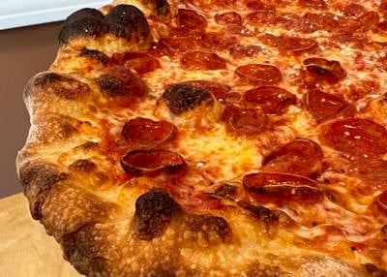
Zee's Pizzia
Pizza with Pizazz
Zander White opened Zee’s Pizza on July 28th of 2022. The Zony Mash pop-up turned Pizzeria is located on 3914 Baronne street, as part of the redeveloped Fine Arts Theater, a block away from Martins Wine Cellar. This is Zander’s ode to his childhood and his father.
Zander, who was originally from Maine and Connecticut and spent his youth going to Pizzerias all over New Haven and New York. Developing his taste for thin, crusty styled Pizza, and if that is your thing then nowhere in the world does it better than New Haven. Zander spent time coming to New Orleans with his family during the summers. In 1994 Zander’s family finally moved to New Orleans.
From family weekend dinners to college pizza parties. Zander was constantly honing his craft, perfecting his dough. Zander was in the film industry when covid struck, with a new son and his work drying up he decided to turn his hobby into his job. From pop-up to a beautifully renovated brick and mortar building.
Zee’s feels clean, homy and inviting. With a brand-new kitchen, massive metal oven, toasters and cold stations. Plenty of seating, beer by the slice signs and large windows in front and back letting in natural light. Zee’s offers salads, whole pies or by the slice. A mixture of unique dipping sauces like house ranch, Calabrian chili emulsion, marinara, hot honey and house jalapeno and some inventive sides like their garlic knots. My favorite pizza was their Pa-Ping's Plain which is a plain cheese pizza with extra garlic and chili flakes!
Zander uses a metal gas-powered oven which is lined from top to bottom in bricks. Which may not be the traditional coal powered oven that you will most likely find in New Haven. But as Zander says, "There's nothing about the way you cook you Pizza that’s going to make it better. You got to do a million different things before it gets to the oven to have a good pizza.” The hot metal can help evaporate some of the moisture ensuring the crust becomes crispy. Zander also says that they don’t completely pound their dough allowing some air pockets to remain. Which gives the pizza its signature bounce.
The framework, the substructure is thin and crispy, it holds up straight with just three fingers. They use “Grande” cheese, a high-quality ingredient, that knows the part it plays, a side character. The sauce is slightly sweet but also not overpowering. With a simple combination every piece must play their part as UGK would say. Those bubbles of char on the outside crust are worth your wait in line and workout after. I’ve talked to pizza people who couldn't dream of waking up and creating something this crispy and this thin. It takes a person a long time to assemble something like this. A Frankenstein if you will.
There is something about talking with a fellow foodie who is passionate and knowledgeable yet humble, that sets the world right, that keeps us all going. As Zander says, “Pizza is just bread and cheese, but I am not a baker.” Whatever we choose to do in the life we are given, I hope we can all find that level of intricacy. To do something at a high level consistently, yet never stop searching. Zander was in the film business before covid, this is his new art, and it’s selling.
As one yelp reviewer John said so elegantly, “There are plenty of places in New Orleans where one can get a “pizza”; but a pizza of the level of quality that such a food city demands is not in high supply. The crust is what really sets the flavor apart.”
Like most places I have covered this year there are some common themes. I hold New Orleans to a high standard because I believe in us. I know that even when we call ourselves a culinary hub of excellence there are still things we can improve on. We are a tourist town and therefore are at the beck and call of those traveling, who want what they can't get back home. We all have our own gumbo recipe, but does that mean I can’t get a good pie? Well, this place is for us, our own little piece of the Northeast.
Zee’s is located on 3914 Baroone St. NOLA 70115. Phone number (504)766-6056. Dine in or take out, no delivery. Closes Mondays and Tuesdays. Instagram is @Zeespizzeria.

Short Articles
Take Box Mushroom Farm and Francolini
Be water my friend, or be a Mushroom
Have you ever wanted something healthy to eat that your place of work, neighborhood or school can't provide? Well look no further, Takè Box Urban Mushroom Farm is here. After Covid the last thing on most people's mind after being laid off would have been to start a small business. That is just what Caroline Muneoka and Kyle Holt did with Takè Box, here in New Orleans. Caroline and Kyle took a leap of faith and went for it all, by providing something healthy and sustainable to the public.
They have kept “growing” to the point where they're producing over 200 Lbs. a week in gourmet mushrooms. Takè box sells to consumers directly and provides wholesale for local restaurants, promoting sustainable agriculture by eliminating the need to ship mushrooms long distances.
Takè Box provides for establishments such as Barracuda Taco, Margie’s Grill and Pizza Domenica to name a few. I went to eat at Marjie’s grill this past weekend. With so many flavor bombs on the menu including Dino’s chili butter shrimp grilled of coals tossed with lemongrass, sambal butter but my favorite was the coal roasted Mushrooms with Benton’s bacon, savory crab butter, fish sauce and lime and herbs! Standing out on this menu is no easy feat. The mushrooms do what they do best, which is sucking up all the sauce and flavor, so it doesn't end up on the bottom of your dish. With lime and fish sauce and butters all happening at once, in some ways all you need is the right medium, so it is no wonder this dish made such an impact.
With food inflation going up and “food desserts” being always a problem it is nice to have a cheaper alternative to healthy foods. So, when we have the chance, we must support the locally grown products to better ourselves and our communities.

Give me Amorè!
Tara Francolini opened Francolini’s earlier this year with partner Ceasar Nunez as a homage to the food of her home state New Jersey. Located at 3987 Tchoupitoulas Street right past Napolean Avenue. Francolini’s is a classic Italian Deli one you would find in a hustling bustling Northeastern urban center.
For all those that have connections to the Northeast and know what they're missing, we must dream no longer. We now have a place to fill that void.
Francolini’s features such sandwiches as “The Dima” which is a chicken cutlet with fresh mozz, Calabrian (region in Italy) chili aioli, shredded lettuce and Calabrian chili vinaigrette as Tara told me the chicken cutlet is like the shrimp poboy of the Northeast everyone knows where their favorite is made, and you will not be convinced otherwise. Their “Italian” with prosciutto cotto, mortadella, hot capicola, genoa salami, sharp provolone, pepperoncini, red onions, shredded lettuce, house vinaigrette and hot cherry peppers brings me back to my childhood summer days going to Philadelphia to visit my mom's hometown of Philadelphia.
She has spent time living in Vietnam, New Zealand and Australia working in restaurants and bars all over the world honing her craft. She moved to New Orleans in 2018 and after working in restaurants throughout the city, eventually decided to start her own. She was going to bring her favorite hometown foods to her and the locals of New Orleans.
I have spent time in the industry and was born and raised here, so I feel okay saying what I am about to say. Our economy is tourism, so our food revolves around that. Our culinary scene is meant to serve foreigners who are down for business. Meaning our restaurants tend to revolve around French southern styles, and we have trouble differentiating. I love to see new people bringing new flavors into the city. Francolini’s is here to save us from ourselves.
Tara wants to start with the Italian deli first before she takes on Jewish delis and bodegas. She has the burden of doing it all for us, but if not her then who? Hopefully the pastrami and chopped cheese will be next.

Interested to work with me?
Drop a message to WDurante@uno.edu

