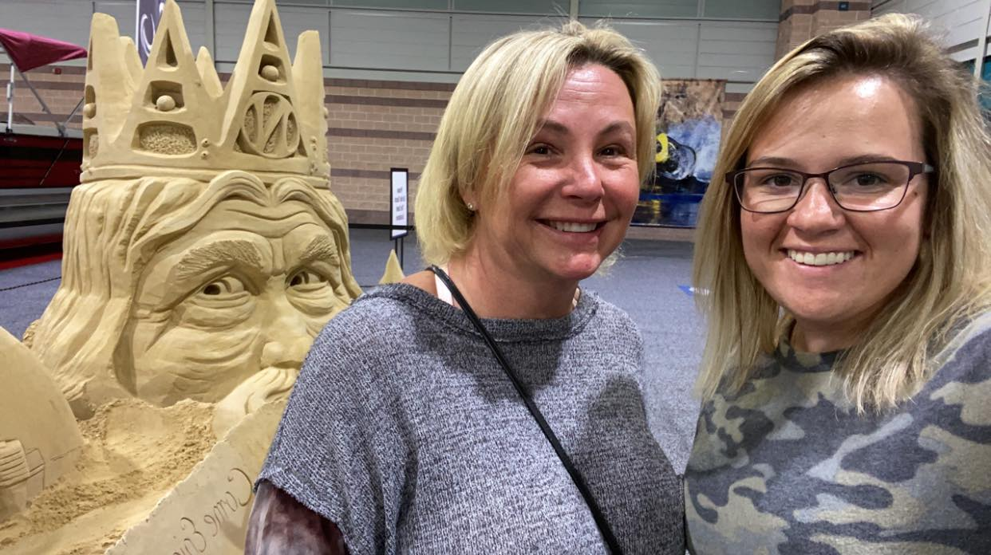 |  | Allison ONofrietti-cox  609-408-8372  onofriettia@yahoo.com
Highly organized and detail-oriented individual with a strong background in technical support and data management seeking a Police Records Support Technician position. Proficient in database management systems and skilled in providing technical assistance to law enforcement personnel. Dedicated to ensuring the accuracy and integrity of police records while adhering to strict confidentiality protocols. Eager to contribute to the efficiency and effectiveness of the police department's record-keeping processes." |  | EDUCATION  Richard Stockton University  August 2022 - Present  - Full time student, Dean's list 2022 with a current GPA of 4.0  Atlantic Cape Community college  August 2014-June 2021  -Overall GPA of 3.5  Lower Cape May Regional High School  September 2010- June 204  -Honor Roll  WORK EXPERIENCE  Cape May Police Department, Administration  May 2019-resent  -Perform data entry for criminal reports, arrest sheets, parking summons, D.U.I,  -Driver’s license and registration plate information, or traffic tickets.  -Positive room for advancement and growth.  Cape May Police Department, Special Law Enforcement Officer  May 2019- Present  -Authorized to perform routine traffic detail, spectator control and disorderly  persons.  -Issue summonses for disorderly persons and petty disorderly persons offenses  Jeanie’s Cleaning Service, Crew Leader  September 2008- Present  -Clean and maintain designated areas, including offices, hallways, restrooms, and common spaces.  -Empty trash bins and dispose of waste in an efficient and environmentally responsible manner.  -Perform deep-cleaning tasks on a rotating basis, including carpets, upholstery, and vents.  SKILLS  Goal Oriented Team Leader Problem Solver Attention to Detail  Dependable Willing to learn Critical Thinker Go Getter
References

Chief Dekon W Fashaw
Cape May Police Chief
609-780-5242
15 Years of friendship

Marcia Kelleher
Business owner
609-675-3391
28 Years of Friendship

Dorann Hemminway
Police Administration
609-425-2451
5 years of friendship

