NOAH HULLINGER

DOB:4.22.13

[Kimberlycloon@msn.com](mailto:Kimberlycloon@msn.com)

C:412.251.8798

Arthur Massei-Manager

C:929.260.0151

[Nyoffice@talentink.net](mailto:Nyoffice@talentink.net)

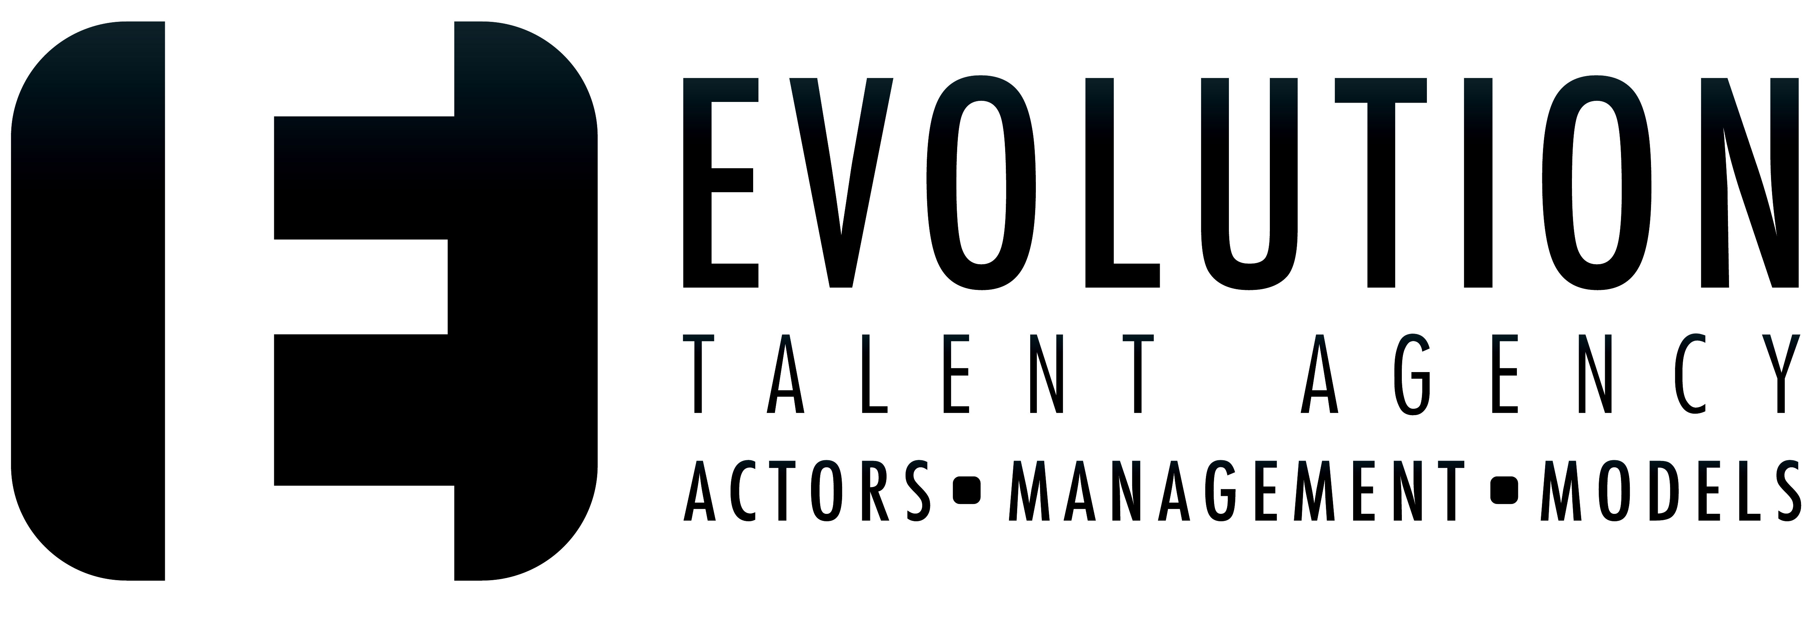

Avalon Artists Group- Youth division Evolution Talent Agency

Ted Maier C: 310.703.4490 Office:704.375.9797

[Ted@avalonartists.com](mailto:Ted@avalonartists.com) Shawn Carter [Shawn@evolutionmt.com](mailto:Shawn@evolutionmt.com)

___________________________________________________________________________

HEIGHT: 4’7” WEIGHT:70 Lbs. HAIR: Blonde EYES: Blue/Green

**FILM**

Rabbit Ears Lead- Owen Strawhouse Pictures

Monster Metaverse-The Dark Queen-IMDB Lead-Brad Butler Premiere Plus-WB Studios

Monster Metaverse- PT 2 TBD - IMDB Lead-Brad Butler Premiere Plus

Monster Metaverse- PT 3:

Vampires,Wearwolves,& Big Foot- Oh My! Lead- Brad Butler Premiere Plus

**COMMERCIALS**

Royale Tissues Featured Sick Kid Off Screen Romance

Food Lion Supporting Background Chirp Films

**THEATER**

Harry Potter Camp Harry Potter and Ron Acting Out Studio

Wednesday Camp Tyler Acting Out Studio

**TRAINING & WORKSHOPS**

Lisa London’s On Camera Camp Lisa London A Class Act- New York

Advanced Improv-Youth Improv Team Karla Dingle Acting Out Studio

British Accent Coach Sarah Valentine Actors Accent Coach

Advanced Talent Inc. Acting Class Remy Wallace Acting Out Studio

Audition Techniques Aleshia Price Acting Out Studio

Acting for the Camera Remy Wallace Acting Out Studio

TV Commercial Acting Kamber Hejlik Acting Out Studio

Film Acting Aleshia Price Acting Out Studio   
Improvisational Acting Kamber Hejlik Acting Out Studio   
Interview Skills Remy Wallace Acting Out Studio   
Photo Movement Kamber Hejlik Acting Out Studio   
Runway Kamber Hejlik Acting Out Studio

Breaking into the Biz Brett Zimmerman Los Angeles, CA

Acting for the Camera Craig Holzberg Avalon Artists Group of NY & LA

Acting & Musical Theater Self Tapes Joey Zangardi-Dixon New York Film Academy

7 Secrets of a Working Actor Bryce Russel The New York Conservatory

Perfecting the Self Tape Craig Holzberg Avalon Artists Group of NY & LA

Pre-Production Acting instruction Ali Flannagan Premiere Plus

Master Acting Workshop Michael Palance Premiere Plus- Los Angeles, CA

Celebrity Acting Workshop Michael Palance Premiere Plus-Los Angeles, CA

**SPECIAL SKILLS & INTERESTS** Soccer, Surfing, Improv, Football, Impressions, Comedic Physical Humor, loves Scary Movies and Corgi’s, Loves playing Jokes and Pranks on people, Drummer (beginner), Hard Rock Music