Category | Actress

Name | Karina Lashkova | Gender | Female | 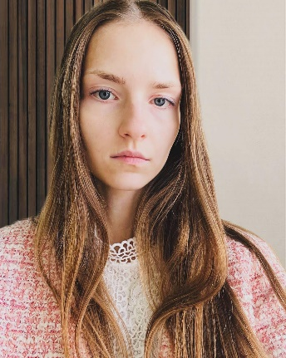
Date of birth | 13/06/1999 | Nationality | Belarus
Height | 174 | Weight | 48
Cellphone No. | +375447268856 | School / occupation | Secondary educational school with an aesthetic direction, State Regional Lyceum No. 3, Belarusian State University Institute of Business.
E-mail | carinalashkova@gmail.com
Address | Mogilev, Krupskaya lane, 11 sq. 8

Hobbies / Talents | I studied at an art school for 3 years. I like to take pictures and study painting. In my spare time, I like to read and travel, try to make things with my own hands. I do vocals, have basic knowledge of piano and guitar.
Activities & Awards | The winner of the fiction of the city region is the 3rd place. The 1st place in the cross-country running competition. Participation in commercial filming. The winner of university competitions in innovations and business planning.

