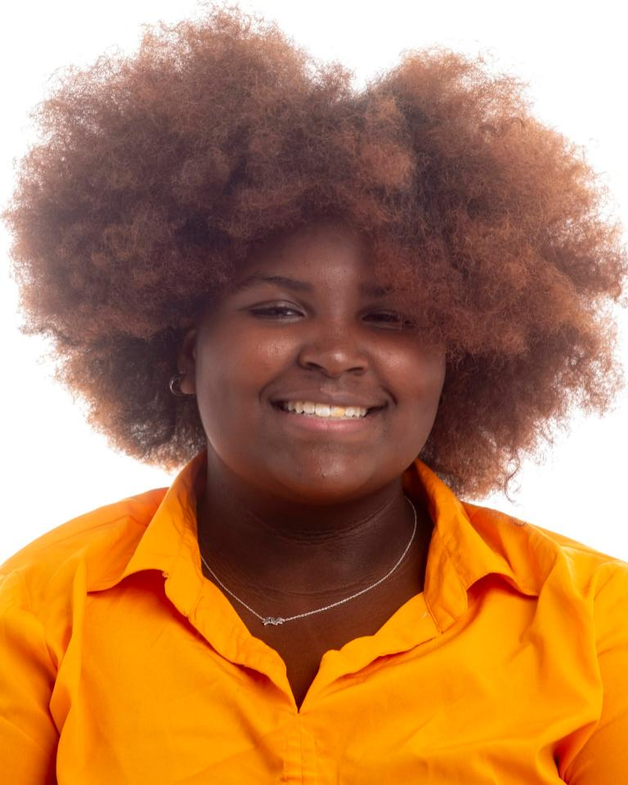

**Ja-Nira Rivera**

Height: 5’3” Hair: Black/faded red Eyes: black

Non-Union Email: Janirarivera26@gmail.com

**FILM**

The Dolla Party Desi/Lead Sherean Jones

**THEATRE**

Tuck everlasting The Man in The Yellow Suit Ridley Performing Arts Program

SpongeBob the Musical Ensemble Ridley Performing Arts Program

Lion King Jr Ensemble Ridley Performing Arts Program

**EDUCATION**

Virtual Film Academy 2024 WQED

Modeling & Photo Movement 2024 Barbion of Pa

Acting Class 2024 Barbion of Pa

Improv Class 2023 Weary Arts Group

Musical Theater Class 2023 Weary Arts Group

Auditioning Class 2023 Weary Arts Group

**SKILLS**

Improv, Singing, Leadership, Good with Kids, Crochet, Sewing, beginner flute level, filming, photography, social media, editing,