**Georgia Demmon CV**

14A Mornington Road,

Ashford, Middlesex,

TW15 1NW

Mobile: 07786 178138

Equity Membership Number: B00454395

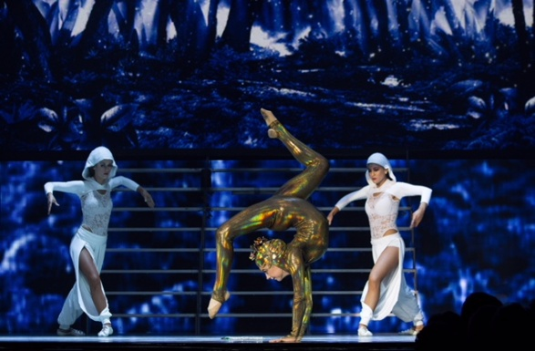

Basic Information

Height 5ft 4

Build Slim

Eyes Brown

Hair Brown

Nationality British

Personal Statement

I am an aerialist / contortionist.

I started doing gymnastics when I was four years old and started acrobatic gymnastics when I was 9. I won numerous competitions during this time. My greatest gymnastic experience was performing at the Closing Ceremony of the Olympic Games and this made me realise how much I love to perform.

I left competitive gymnastics in October 2014 to play the role of Little Spirit (Contortionist) in Michael Flatley’s Lord of the Dance at The London Palladium to cover for the current performer who was injured. I then did the same role for two shows a week at the Dominion Theatre in London (May 2015 – end of August 2015).

On **10 October 2015** this lead role was given to me full time with the London troupe. I did 8 shows a week at The London Playhouse and in total did 120 shows in this theatre.

From **6 Feb 2017** – **26 Feb 2017** I went back into the role of Little Spirit on tour performing in 5 venues during this three week period.

**June/July 2018** – performing as a contortionist / dancer at London Zoo Friday nights

**June 2018** – extra (contortionist / yoga person) new Holmes and Watson film starring Will Ferrell

**October 2018** – Handbalance - Burlesque’d – The Aeronaut

**November 2018** – Featured Acrobat – Film4 film - Saint Maud

**August 2019** – Contortion Photoshoot – SFG Club Shoreditch

**November 2019** – Extra (Visitor) Holby City - BBC – Guys and Dolls Agency

**October 2019** - Handbalance and Contortion Act – MNKY House London

**October 2019** - Handbalance and Contortion Act - Victorian Bath House London

**September 2020** – Extra (University Student) Inside Man – Twist & Shout – Guys and Dolls Agency

**October 2020** – Contortion and Handbalance Act - Cirque des Reves – Aeronaut Theatre

**November 2020** – Contortion and Handbalance Act – The Lamb Surbiton

**November 2020** – Extra (Cheerleader) - Stand Up Sketch Show – Spirit Media – Guys and Dolls Agency

**November 2020** – Extra (guest) – Starstruck – Avalon – Guys and Dolls Agency

**January 2021** – Stunt Witch – Discovering Witches – Biscuit/Sky Q – Catnap Agency

**March 2021** – Extra (yoga student) – Jerk 2 – Guys and Dolls Agency

**March 2021** – Extra (singing on night bus) – Vibes and Stuff – Guys and Dolls Agency

**April 2021 -** Contortion Act – Sexy Fish Restaurant video– Klodi Dabkiewicz

**May 2021 –** Contortion Act – Sexy Fish Restaurant opening night – Klodi Dabkiewicz

**September 2021 –** Extra (Café Customer/Party Goer – Eastenders – Guys and Dolls Agency

**September 2021** – Champagne Pouring Aerialist – Black Birdcage Agency

**October 2021 –** Bavarian Waitress – Electric Ballroom Brixton - Black Birdcage Agency

**October 2021 –** Extra – Waiting Staff – Suspect – Guys and Dolls Agency

**October 2021 –** Extra – Sexy Lady – Stand Up Sketch Show – Guys and Dolls Agency

**October 2021 –** Door Person – Chelsea Lodge – Black Birdcage Agency

**November 2021** – Extra – San Francisco plane passenger – Better Things – Guys and Dolls Agency

**November 2021 –** Extra – Café punter – Street Dogs – Casting Collective

**December 2021** – Contortion Act – Victoria from Cats the Musical at Westendmusicalbrunch

**December 2021** – Contortion Act – Private Party – Looking Glass – Shoreditch

**May 2022** – Contortion Duo Act – Indian Wedding – Tumbelina – Sofitel, Heathrow

**May 2022** – Contortion Duo Act – Corporate Event – Tumbelina – Westminster Plaza

**June 2022 –** Lollipop Hoop – Corporate Event – Black Birdcage Agency – Natural History Museum

**July 2022 –** Contortion – Brunch – Black Birdcage Agency – London

**July 2022 –** Lollipop Hoop – Private Party – Black Birdcage Agency – Ibiza

**October 2022** – Contortion – Halloween Party – Black Birdcage – Annabels London

**February 2023** – Contortion – Party Like Gatsby – Clapham Grand, London

**February 2023** – Contortion – Party Like Gatsby – O2 Ritz – Manchester

**February 2023** – Contortion – Party Like Gatsby – Usher Hall, Edinburgh

**May 2023 – July 2023** – Contortion - Special Act – Tui Hotel, Bodrum, Turkey

**October 2023** – Contortion -Cirque Des Reves – Soiree Parisienne – George IV – London

**October 2023** – Contortion – Halloween Party – Black Birdcage – Maison Estelle - London

Gymnastic Training

I trained at Heathrow Gymnastics Club for around 20+ hours a week up until October 2014 (when I left to take part in Lord of the Dance). This training as well as acrobatic training also incorporated ballet.

Circus Training

I started my circus training at Circus Suburbia in Surbiton doing contortion hoop and straps. I have completed a foundation course at Flying Fantastic and now train in aerial hoop, silks and contortion

Key Achievements

British Open Tournament 2010 Gold Medallist 11-16 (Women’s Group)

British Championships 2011 Gold Medallist 11-16 (Women’s Group)

British Championships 2012 Bronze Medallist 14-19 (Mixed Pair)

Performed with Spelbound - 2012 Olympic Games Closing Ceremony

Performed as Little Spirit in Michael Flatley’s Lord of the Dance

Links

<https://www.instagram.com/georgiad_contortion/>

<https://www.youtube.com/watch?v=Cx91kwsgj10>

<https://www.youtube.com/watch?v=4dm-FrnXX3g>

<http://www.thehollywoodnews.com/2017/02/16/lord-of-the-dance-dangerous-games-review/>

<https://www.youtube.com/watch?v=1NlwQ7DCO0w>

<https://www.youtube.com/watch?v=8ori9pgnhTs&t=28s>

<https://www.youtube.com/watch?v=NMH7sYB6Ufc&t=77s>

<https://youtu.be/q2uUWK4yfhM>