Sadiq Olive
  - Actor/Talent
 | 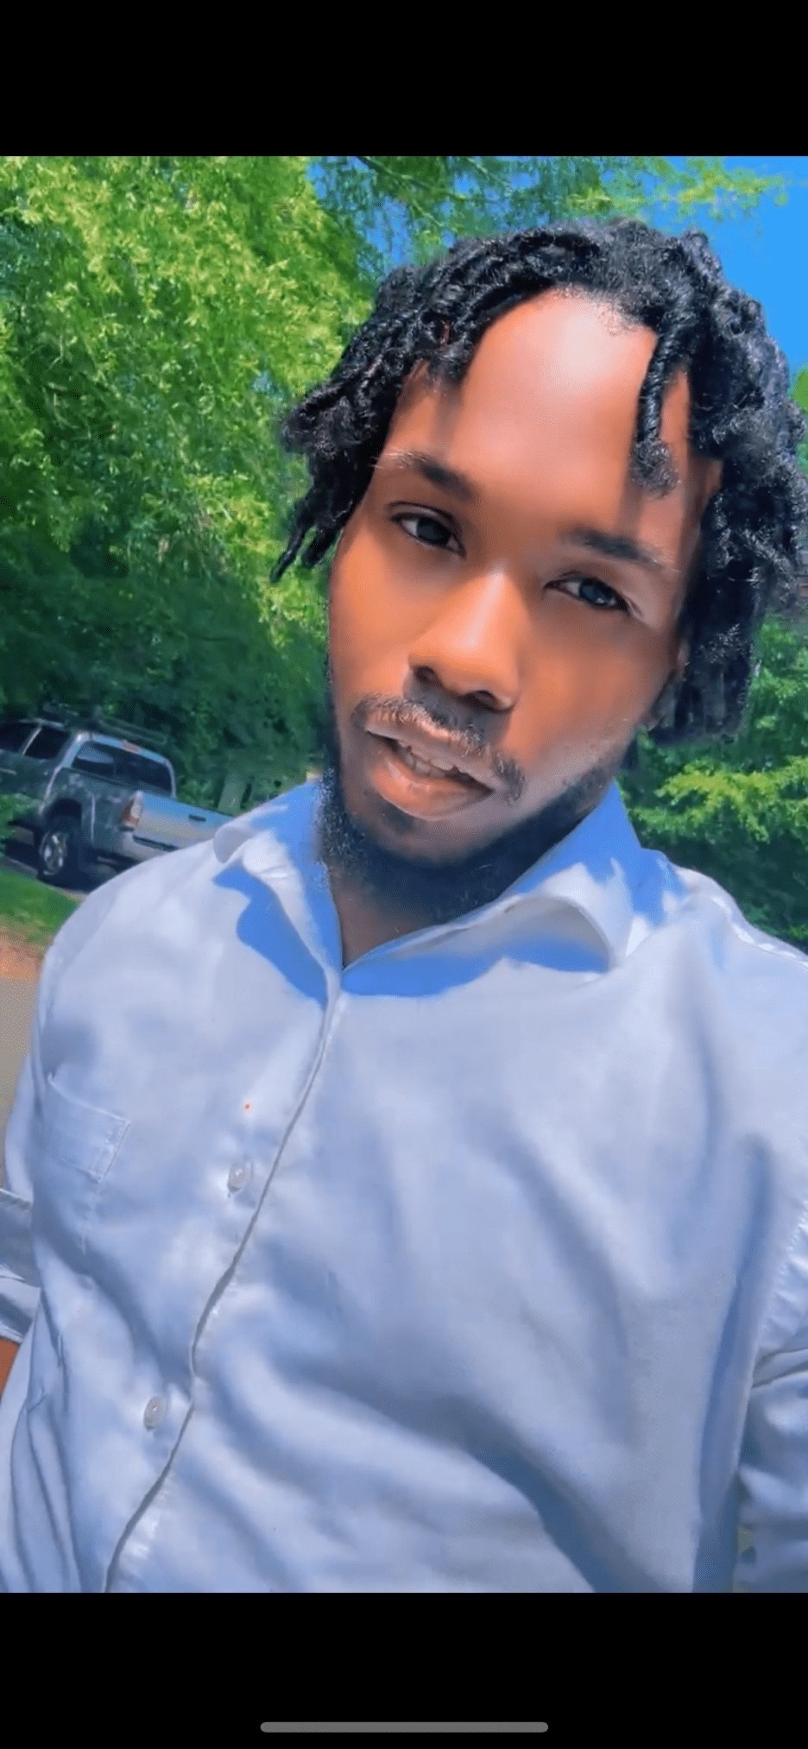 |  | Physical Description  - Race- Black/ African American/ Dominican  - Eye Color-Brown  - Hair Color- black  - Medium stout Build  - Shoe Size 9  - Accent- Nj Accent/ Professional Accent  - Language- Fluent English  - Hometown- Newark Nj  - Location- NC, ATL, ,ETC BUT I TRAVEL FOR LEAD ROLES  SKILLS  - Sports or action  - Musician(hip-hop/rap)  - Dramatic  - Charismatic  - Charm  - Action  - Stunts  - Comedy  - Improv  FILMS  - I MADE YOU- (KENDALL)- Barry Williams Films- - Tubi, Amazon  - P.O.M.E- Marquand Films-(BUG) BET+- 2025 Released  - The Summer I Turned Pretty Season 3 Extra work- released 2025

