De’onte Edwards  Model Resume |  |  |  |  |  |  | 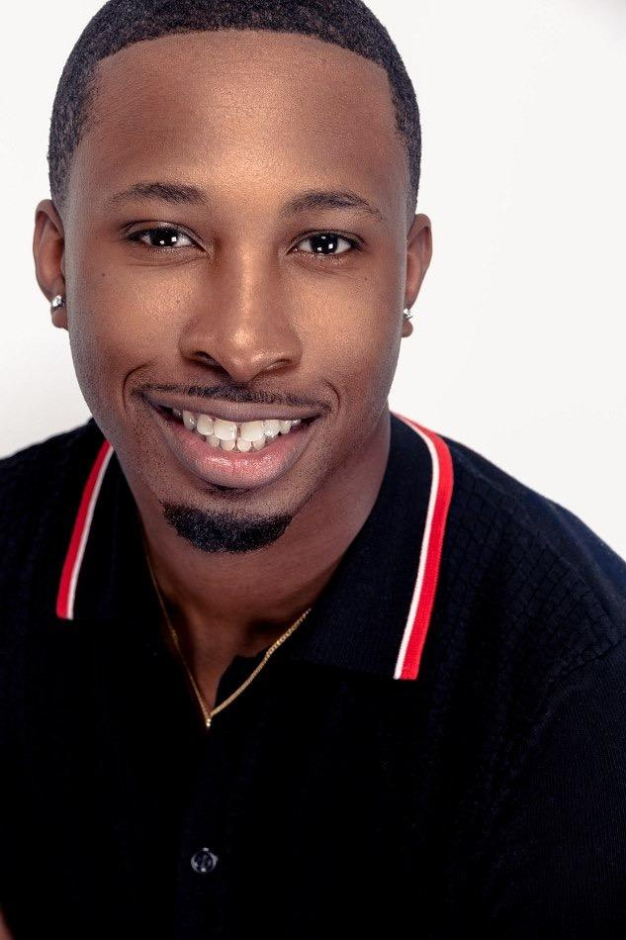
Contact Information
Phone
(334) 407-8600
Email  deonte24edwards@gmail.com |  |  | Website  deonteedwards.modelingfolio.com
Personal Statement |  |  |  |  |  |  |  |  |  | Bio
Professional model with 2 years of experience in fashion, commercial, and runway modeling. Worked on different types poses, runway walks, and taking direction from photographers and directors. I have the great fashion ability to deliver high-quality results for a variety of brands and designers. Seeking to bring my strong work ethic and unique style to a reputable modeling agency. |  |  |  |  |  |  |  |  |  | Eye color: Brown  Hair color: Black  Height: 6’1”  Weight: 179bs
Education
Trainings
Talent Inc USA— Orlando, FL
Courses: TV Commercial Acting, Improvisational Acting, Runway Techniques/ Photo Movements Workshop, Acting on Camera, Emotional Acting, Film Acting, Perfecting Self-Tape, Audition Techniques, Acting on Stage & Screen
Special Skills
 | - Fluent in English  - Excellent posing and runway skills  - Pianist |  |  | - Excellent time management  - Physically fit  - Team collaboration |  |  |  | - Strong interpersonal skills  - Able to take direction well  - Strong work ethic
Work Experience Television Experience
 |  | 2022–Present  Talent Inc Fashion Runway- Orlando, FL  Snips Designs Wild, Wild West— Selma, AL  Atlanta SAE Institute Fashion Week Runway- Atlanta, GA  Atlanta Sneakers Ball ATL Runway- Atlanta, GA |  |  | P Valley Season 3 - Background Actor - Atlanta, GA
2023- Present
Tribe Talent Management — Nashville, TN
 |  | 2021-2024  Freelance Model — Alabama, Tennessee, Georgia |  |  | Worked with 10+ independent photographers on creative fashion runway shoots; Used social media to showcase work, attract clients, and engage with followers

