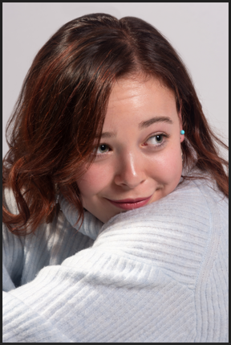

**Name**: Sophia Totaro  
**Date of Birth**: 19.07.2008  
**Location**: Rome, Italy  
**Contact Information**:

* Email: Sophiatotaro2008@gmail.com
* Phone WhatsApp: +44 7742 901126
* Phone: +39 351 7898683

**Education**

From the age of eleven, homeschool has been my primary source of education. Although studying at home can provide many much-needed distractions, it encouraged me to practice self-regulation, determination and the chance to practice dedicating myself to work. This form of learning also has gifted me with the flexibility I need to pursue my interests.

**GCSEs (Completed 2024):**

* Psychology: A
* Mathematics: A
* English: A*
* Biology: A
* Chemistry: A*
* Physics: A*
* Geography: B

**A Levels (Ongoing, 2025-2026):**

* Biology
* Chemistry
* Physics
* Maths -Mechanics
* Maths -Pure

**Amateur Production**

* *The Greatest Showman* as young Charity
* Although short the time spent on stage, I made the most of those few minutes, receiving an overall positive response from the audience.
* Consistency was necessary, especially when I had to sing and dance, a challenge I accepted and faced with enthusiasm.

**Local Theatre Production**

* *Aladdin and the Magic Lamp* as Scheherazade
  + The audiences relied upon my narration to determine the pace and tone of the following scenes, requiring confidence and a strong stage presence.
  + To prevent distraction from the ongoing scene, it was expected that I hold static and dynamic poses for extended periods, showcasing endurance and discipline.

**Training & Activities**

* **Theatre**: Participation in theatre productions provides experience, a chance to hone my skill and practice teamwork.
* **Aerial Hoop (5-6 months)**: Developing strength, flexibility, and poise were benefits of the sport, proving to be incredibly relevant to performance roles.
* **Volleyball (1 year)**: Enhanced coordination and teamwork were required skills to develop to play to the best of my abilities.

**Skills**

* Acting: Confident in delivering lines, maintaining stage presence, and collaborating with cast members.
* Physical Fitness: Experience in aerial hoop and volleyball demonstrates my agility and endurance.
* Academic Excellence: High achiever with a focus on precision and detail.

**Hobbies & Interests**

* Theatre and Performing Arts
* Language Learning
* Creative Writing and Storytelling

**References**

Ailleen Moir (Director of Aladdin and the Magic Lamp): [ailleenmoir@aol.com](mailto:ailleenmoir@aol.com)

Faith Thompson: [Faith.thompson@wolseyhalloxford.org.uk](mailto:Faith.thompson@wolseyhalloxford.org.uk)