Billie Palmer
19 years old. From Sydney. Female (and female presenting).

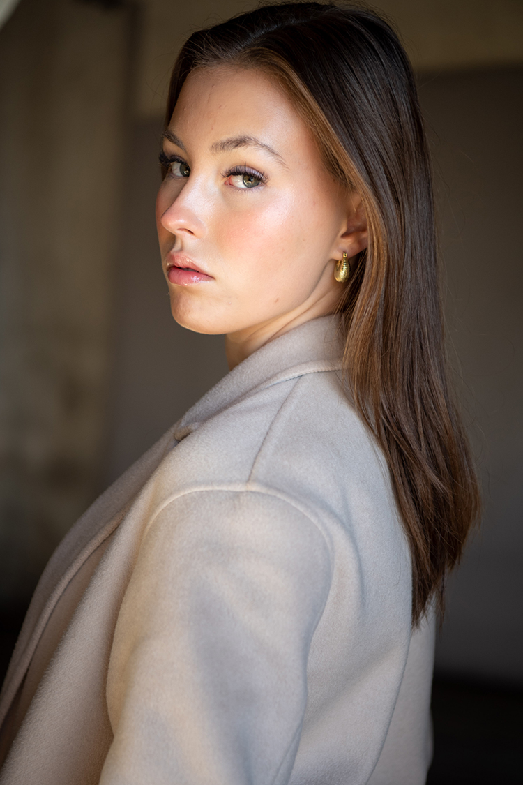
Profile  Hello! My name is Billie Palmer, and I am an 19-year-old girl from Lilyfield, Sydney. My love and passion for drama, film, acting and theatre has always been apparent in my bubbly personality and loud voice. Ever since the age of 3, I have been performing and finding my love for the performing arts throughout my life. Now as an adult, I have carefully tuned into my passion and turned it into a perfectly crafted art and hopefully a career. That’s where you come in! I hope you can join me in my journey of making my lifelong passion and talent become my forever passion as my career. But of course, no deal can be sealed unless I share what I can do for you…  So, what do I bring to the table?  A vivacious, hard-working, reliable and focused young adult who is positive in every aspect of her life, dedicated and full of love she wishes to share.  I can’t wait to work with you!  -Billie  Contact  PHONE:  0420 894 475  EMAIL:  billiekpalmer@outlook.com |  | EDUCATION  SCEGGS Darlinghurst  2014 - 2023  Received my high school diploma at SCEGGS, gaining a top ATAR receiving distinctions and high distinctions in every subject. I also received my Diploma of Communications whilst at school. I was awarded many awards during school but specifically drama awards  University of Sydney  2024 - Present  I am currently completing my Bachelor of Arts with a major in Theatre and Staging Performance and a minor in Film Studies.  WORK EXPERIENCE  Award-winning Short Film Riceballs  2016  https://www.imdb.com/title/tt4871370/?ref_=nm_flmg_t_1_act – link to IMDB page  Directed and written by Shingo Usami. I played the family friend in this short film. It won 9 awards globally.  Pretty Strange musical  June 2022–October 2022  I played a lead role in this original musical, written by Olivia Satchell, called Pretty Strange.  Appleton Ladies Potato Race musical  January 2023-June 2023  I played the lead character, Penny Anderson, in this Australian play.  DEVILS INTERVAL – short film  2024  I played the lead role “Brown hair girl” in this Melbourne short film produced by the new producing studio, ‘Lemon studios’. IMBD credits are coming soon.  PARENTS FOR CLIMATE ‘Later is to late’ – campaign/commercial  2024  Filmed in Dec 2024 in Stanmore, Sydney and will be dropped in January 2025.  I played the Year 12 high school leaver who is getting ready for their last day of school and has an emotional goodbye with mum and then walks to school.  https://www.youtube.com/watch?v=RS0zg5VZ1QY  SKills, qualifications and awards  Skills: Dance (beginner level), Acrobats (intermediate level), impressions & voiceover – like Elmo, Miss Piggy, Kermit as well as other voices I make up myself (intermediate level). Bike riding, Pilates, dancing in heels, softball, AFL, basic French speaking.  Qualifications: NIDA Acting Techniques Adult Course, Diploma in Communications, NIDA Acting on Screen grades 7-10.  Awards: POCKETS in Drama (prestigious prize for excellency, talent and hard-work from SCEGGS Darlinghurst),

