Joseph C. LaPietra
Resume

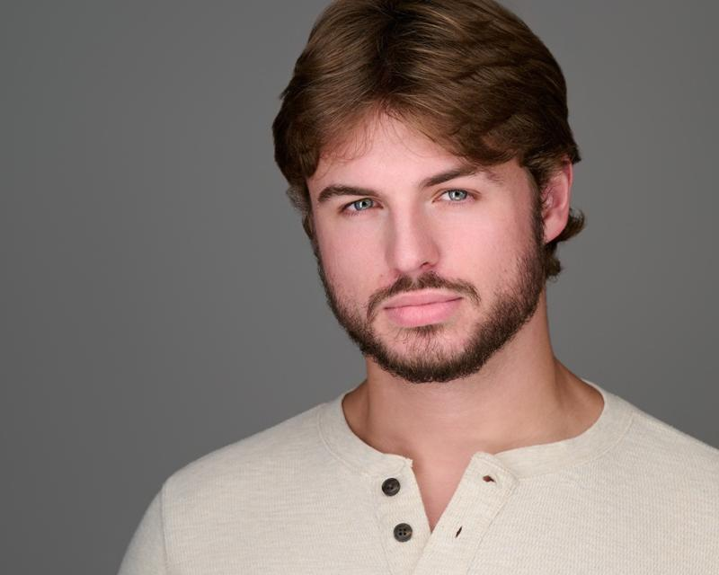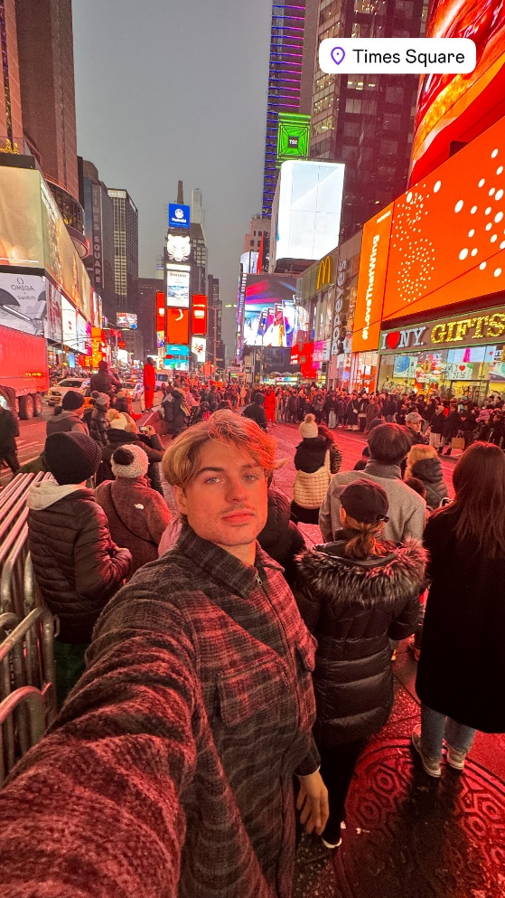
Contact Information:
Miami, Florida
Email: lapietrajoey@gmail.com
Phone: (301) 318-2209 (Preferred)
Height: 6'1"
Weight: 175 lbs.
Hair: Long Dirty Blonde
Eyes: Blue
Build: Athletic
Professional Summary:
Highly versatile actor with a striking on-screen presence and an athletic build that enhances a wide range of character portrayals. Standing 6’1” with long blonde hair and captivating blue eyes, I bring a dynamic look perfect for roles requiring charisma, strength, and approachability. In addition to acting, I model professionally, which has sharpened my understanding of visual storytelling and physical expression. My athletic background ensures I am physically capable for demanding roles, including action and movement-intensive scenes. With a professional, dependable work ethic, I bring dedication, adaptability, and enthusiasm to every project, striving to contribute creatively and collaboratively to productions of all kinds.

Objective
Dynamic novice actor with a background in creative writing and improvisation, actively seeking roles that challenge and utilize my skills in acting and film craft. Dedicated to continual professional development at the New York Film Academy.

Education
New York Film Academy
Master of Fine Arts in Acting for Film
Courses Include: Scene Study, Voice and Movement, Filmcraft
Florida State University
Bachelor of Arts in Creative Writing, 2022
Including courses in Improvisation

Acting Experience
Dexter Original Sin
Featured Bartender
Page 1
Joseph C. Lapietra
Student Films at NYFA
Roles in various short films, encompassing dramatic and comedic performances.

Skills
- Scene Study and Character Development
- Voice and Movement Techniques
- Film Editing and Camera Work
- Fluent in English; proficient in Spanish

References
Available upon request
Page 2

