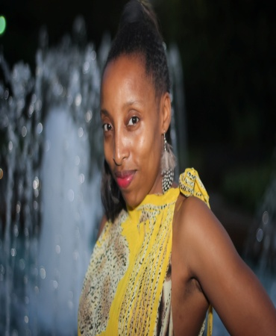

Alicia Robinson

470-235-9192 Height 5’0”

[Rlesh9701@gmail.com](mailto:Rlesh9701@gmail.com) Weight 105 lbs

[Arob_2301@yahoo.com](mailto:Arob_2301@yahoo.com) Eye Color: Brown

**Theater Course**

Intro to Theater Community College of RI Warwick, RI ‘2001

**Film/TV**

Movie Extra The Blindside-Feature Film Atlanta, GA 2009

Movie Extra Universal –Television Pilot Sweet28 Atlanta, GA ‘2010

Movie Extra The Child Care Network Atlanta, GA ‘2011

Audition The Barbra Shop Dunwoody, GA ‘2016

Audition Fashion Show-Town Center Mall Kennesaw, GA ‘2018

**Education/Training**

University of RI Undecided Kingston, RI ‘97-‘97

Community College of RI Liberal Arts Prov., RI 02901 ‘97-‘98

Rhode Island College Communications/Writing Prov., RI 02908 ’98-‘01

