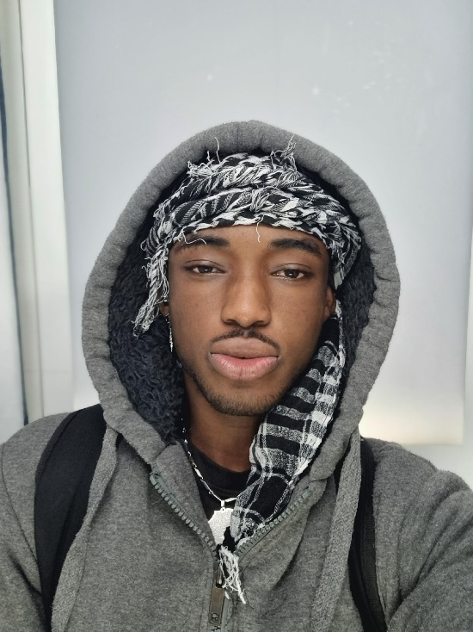**Curriculum Vitae**

**Personal Information**

**Name**:

Myron Afriyie Benxton

**Address**:

Scheideholzhang 5d, 21149 Hamburg, Germany

**Phone**:

+49 40 608 50097

**E-Mail:**

[myronafriyiebenxton@gmail.com](mailto:myronafriyiebenxton@gmail.com)

**Education**

2014 – 2018: Schnuckendrift Primary School, Hamburg, Germany

2018 – 2020: Süderelbe Gymnasium, Hamburg, Germany

2020 – Present: Fischbek Falkenberg Comprehensive School, Hamburg, Germany

**Professional Experience**

2023 – Present: Tutor and Educational Support

* Employed on a contract basis as a tutor at the school.
* Provide paid tutoring to students of various age groups, focusing on subjects where they need extra help.
* Work alongside a teacher to support students struggling with the curriculum due to significant skill gaps.
* Assist in educational and pedagogical tasks to help students catch up academically.
* 2023 – Present: Restaurant Employee
* Part-time position as a waiter in a large restaurant.
* Responsible for customer service, teamwork, and maintaining a professional demeanor in a fast-paced environment.

**Modeling Experience**

Participated in several modeling assignments for local campaigns and small fashion projects.

Passionate about fashion and style since childhood, constantly improving knowledge in aesthetics and design.

**Interests, Hobbies, and Skills**

**Sports Skills:** Fitness, gym, football, and versatile athletic abilities.

**Creativity**: Drawing and crocheting – particularly designing and creating unique clothing items with high standards.

**Social Skills:** Excellent interpersonal skills, emotional intelligence, strong communication, and adaptability.

**Languages**: German (native), English (fluent), Twi (Akan), Spanish (currently learning).

**Special Talents and Goals**

**Acting and Modeling:** Passion for creative expression, with a strong presence both in front of the camera and on the runway.

**Personal Attributes:** Ambitious, creative, eager to learn, highly motivated, and open-minded.

**Personal Information for Modeling Applications**

Age: 17 years

Height: 1.77 m

Weight: 70–74 kg (depending on training level).

Myron Afriyie Benxton