### 

### **Printer Repair in Dubai U.A.E by ZD Computer Trading 2024**

ZhongDong Computer Trading is a leading provider of premium printer repair, maintenance, and rental services across Dubai, Abu Dhabi, Sharjah, and the U.A.E. Our expertise spans all major brands, including HP, Canon, Epson, Xerox, Konica, and Brother. From resolving simple paper jams to tackling complex hardware issues, we ensure fast and reliable solutions customized to your needs. Additionally, our proactive maintenance services help extend the lifespan and efficiency of your printers. Trust ZD Computer Trading for seamless, high-quality **printer repair in Dubai** services.

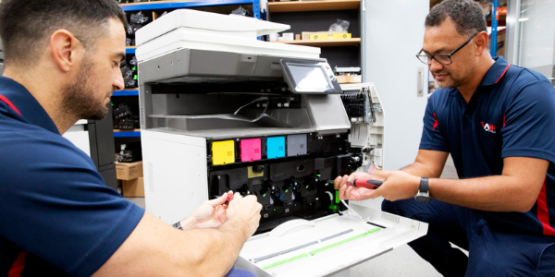

### **Company Information**

**Website**: [zdcomputertrading.com](https://zdcomputertrading.com/)

**Email**: info@zdcomputertrading.com

**Backlink Email**: zdcomputertrading2@gmail.com

**Backlink Password**: Vision@345#

**Dubai Postal Code**: 25314

**Phone**: 056-9484845 / +971 4 453 4476

**Address**: ONE BY OMNIYAT, 18TH FLOOR, OFFICE NUMBER 31, BUSINESS BAY STREET, BUSINESS BAY, DUBAI, UAE

### **Social Media Links**

**Facebook**: [ZhongDong Computer Trading LLC](https://www.facebook.com/profile.php?id=61555185514824&mibextid=LQQJ4d)

**Instagram**: [@zhongdongcomputertradingllc](https://www.instagram.com/zhongdongcomputertradingllc?igsh=dzlrM3ZzYmpvaWF5&utm_source=qr)