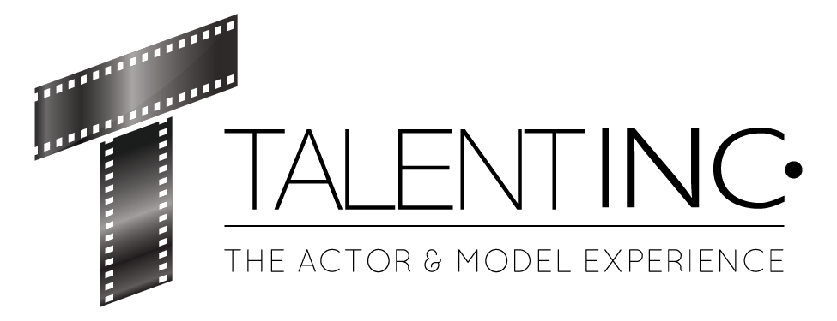

Chardonnay Stone

Julia Lang

Julia@Talent-INC.com

______­­­­­­­­­­­­­_________________________________________________________________

HEIGHT: 5’5’’ WEIGHT: 140lb HAIR: Brown EYES: Brown

TRAINING

Acting for the Camera Craig Holzberg Avalon Artists Group of NY & LA

Auditioning “In the Room Where it Happens” Joey Zangardi-Dixon New York Film Academy

7 Secrets of a Working Actor Tom Blushi & Bryce Russell The New York Conservatory

Making It On Broadway Neka Zang AMDA of New York & LA

Audition Techniques Scott Cooper Orlando, FL

Acting for the Camera Dillon Mann Orlando, FL

TV Commercial Acting Devin Michael Orlando, FL

Film Acting Dillon Mann Orlando, FL   
Improvisational Acting Dillon Mann Orlando, FL  
Interview Skills Dawn Rickus Orlando, FL  
Photo Movement Devin Michael Orlando, FL  
Runway Devin Michael Orlando, FL

Line Memorization & Inflection Lauren Hudson Zoom

Formatting Entertainment Resume Omar Padilla Zoom

Voice Acting (2) Omar Padilla Zoom

Landing Commercial Auditions Shawn McLaughlin Zoom

Acting Archetypes Omar Padilla Zoom

SPECIAL SKILLS & INTERESTS

Ability to sing Opera. Floral arrangements. Voiceover. Animation. Modeling. Organizational skills. Multitasking skills.