  - 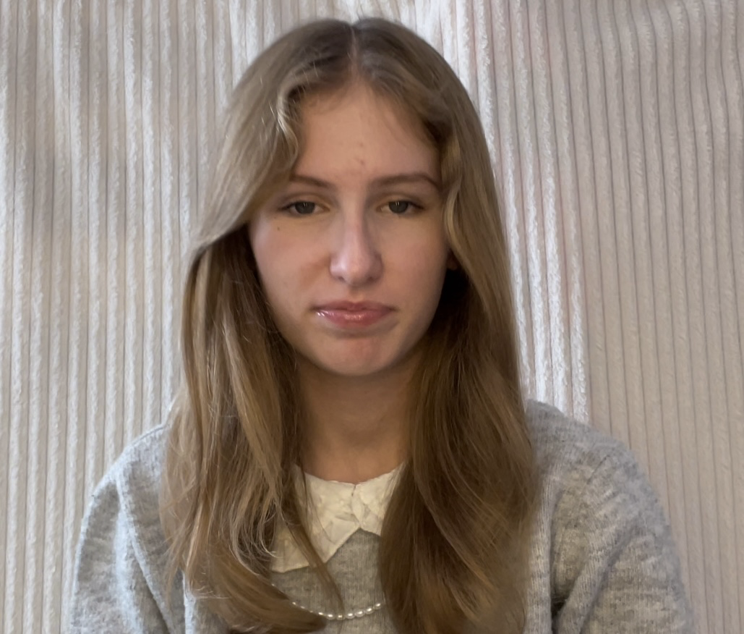
 |  | Carys stannard
- Contact  +44 07368243459  Instagram- carys_stannard  Facebook- Carys stannard  carysstannard5@gmail.com  - Education  High school  Yr9-13yrs old  Sir John leman high school  -Beccles England  - Skills  - I am great with my social skills and I will Communicate with anybody I am put and I will be work with them without no trouble.  - I’m good at sports and I am very athletic  - Great at improvising anything and writing scripts for any subject  - I will always be on time for things and won’t be late to anything |  | Experience  Dance  I had done shows  I learnt frantic assembly , giving types of emotions in speeches and using different posture positions to show the physical emotions.  DRAMA  In drama I’ve learnt how to create different tableaux’s professionally to create different story’s . Also chair duets to create different levels of scenes that provide clearly what the story’s about.  MUSIC  I have learnt to perfect my pitch in singing . I also know how to play the piano(I know how to do a couple songs in chord and normal notes.  OBJECTIVE  My objective is , to be able to be hired by someone that is willingly be able to let me work with them and doesn’t judge me or other people for who they are!

