 | Patrice Matthes  - 843.535.3975  - Whispermatthes@gmail.com  South Carolina  Instagram.com/Whispermatthes2 |  |  |  |  | Eyes: Blue  Hair: Brown/gray  Height: 5’6”  Weight: 175 lbs. | 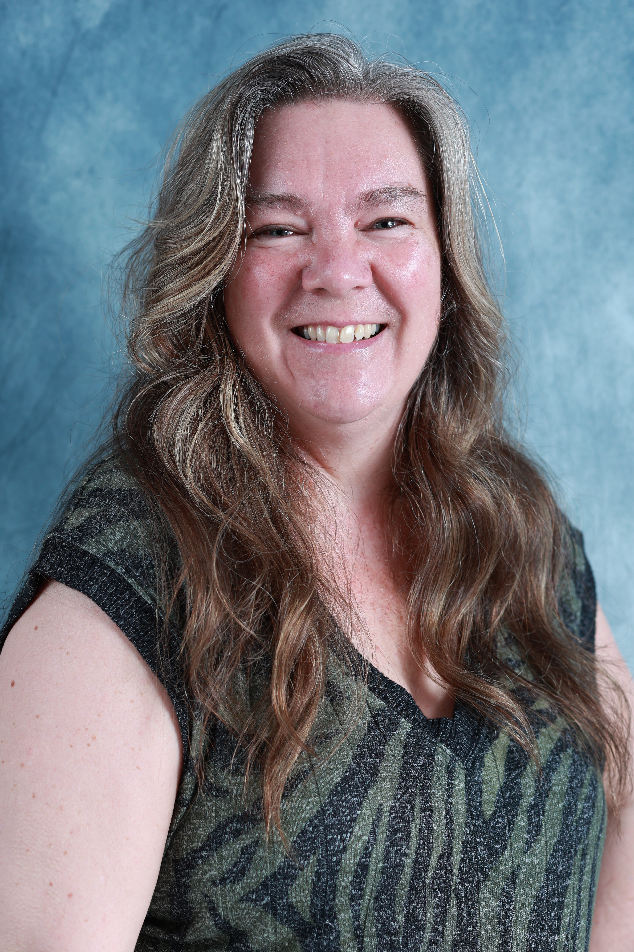
 | credits  ROLES  - Mother delivers baby in the ruble  - Wife crossing the line |  |  |  | THEATER  THE DAY AMERICA DIALED 911  BY JOHN AKERS  Collbran school auditorium
 | Training and education | Steve Lesser |  |  | STAND UP COMEDY  Six-week course with instruction and graduation performance in a Comedy Club
 |  | Matthew Lunsford |  |  | Lets IMPROV  Improvisation workshop at the ARTS international showcase Orlando FL Summer 2024
 |  | Chad Broskey |  |  | Self taping  Owner of Heyman Talent agency, ARTS International Orlando FL Summer 2024
 |  | Leesa Williams |  |  | Working with your Voice  Exploring next steps for a career as a voice actor. ARTS International Showcase Orlando FL Summer 2024
 | Skills & Abilities |  | - Stand-up Comedian  - Gun handling; including revolvers, pistols, shotguns, automatic rifles and hunting rifles.  - Western horseback riding, line dancing, bike riding, roller skating, swimming, cooking.
 | ACCENTS |  |  |  | Western American, Southeast Southern, New England/New Jersey

