 | Mone't Greenlee
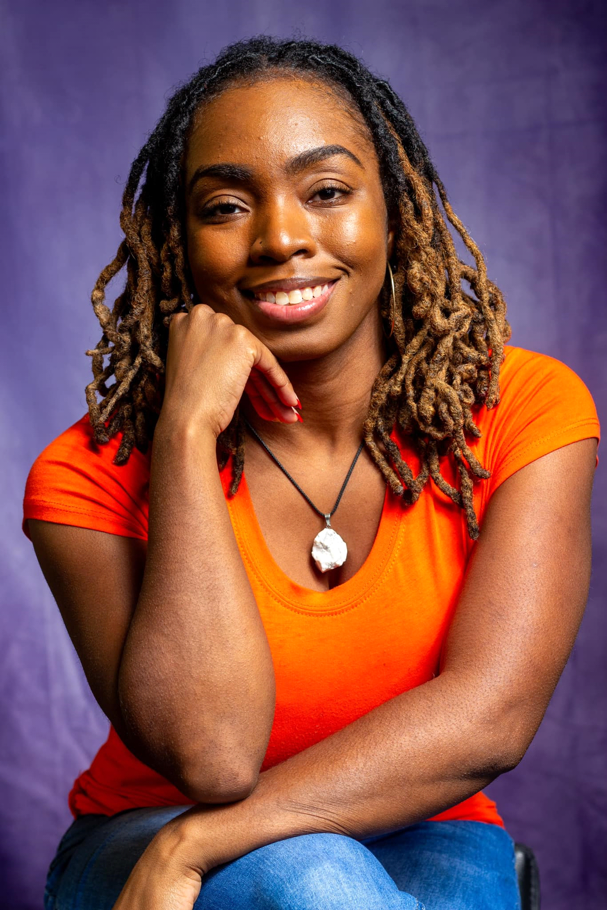 | Contact  Phone: (313)696-6054  Email Address: Monetg_2012@yahoo.com  Height: 5’0"  Weight: 130 lbs.  Eye Color: Dark Brown  Hair color: Off Black  Voice: Soprano and Alto

Education
Pershing High School
Class Of 2012

Adlai E. Stevenson High School
2010 – 2011 School Year

Macomb Community College

Training
- MBS Training Center of Performing Arts | Artistic Director: Beverly Stone
- 3D Dance Divas and Divos | Instructor: Sharon Freed-
- Teen H.Y.P.E. (Helping youth by providing education)|Non-profit organization program for teens | Co-Founders: Franky Hudson & Ambra Redrick

Film/Tv
- The Radical 187 | Directors: Carlos Clark, Eddie Johnson and William Dunham
Role: Officer Tina
- Eastside Story:The Musical | AngelTouch Productions | Director: Keith Rice
Role: Julez
- Who Ya Wit | DR2 Productions | Director: Cheri Amor
Role: Woman 1
- Connected Through Blood | Makeiva Albritten Film | Director: Kamal Smith
Role: Riley
- Birth Of A Savage | Coatail Entertainment LLC & Reel Riches Entertainment | Director: Jezar Riches
Role: Street Fighter
- What Lies Within | Thomas Pawlowski production | Director: Thomas Pawlowski & Assistant Director: Jhaylaa Mosley
Role: Therapist

- Black Trojan | Jacote Films & Kreddible Kross | Director: Kross James Coats
Role: Michelle

- Roxy | A Katon Global Media Group LLC. | Director: Anton Mitchell & Archie L. Johnson III
Role: Angela Hilman

- Bishop Bling | 180th StreetFilmz production | Director: Iesha Brown
Role: Bestie

- Ghetto Angel(Tv series) \ SDM Film Production | Director: Motana Barrett (Autor of this novel) role: Brittanny

- Twerk: The Movie |Director: Adon (ID) Dewayne | Dance choreographer: Rita Mosley
Role: Tina
Background Acting Experience
- Through The Eyes Of a Hairdresser | Another Jade Production | Director: Jejuan Hatcher
Role: Hair Client

- Street Code broken 2 | Black – Smith Enterprise | Director: Kamal Smith
Role: Prison Visitor

- Justice | DR2 Productions | Director: Dennis Reed
Role: Police Officer

- Make it Out | Plush Production | Director: Buck
Role: Basketball crowd member

- The Heathen: The Movie| Rockin D. Visions | Director: Robin Adaeze
Role: Restaurant & Jazz Club Patron

- P–Vally Season 3 (Tv series) | STARZ Family Productions
Role: High Roller Casino Patron
Theatre
- Charlie Brown: Stage play | Adlai E. Stevenson High School Theatre Club
Role: Olivia
- Journey to The Wiz: A Detroit Musical stage play | Casoe Youth Theater Group | Directors: Janice Smith and Pamela Russell
Role: Choreographed “Motown” scene -25+ people & Danced in “Storm, Motown, Emerald City, and New Day”

- The Whiz: Road to Recovery The Musical | PR Productions | Director: Pamela Russell
Role: Crow #1 & Wicked Witch of the Westside Helper #1
Credit: Danced & Choreographed: “The Storm, Scarecrow, and Emerald City” Scenes

- Stiletto Monologues strut 2, Stiletto Monologues strut 2 reboot & Carnage: When Love Splatters | A Stiletto Boss Production | Director: Renee Ingram - Dunham
Roles: Actress & Dancer in Different Skits

- One Harlem Night: Jazz Musical Thriller Stage Play | Sherry Henderson Entertainment | Director: Sherry Henderson
Roles: Red (Understudy) & Background actor

- Salt City: A Techno Choreopoem | Jessica Care Moore LLC | Directors and Choreographers: Aku Kadogo & Marlies Year
Role: Chorus - The minds and 909 tribe
Special skills
- Dancer
- Dance Choreographer
- Actress
- Singer
- Model
- Stepper
- Cheerleader

