Maya Vargas

Mature bilingual (fluent in Spanish) and reliable high school sophomore with experience looking for job opportunities.

C: +1(562)280-4515, [mayavargitas@gmail.com](mailto:mayavargitas@gmail.com) Long Beach, CA 90814  
  
Work Experience:  
  
**C2C Logistics LLC (Gardena)**

**Warehousing, transshipment and transportation 3PL by Port of Long Beach focused on renewables, e-commerce and electronics order fulfillment.**

**Role: Customer Service Associate (full time, summer of 2023, Jun-Aug)**

- Serviced key customer inquiries and process customer orders for up to 15 containers daily of product outbound from warehouse and 10 containers daily of product inbound from Port of Long Beach. Total 25 orders/day to be coordinated with warehouse manager and 53' truck dispatching/pick up operations.

- Process inbound, outbound transactions in Warehouse Management System (3PL Central Extensiv) which reports EDI directly into USA and China offices of customer for available to promise inventory. Customer handles up to USD 25 million in inventory of solar panels and renewables accessories.

- Study and process customer insurance claims for up to USD 100,000 per container, communicating with trucking suppliers and coordinating back to back contract fulfillment for value resolution facing customer's claims to be paid in full. Coordination with police, insurance company, trucking supplier and customer representatives.

- Generate service invoicing and monthly invoice reporting for clients with values of up to USD 600,000/monthly for key customers. Process invoices in Quickbooks

- Led project for new CRM implementation through a cloud system, implemented sales pipeline for sales budget monitoring and trained sales team.  
  
Education:  
  
**Wilson High School, CA; expected in 27**’  
- Freshman GPA of 3.83  
- Took AP Human Geography freshman year  
- Varsity Gymnastics 23-24’

- Frosh Girls Volleyball 24-25’  
**Rogers Middle School, CA; graduated 23’**  
- Total GPA of 4.00  
- Principals’ Honor Roll  
- Member of California Junior Scholarship Federation (CJSF)

- Member of WEB (Where Everybody Belongs) as 8th graders welcoming, giving tours, and having activities for incoming 6th graders.

Professional andVolunteering Experience:

**Soup Kitchen by the Carmelites of the Most Pure Hart of Mary, Lima Peru (1 full week in January 2024)**

- Fed the less fortunate, cooking 120-130 meals per day. The Soup Kitchen provides up to 30,000 meals/year

- Assisted in purchasing ingredients daily for a week, to prepare meals, at farmers market, negotiating price and quantities and checking on product quality

- Gained experience in menu planning, adapting recipes, and successfull preparation of mutiple dishes, balancing carbohidrates, protein and vegetables

- Assisted kitchen manager with day to day tasks including food serving and portion quantity control, ensuring cleanliness, healthiness and quality.

**Little paws care shelter (1 full week in January 2024)**

- Took care (cleaning, bathing and feeding) of 19 dogs at the little paws care shelter. All dogs/puppies are rescued from the streets of the low income neighborhoods in Lima, Peru.

- Keep aggresive dogs segretated in their cages/rooms and take care of wounds for hurt dogs coming to the shelter

- Led the twice a week excursion to feed and rescue street dogs at the north city slums of Lima. Rescued two puppies and fed about 35 dogs per excursion with full blown meals. Identified and marked dogs that require veterinarian assistance for next excursion to be checked by vet.  
  
**St. Bartholomew Service Projects (confirmation)**

**-** Worked a four hour shift at Habitat for Humanity ReStore in Bellflower, CA (December 10th, 2023); sort and price donated items, restock shelves, maintain clean floor inventory, provide customer service.  
- Multiple beach clean ups at Belmont Shore.  
- Worked shifts, cooked, and prepared food for St. Bartholomew’s Thanksgiving dinner.

**Girl Scouts (4 years)**  
- Learned skills such as goal setting, decision making, money management, people skills, and business ethics when participating in the fall sale program and Girl Scout Cookie program for multiple years.

- Girl Scout Bronze Award: Highest honor given to Girl Scout Juniors (4-5th grade) earned by going on a “Girl Scout Journey” in order to make your community a better place. Not only earning the award but also project management skills, problem solving, communication, team management, as well as growing a passion for helping your community.  
- Learned many survival skills such as tying knots, cooking with fire, and camping at Girl Scout camps.

**La Quinceañera Model and Sales Associate (November 23’ - Present)**- Learn how to promote a business and how to sell what you are modeling, as well as being able to represent a company professionally. Worked from 11-7 on certain weekends and helped try on dresses on upcoming quinceañeras.  
- Participate in yearly pageants where you use skills such as public speaking and creativity when creating fantasy outfit.  
- Work with other companies such as photographers, dance, makeup, etc.  
  
  


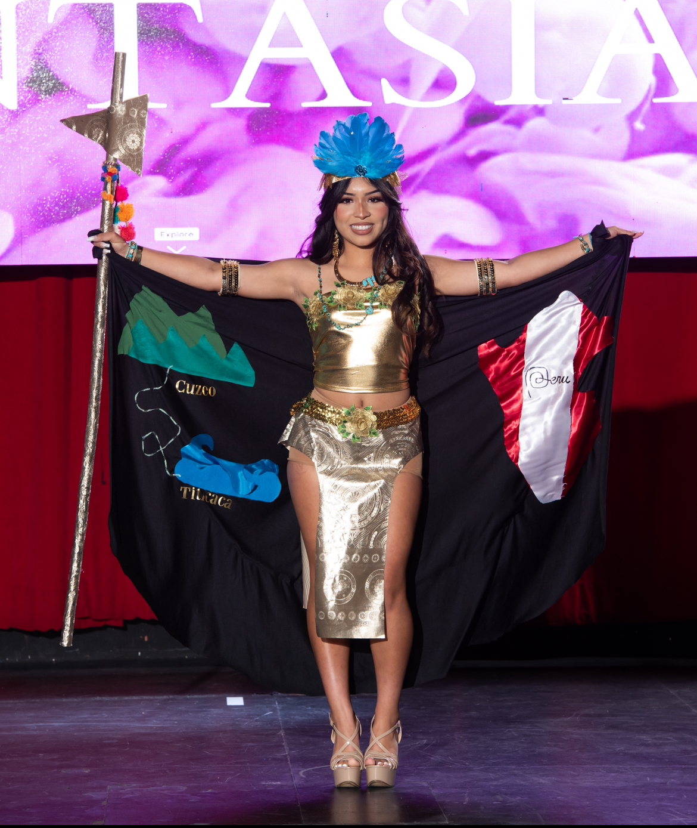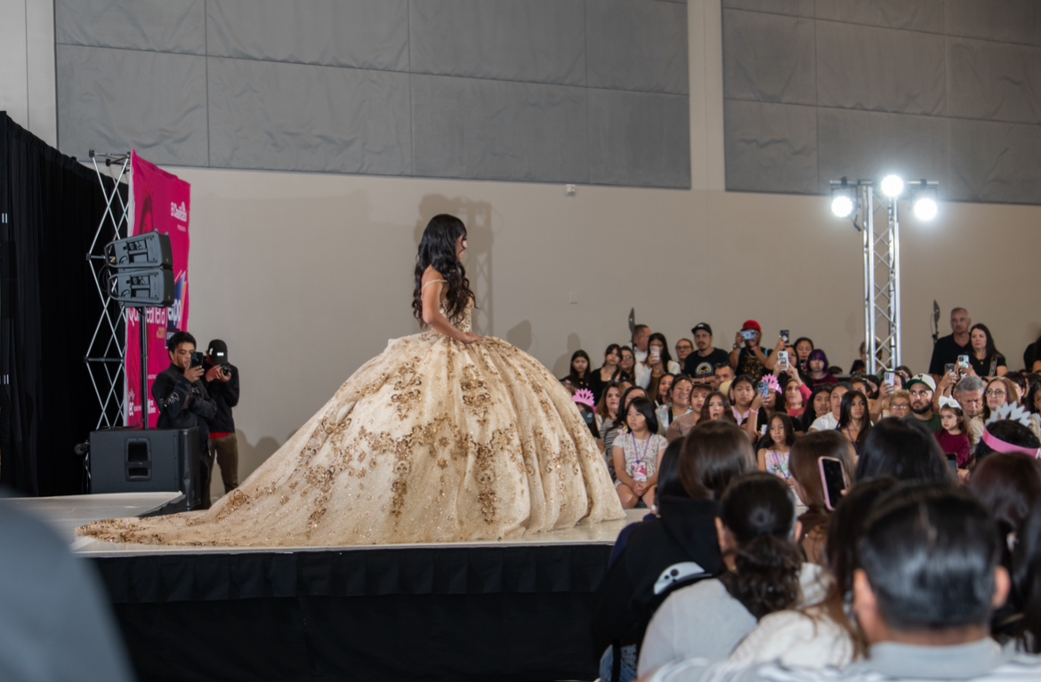

References:

Reyna Garcia, Customer Service Supervisor, C2C Logistics: reynag@c2clogisticscorp.com, +14245650009

Jose Isarraras, Chief Operations Officer, josei@c2clogisticscorp.com, +1 (213) 880-8423

Pedro Berruete, Co-founder of La Quinceañera, Instagram: @la_quinceanera_info