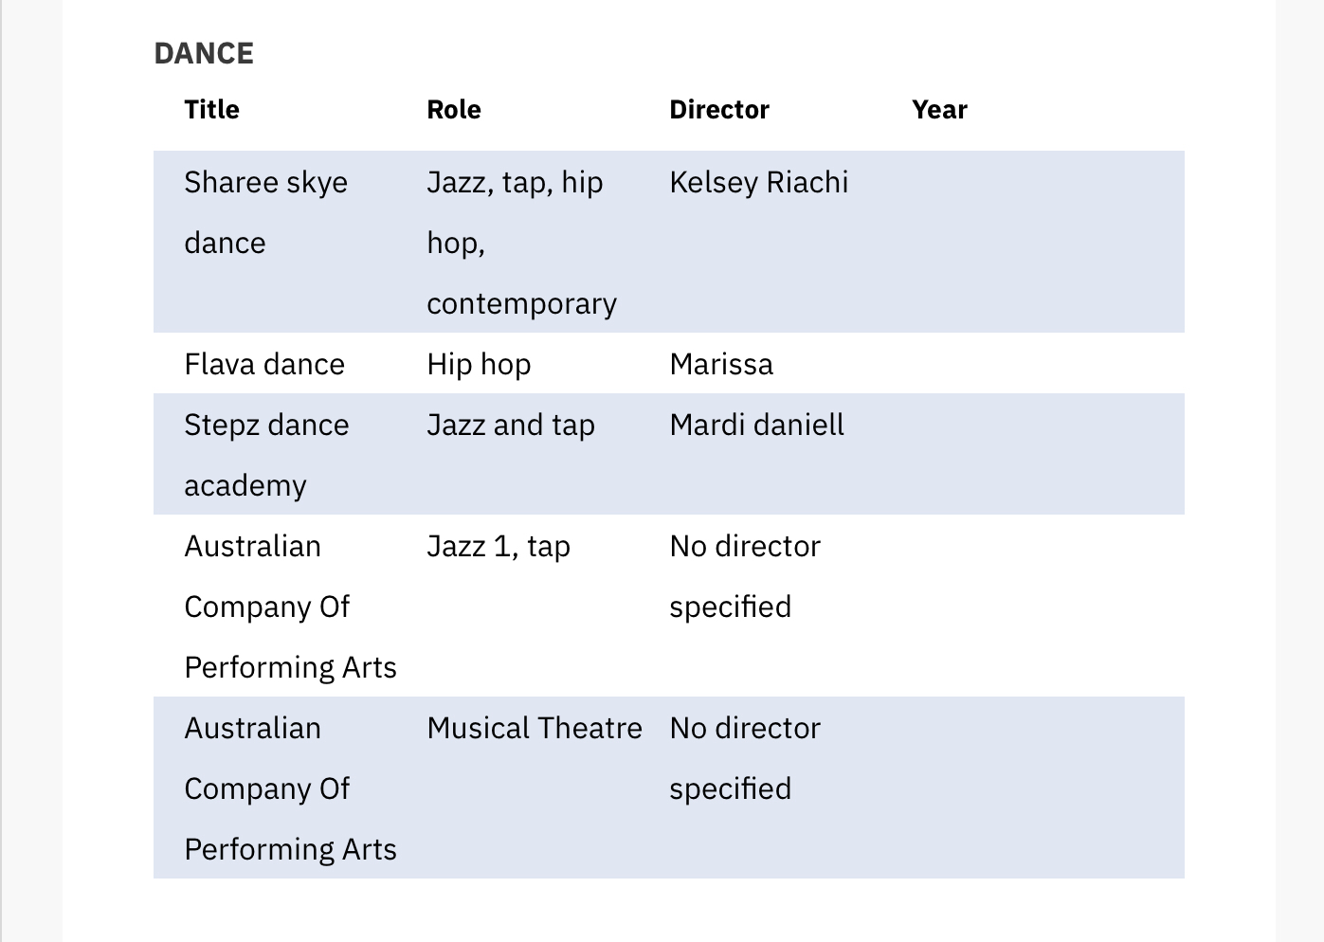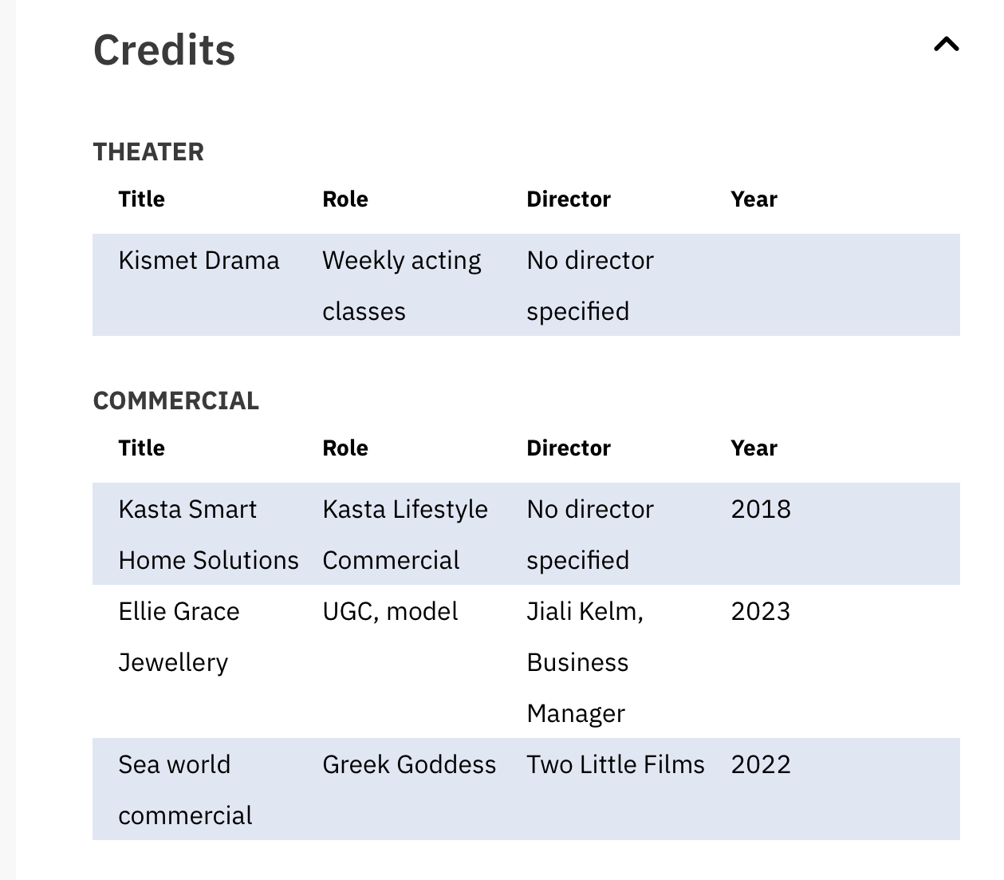

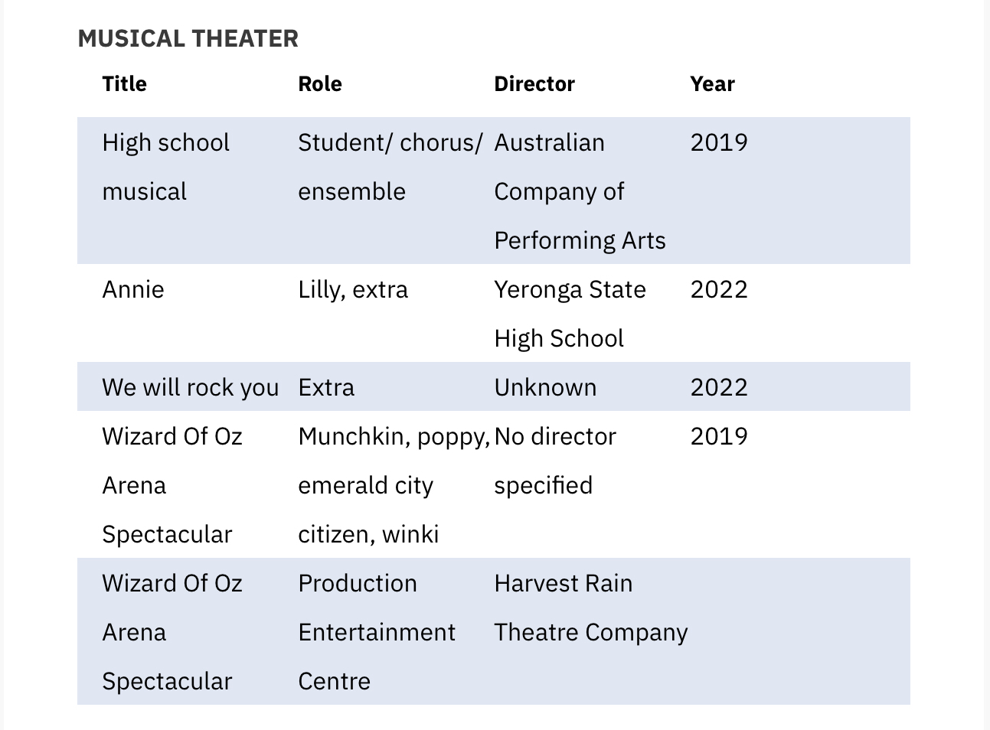

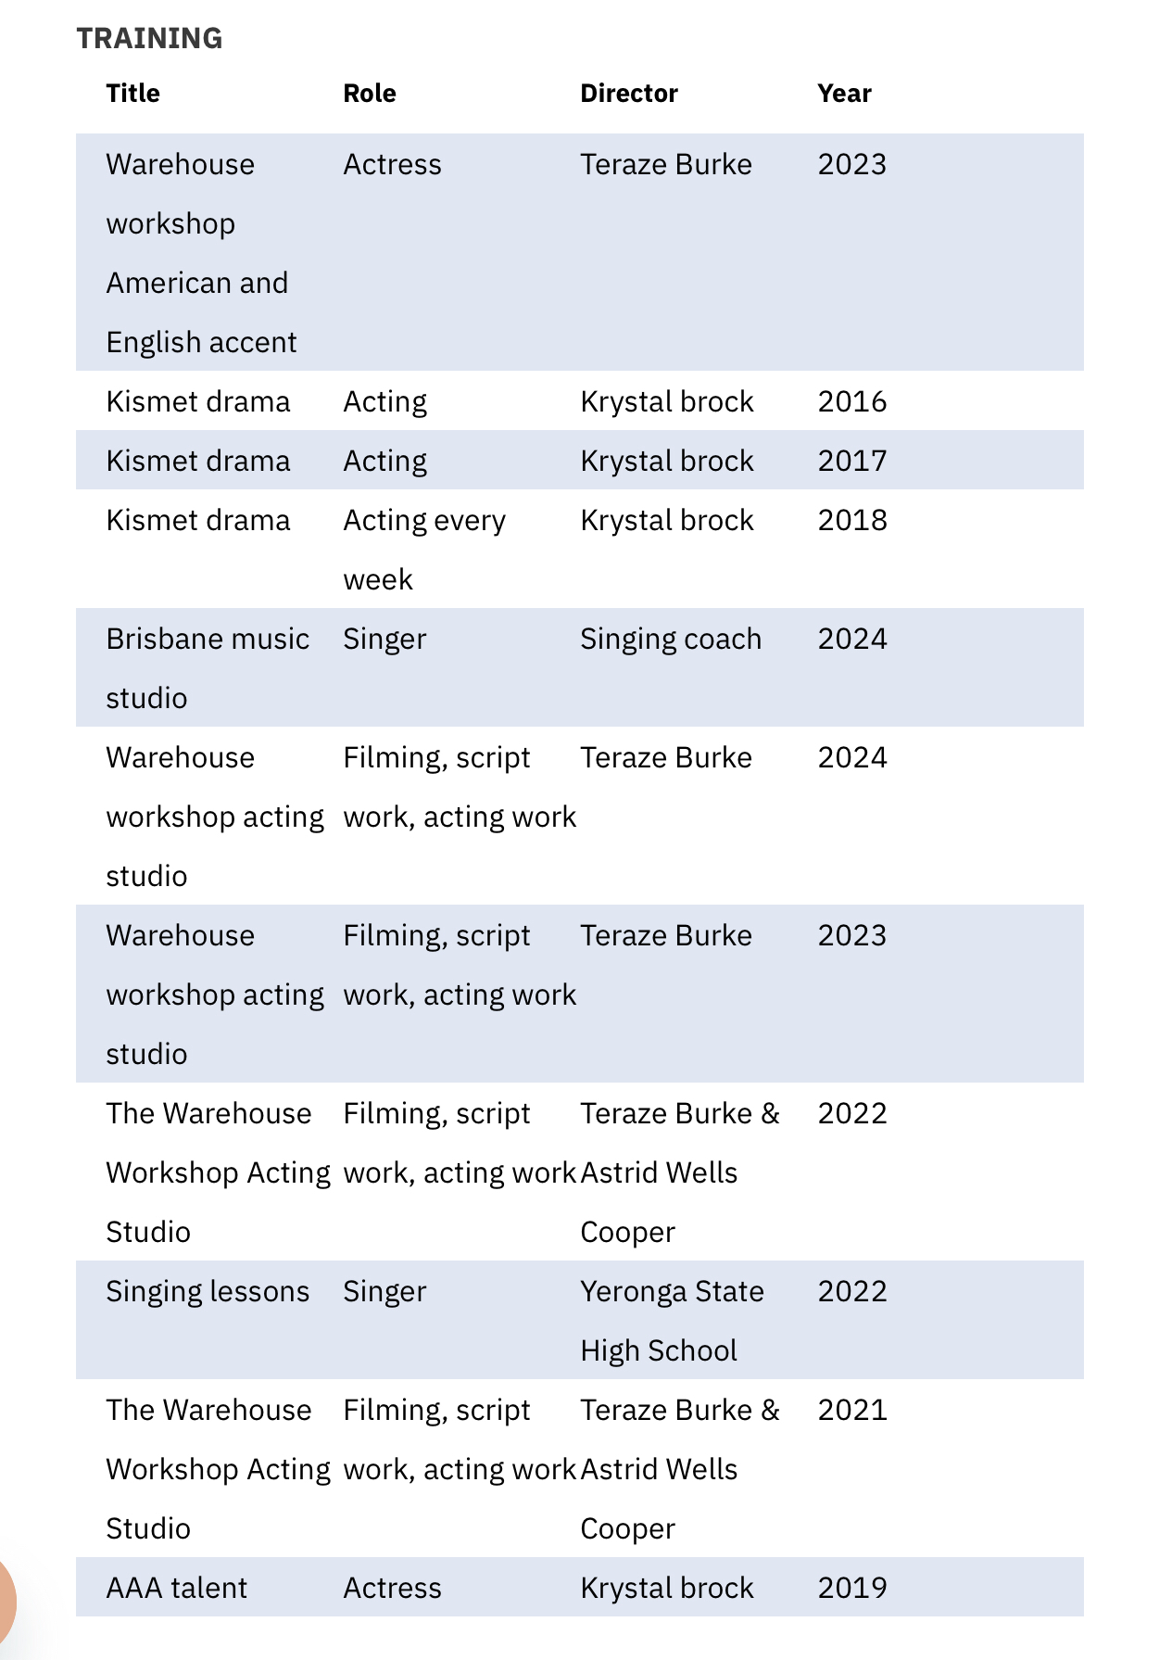

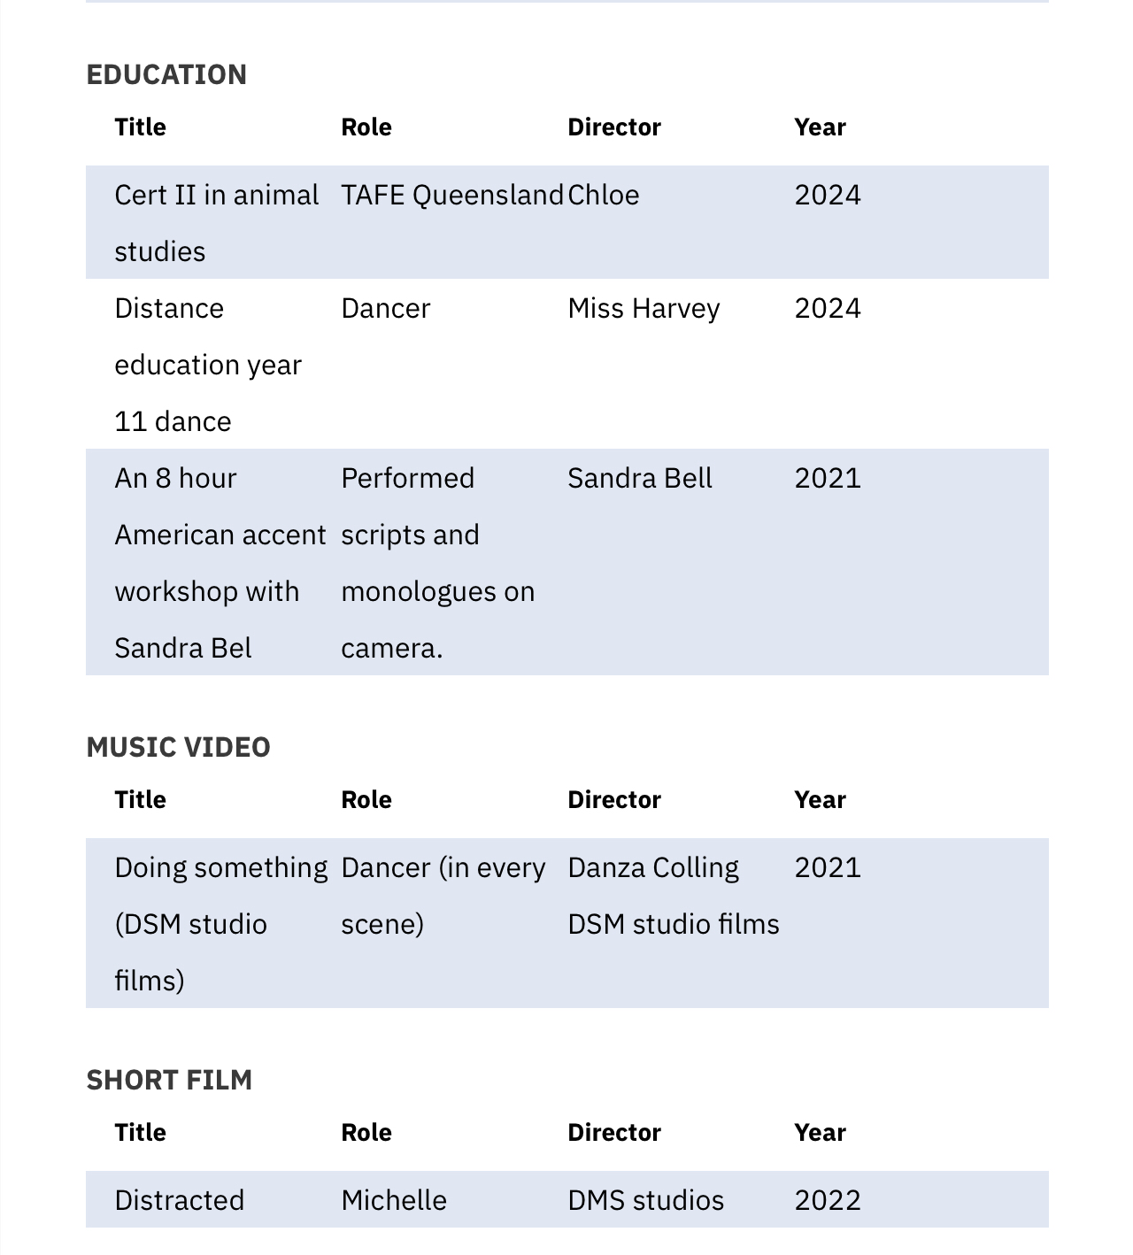

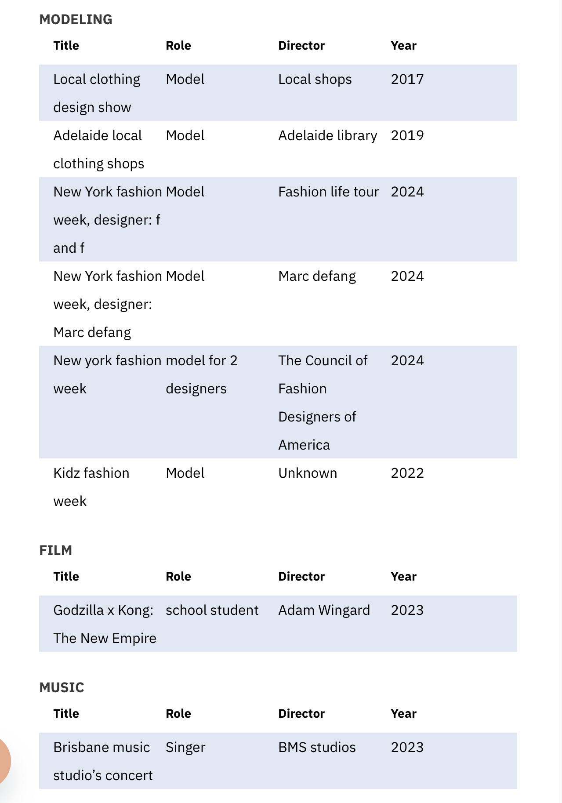

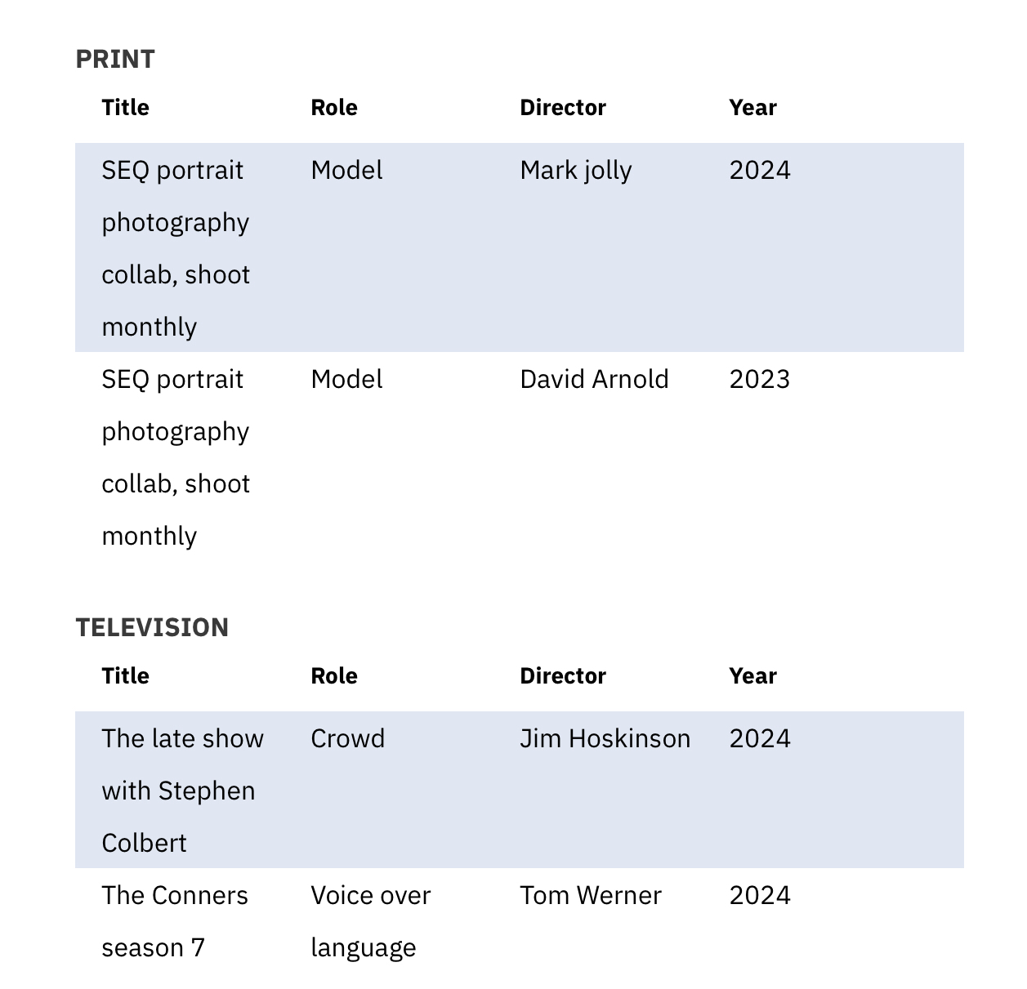

Laughing

Other

2024

Title; Blueys world immersive experience Brisbane ( training)

Role: actress/ puppeteer/ chaperon ( fairy )

Director: **Jess Gollé,** Experience Manager, Andrew Kay & Associates HVK Productions

Title: Santa land

Role: actress/Santa helper

Director: Gemma Godwin Events & Entertainment Consultant Aerial Angels Australia

Title: Halloween promo host

Role: actress, Promo host

Director: LARF Productions, Nareeda Blue

2025

Title: the veil of night Film

Role: Caroline

Director: Drive by Night Productions

Matthew Dixon, Director; Stephanie Allsopp, Assistant Director; Will Tubman Producer.