**Alva Jenkins-Houston**

**(504) 909-5901**

**JenkiaL1@yahoo.com**

**FILM & TELEVISION | Modeling**

“Crime and Punishment” Brenda Acting Out Studios

“Botch” Background Role alnukefilms

“What Would You Do” Wanda Rag Girl Entertainment

“The Preacher and the Whore” Sabrina Rag Girl Entertainment

“Unbelievable Revenge” Secretary Rag Girl Entertainment

“Fashion Modeling ” Model Face2Face Talent

“Model & Brand Ambassador Model Celebrate the Gray

Co-Athor” My Journey to Love Vol 2

**TRAINING**

Improv I Workshop Kelley Cody-Grimm Acting Out Studios

Improv II Workshop Kelley Cody-Grimm Acting Out Studios

Slate Workshop Kelley Cody Grimm Acting Out Studios

Scene Study Workshop Lance Camarillo Acting Out Studios

Script Analysis Workshop Kelley Cody-Grimm Acting Out Studios

Headshot Workshop Luis Martinez Luis Martinez Photography

Talent Agent Workshop

*“Ask An Agent”* Jason Lockhart AMT Agency

Monologue Workshop Kelly Cody-Grimm Acting Out Studios

Rehearsal Workshop Lance Camarillo Acting Out Studios

Casting Director Workshop Pat Skiles GS Casting

Actor’s Boot Camp Jordrell Benjamin Rag Girl Entertainment

Acting Class Ladon Whitmire TSLW Production

**SPECIAL SKILLS**

I am an Actress, Model, Brand Ambassador, Influencer, who believes in living my best life, one moment at a time. I have also enjoyed chasing my dreams, not perfection. In my past I have ventured into cheerleading, softball, basketball, dancing, and improv skills and training.

Age Range: 40 and above

Ethnicities: African American

Appearance: Female; height – 5’4; weight – 135; eyes – dark brown; hair – grey (black); hip size – 39; 34 - D chest/bust · 4 dress size; Shoe size – 6.5

Contacts: City, State - Atlanta, GA.

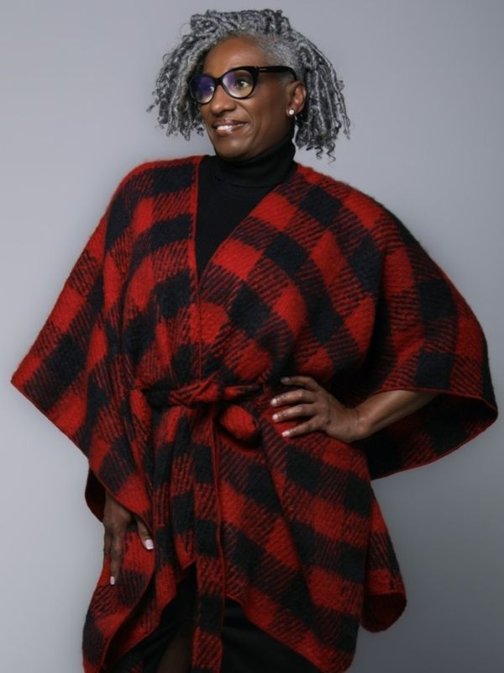 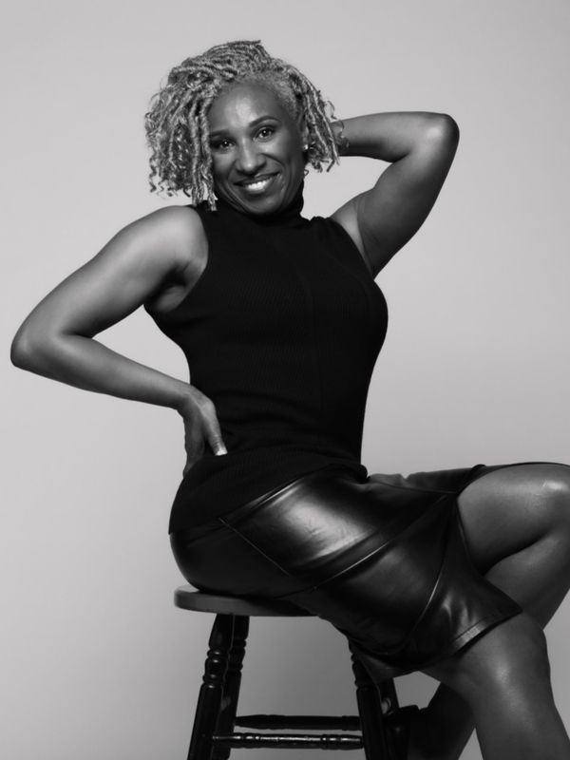 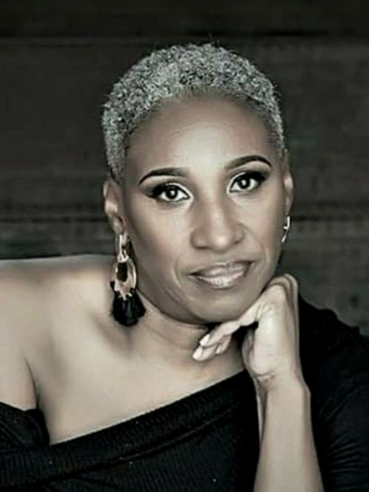

**Bio:**

Introducing the captivating and dynamic talent of Alva Jenkins-Houston, a rising star in the world of entertainment. With a passion for the performing arts that burns brightly, she is making a name for herself as a versatile and accomplished actress on the brink of stardom.

Hailing from her hometown of New Orleans, LA, Alva's love for acting was discovered at a young age, and her journey has been a testament to unwavering determination, raw talent, and an unshakable commitment to her craft. She is a true embodiment of the saying that no matter how old you are, "dreams do come true when you work for them."

Alva's dedication to the art of acting has seen her master a diverse range of roles and characters, from the heartfelt and emotional to the charismatic and comedic. Her ability to immerse herself in the essence of a character is nothing short of mesmerizing. With each performance, she brings authenticity and depth, leaving audiences moved and inspired.

She has honed her skills through formal trainings such as Actor’s Boot Camp, Acting Out Studios, TSLW Productions, AMT Agency, and GS Casting, where she sharpened and learned her craft to develop a deep understanding of the acting world. Her natural talent, combined with rigorous training, sets her apart in the competitive landscape of the entertainment industry.

As a talented actress, Alva has already begun to make her mark with noteworthy roles in the independent film world. Her performances have garnered critical acclaim and the admiration of both peers and audiences, earning her a devoted following. Her work is a testament to her passion for storytelling and her ability to connect with people through her art.

In addition to her on-screen accomplishments, she is also known for her radiant charisma, professionalism, and ability to collaborate seamlessly with cast and crew. Her positivity, work ethic, and dedication to her craft have made her a beloved presence on set and in the production world.

As Alva continues to grow and evolve as an actress, she is poised for a future filled with even more remarkable roles, captivating stories, and a journey that promises to inspire others to follow their dreams.

With her unstoppable drive, unyielding talent, and unwavering passion, you can bet that Alva is a shining star in the making, destined to leave an indelible mark on the world of acting and the hearts of those who have the privilege to witness her performances. Watch this space, as her star continues to rise in the world of entertainment.