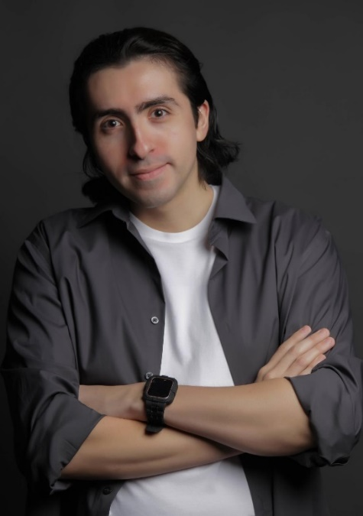
ANGEL HERNANDEZ
ACTOR
Email: angel.hernandez919@yahoo.com
Phone: 510-316-0172

BIO
Non-Union Height 5’11
Hair: Black Eyes: Brown
Ethnicity: Hispanic Weight: 181lbs

FILMOGRAPHY
Intruder Director/Writer/Supporting Angel
Second Chance Lead Tara
The Confession Lead Ashley
Roulette Lead Tony

SKILLS
YouTube Influencer, Handgun Training, Stage Combat, Comedy, Physical Comedy, Modeling,
Cinematography, Editing, Meisner, Improve, Voiceover, Angry, Drama, High Energy, Lazy,
Screen Acting, Shakespeare training, Podcast, Shorts.

EXPERIENCE
2024 – Pro Wrestler / Oasis Pro Wrestling, Berkeley, CA

EDUCATION
2023 – BFA, Acting / Academy of Art University, San Francisco, CA
2020 – AA, Acting / Academy of Art University, San Francisco, CA
2015 – Diploma / James Logan High, Union City, CA

