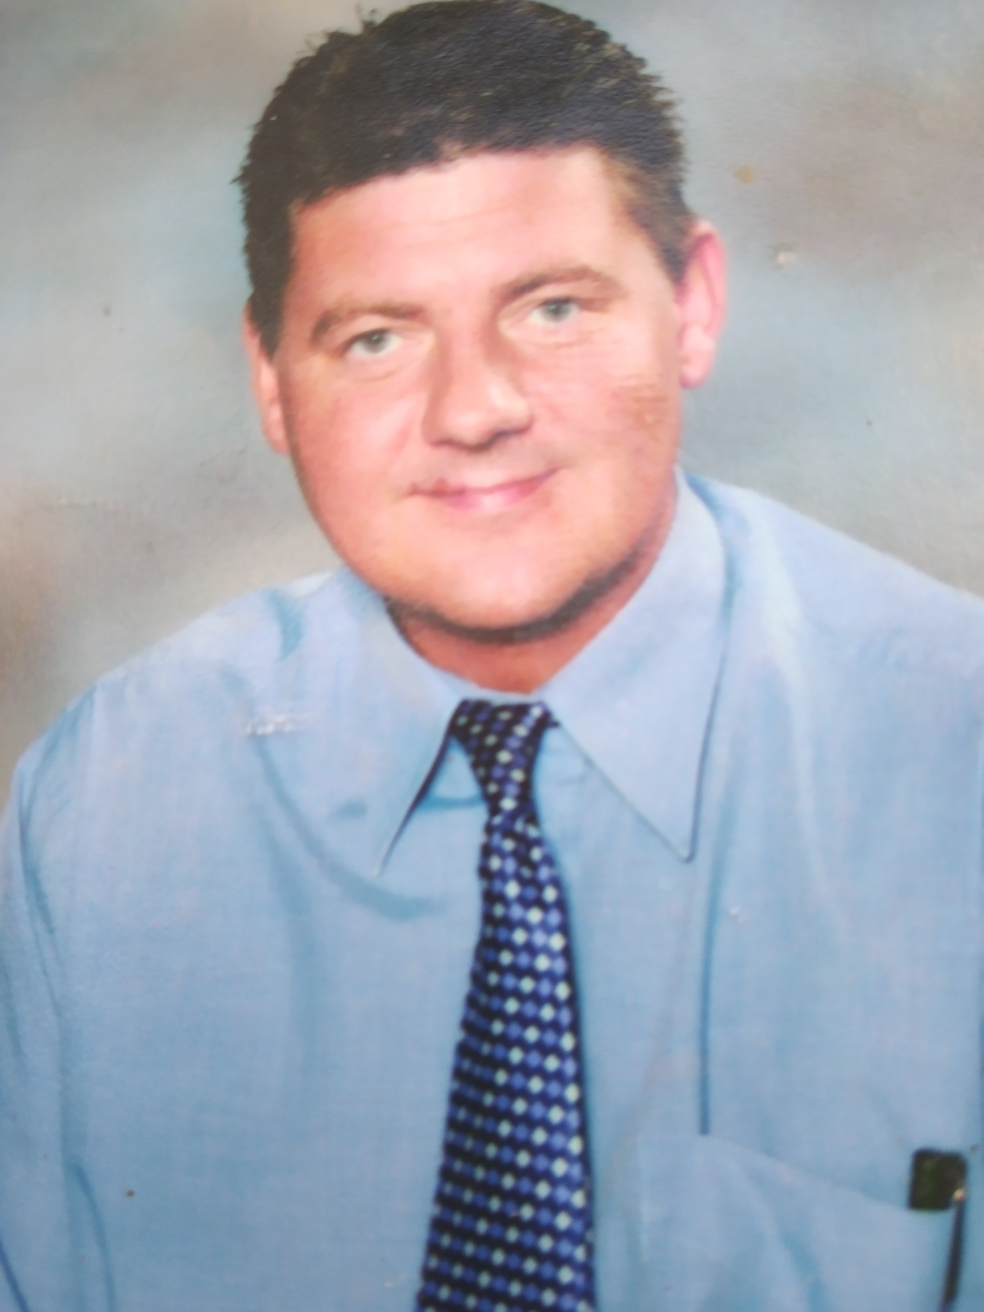

Derek Monaghan
My journey…

Linguist, Teacher, Lecturer, Dramatist, Voice Coach, Musical Theatre Director, Entrepreneur...

I was born in Glasgow, Scotland in 1967. Having graduated from the University of Glasgow with a master’s degree in philosophy and French Language & Literature, I pursued further extensive postgraduate studies in Pedagogical Science and Multicultural, International and Comparative Education. My thesis highlighted the importance of Ethnic Recognition, Multiculturalism and Multilingualism within the Management of Educational Systems and Institutions. I taught Languages and Philosophy for 32 years, with a portfolio that included the design, content, and development of numerous e-learning and digital media products in language and literacy education. As well as teaching in the UK, I also worked extensively as an educator in various international settings, including the Sorbonne University in Paris, the Saudi Government Institute of Public Administration in Riyadh, and the Kandy branch of Colombo International School in Sri Lanka. As an International Teacher Trainer and Global Education Consultant, the themes of mutual respect, cultural sensitivity, and clarity of communication have all become central elements of my vision and mission. I recently decided to concentrate my energies relating to my experience, knowledge and expertise on enhancing my passion for voice and language diversity by becoming a full-time voiceover artist.

